1. EXODUS - INTRODUCTION
"And these are the Names..."

ITS PROVOCATIVE TITLE
The title of the book in Hebrew is Ve-eleth Shemoth, the words that form the opening of the book: "And these are the Names..." It introduces the names of those who went down into Egypt, as people marked of God as His own in the land of sin, slavery and death. The children of Israel provided the basis for all God's future operations in delivering humanity from the bondage of corruption into which sin had brought it. They provide a pattern of redemption for all who subsequently seek the divine mercy. The title Exodus is derived from the Greek word in the Septuagint Version, and signifies Departure or Going out. The word occurs in Heb. 11:22, "By faith Joseph, when he died, made mention of the departing (RV "departure") of the children of Israel; and gave commandment concerning his bones." This statement links Exodus closely with Genesis. The link is made even stronger by the opening verse of Exodus which, in the Hebrew, commences with "And." Exodus, therefore, is set forth as a continuation of Genesis, a new section in the developing revelation of God.

The Divine Plan for a Way Out
In Luke 9:31, the Greek εξοδυη exodos is rendered "decease," but in such a remarkable way, as to provide a key to the whole record of Exodus with its types and shadows. It records that, on the Mount of Transfiguration, the apostles saw Moses and Elijah in glory, speaking of the Lord's "decease which he should accomplish at Jerusalem." Decease and accomplish are both significant words in this statement. The first is the word exodon and signifies a way out; the second is the word pleroun, and means to finish or fulfil a period or a task; or to verify or complete a prediction. The Lord's death and resurrection are the means God provided for the way out of the slavery of sin and death which became the heritage of mankind, and revealed the way to deliverance. What was accomplished in Christ, was prefigured in Exodus, and therefore, it is appropriate that the Lord's work should be described as an Exodus. The pattern of redemption revealed in Exodus shows it to be closely linked with the work of Yahweh in Christ. Thus the events therein narrated, provide vivid, interesting typology of the dramatic deliverance of humanity as provided in Christ. Therefore the title of the book before us is provocative, whether considered in its Hebrew or its Greek forms.

The Story of Deliverance from Sin and Evil
The book records that, through the intervention of God, Israel was able to snap the shackles that held the people bound to Egyptian slavery, and was shown the way out toward the liberty as revealed in divine worship. It records the establishment of the Passover, the giving of the Law, the confirming of the Mosaic Covenant, and the erection of the Tabernacle with all its amazing symbolism. It is a book of tremendous drama. It commences with an account of the bitter bondage and hopeless sighing, of the people of God in Egypt. It moves on to their rejoicing at the deliverance effected through the passage of the Red Sea. It culminates in the spiritual elevation of Truth in the midst of the newly formed nation of Israel, constituted as the kingdom of God on earth. Is there in all history a more amazing spectacle than the Exodus? Does the Old Testament record a more solemn and tremendous revelation of God than at Sinai — whether in revealing the divine Name to Moses, or delivering the Law to Israel? What human figure, apart from that of the Lord Jesus Christ in the days of his flesh, exceeds the man Moses (Deu. 34:10)? Where is there a political incident that is more significant than the founding of Israel as a theocracy? All these facets of divine revelation, and principles of divine grace are revealed in Exodus.

The Principles of Power, Holiness and Wisdom
In the deliverance from Egypt there is revealed the power of God (chs. 1-18); in the revelation of the Law, there is emphasised the holiness of God (chs. 19-24); in the design of the Tabernacle there is symbolised the wisdom of God (chs. 25-40). Israel reaches nationhood in Exodus. It is brought into a new state: that of freedom from bondage. It is given a new constitution: the theocratic. It is provided with a new worship: the Mosaic. The Exodus brought the Hebrews to a newness of political and religious life. The Law limited liberty and emphasised responsibility; whilst the Tabernacle granted privilege and provided worship. Above all else, the Book of Exodus provides a pattern of redemption. Its history of deliverance is re-enacted today in the call of Gentiles to salvation in Christ. It sets forth nationally what every believer must go through individually if he would attain unto the kingdom of the future. Thus its lessons live as exhortations for those who would separate from the spiritual Egypt of modern life.

The Key Verse of Exodus
This is suggested as ch. 3:8, "I am come down to deliver them out of the hand of the Egyptians, and to bring them up out of that land unto a good land and a large, unto a land flowing with milk and honey."

THE AUTHOR
The author was evidently a witness to the events narrated. The vivid descriptions of the plagues upon Egypt, of the thunderings at Mount Sinai, and of the manna in the wilderness, require an eye witness. The minute details concerning the wells and palm trees at Elim, the two tables of stone, the worship of the golden calf, and many other things testify to personal observation. Since there is little or no evidence of later additions to the book, it may be safely assumed that the writer of Exodus composed his material during or shortly after the experiences recorded, narrating the deliverance of Israel from Egypt — an entire race of people suddenly and forever flinging away the shackles of servitude in a land of slavery and death, migrating to a new country and a new corporate life — and doing so "through water." This is followed by the establishment of the Mosaic Covenant, and the testing of the people by Law. There is recorded the erecting of that marvellously symbolical structure, the tabernacle as the centre of religious life for the nation; the formation of the tribes into a nation; the lessons of the wilderness wandering; the development of Moses as prophet and shepherd to the people. Paul comments: "Now all these things happened unto them as types; and they are written for our admonition, upon whom the ends of the world are come" (1 Cor. 10:11). Therefore, in the amazing events recorded in Exodus, there is discerned a remarkable pattern of redemption, teaching its lessons to all succeeding generations, and providing a compelling exhortation for today.

Background Information
With Exodus begins the story of Moses himself. His own life and work form part of the subject matter of Exodus, Leviticus, Numbers and Deuteronomy that he himself wrote. The account of his life comprises about one-seventh of the whole Bible, and is about two-thirds the volume of the entire New Testament. As with Genesis, the Book of Exodus has been attacked by critics of the Bible, who have sought to discredit the account of the deliverance from Egypt, and the miracles associated with it. The Israelitish population explosion it records, has particularly been challenged. It is alleged by critics that it would be utterly impossible for seventy people to grow into a population of about two million (600,000 males) in merely 215 years. But though the increase is large, it is not an impossible one. It requires that there should be a doubling up of population every fifteen years. Given prosperous conditions (and they are implied —Exo. 1:7), this is far from an impossibility. In fact, India almost does so in recent times, even under adverse conditions. To increase from two to seventy in the first 215 years from the time of Abraham and Sarah, required that the population double every twenty-five years, and this was done in spite of the small families of Abraham and Isaac. But the statement of Exodus 1:1 implies that more than seventy went down into Egypt, for it expressly states that "every man with his household came with Jacob." Abraham had a household of three hundred and eighteen males (Gen. 14:14), so that evidently a considerably larger number than seventy went down into Egypt. The remnant of Shechem had been taken into the tents of Jacob (Gen. 34:29), and these, with others, could have been included in one or other of the tribes, when officially incorporated into the nation. In addition, an exceptional increase of population had been promised the fathers of the nation (Gen. 17:6; 26:4; 28:14; 35:11; 46:3), and later, such a development is recorded (Gen. 47:27; Exo. 1:7, 12;Deu. 10:22; 26:5). In The Exodus of Israel, T. R. Burke claims that "the yearly increase in the Scripture narrative, lies about exactly midway between two opposing limits: the rate under ordinary circumstances, and the extreme rate compatible with the usual laws of birth, marriage and natural fecundity." He continues: "Assume an average of six sons, the age of the father varying from 25 to 35 years. Six descents would thus range from 150 to 210 years; would be six compound additions of 51 (the number of grandsons at the descent), and would total 2,379,456. The interval of those who were twenty years old after the Exodus will be 196 years from the descent, or more than 200 from the birth of the grandsons. We have this to deduct from the above, the births in the last ten years, which would be about 51x210 = 10,710. Thus, at the above rate, there would be a population of 2,369,000 males above twenty in the sixth descent alone." In view of the promise of great fecundity (cp. Psalm 127:3-5), the increase to 600,000 males within 210 years is not impossible. In addition, Israel went "with their households," some of whom might well have been adopted into one or other of the tribes, and thus augmented the number from whom the population came.

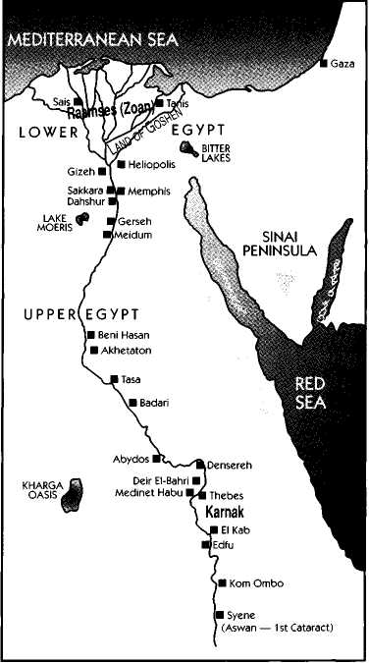
Egypt At The Exodus
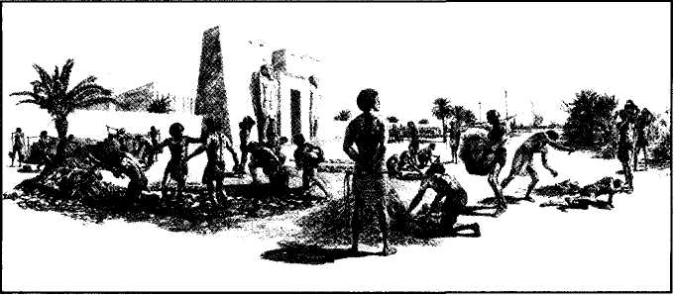
Egypt comprises a valley from 3.5 to 50 kilometres (2-30 miles) wide, with an average width of about sixteen kms (10 miles). It is some 1,200 kms (700 miles) long, cut by the Nile, through the east end of the Sahara Desert, from Aswan to the Mediterranean. On either side, it has a desert plateau about 300 metres (1,000 feet) high. The floor of the valley is covered with black alluvial deposit of rich sediment from the Abyssinian highlands, providing unparalleled fertility, constantly renewed by the annual overflow of the Nile. From the dawn of history the land has been irrigated with vast and elaborate systems of canals and reservoirs. Isolated and protected by the desert, one of the earliest empires of history, here developed a high civilisation. The ancient monuments and records of the past testify to the advanced culture and sophistication of the ancient civilisation. For a longer period than any other empire, it preserved its power and greatness. From shortly after the Flood, until the invasion of Nebuchadnezzar, its power as a nation was feared and respected. The Delta, a triangle formed by the spread-out mouth of the Nile, is about 160 kms (100 miles) long from north to south, and about 240 kms (150 miles) wide from east to west. The land of Goshen, main centre of Israelite habitation, was east of the Delta.

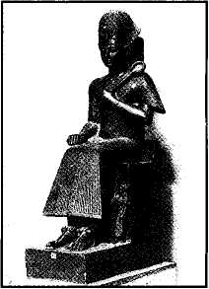
The Pharaoh Of The Oppression
We believe that the Pharaoh of the oppression was Rameses II, sometimes called Rameses the Great. He was one of the greatest of the Pharaohs, and reigned for a period of sixty-five years, which gives adequate time for the events in Exodus to have occurred during his lifetime. However, this is disputed by some on the grounds that it would be impossible chronologically. Others accept Rameses as the Pharaoh of the oppression, but reject the chronology of the Bible. We believe that the chronology of the Bible, being inspired, is exact, and to be accepted. But we do not consider Egyptian chronology as inspired nor exact. In fact, Egyptologists do not agree amongst themselves upon the dates of the Pharaohs. For example, the first year of Merneptah (Rameses' successor) has been set by various authorities and archaeologists thus: A.G. Sayce: BC1280; E.A.W. Budge: BC1263; Breasted: BC1225; Flinders Petrie: BC1207. In Light From The Ancient Past (p .97) J. Finegan states: "From astronomical calculation of the date of a new moon mentioned in the fifty-second year of Rameses n, Rowton has placed the accession of Rameses n in bc1290."
Difficulties in Chronology
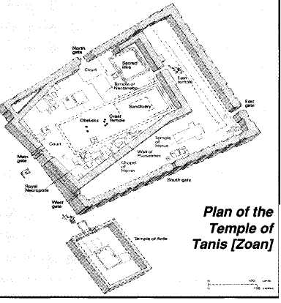
Disagreement among experts in regard to Egyptian chronology is contrasted with the inspired chronology of the Bible. In The Romance of Bible Chronology, Martin Anstey comments: "All Egyptian dates for this period are purely conjectural. The date of the Exodus is fixed quite definitely in the Hebrew text, and as there is nothing certainly known in the records of Egypt to conflict with the Hebrew Bible, there is no reason why it should not be accepted. The Exodus occurred on the 14th Nisan, in the year an horn. 2513, a year which would be expressed by Usher as BC1492, but in terms of the scheme of the present writer as BC1530 (Bible dates) and in the terms of the ordinary received chronology as bc1612 (Ptolemaic dates)." The Ptolemaic system of chronology is that generally accepted today. Ptolemy (ad70-161) was a constructive genius, and the author of the Ptolemaic system of Astronomy. He was one of the founders of the science of geography. But in chronology he was only a late compiler and contriver, for he lived in the second century after Christ. His table and chronology of the Persian kings is disputed. It is contradicted by the Persian National Traditions preserved in Firdusi, by the Jewish national traditions preserved in the Sedar Olam, and by the writings of Josephus. Therefore, though the Canon of Ptolemy is of greatest assistance in the study and synchronisation of history, it should not be used to challenge the inspired record of Scripture. Further comments are made to this effect in The Romance of Bible Chronology. However, there is a problem in relation to Bible chronology, in that Luke inserts Cainan as the son of Arphaxad (Luke 3:36), whereas the Hebrew text gives Salah (Gen. 10:24). It is also noted that the Septuagint gives Cainan as the son of Arphaxad, and, in consequence, adds a further 130 years to the chronology. Despite this, however, it appears that the presence of Cainan in the genealogy at this point is an interpolation, and should be ignored. The Companion Bible comments: "Undoubtedly an interpolation in certain copies of the Septuagint towards the close of the Fourth Century ad." In support, it cites the opinion of A. Hervey in The Genealogies Of Our Lord: "The evidence against his existence is to the utmost possible degree, clear, full, and positive, and not liable to any mistake or perversion. On the contrary, the evidence for his existence... is inferential, obscure, or open to the suspicion of falsification." F.W. Farrar comments: "In v. 36 [Luke 3] the Cainan [who must be distinguished from the Cainan of v. 37] is possibly introduced by mistake. The name, though found in this place of the genealogy in the Septuagint, is not found in any Hebrew mss. of the O.T., nor in the Samaritan, Chaldee, and Syriac Versions (Gen. 11:12; 1 Chr. 1:24). It is omitted in the Codes Bezae (D), and there is some evidence that it was unknown to Irenaeus." The exclusion of this Cainan greatly assists to consolidate Bible chronology to the time of the Exodus. We therefore accept Rameses II as the pharaoh of the Exodus, without conceding the alleged chronological problem between the dating of Egyptologists and the Bible. We believe that the Egyptologists have made a mistake, and therefore accept the inspired chronology as exact. In Light From The Ancient Past, J. Finnegan writes: "Unless we are to regard Exodus 1:11 as an erroneous or anachronistic statement, we must conclude that Rameses II was the pharaoh under whom the oppression of the Israelites reached its climax. This is in harmony with our knowledge of his vast building activities, and particularly with the fact that he resided in the Delta and devoted the opening years of his reign largely to building operations at Tanis. The general impression given by the book of Exodus is that the Israelites were settled not far from Pharaoh's court, and in Psalm 78:12, 43, they are definitely said to have lived 'in the land of Egypt, in the fields of Zoan.' Zoan is the Hebrew name for Tanis, as the rendering in the Septuagint shows, and thus we have a picture of the Israelites as living in the vicinity of Tanis at a time when Pharaoh's court was there. This situation is fulfilled in the time of Rameses II, but not in the earlier days of Thutmos II."

Zoan was situated on the northeastern frontier on the east bank of the Tanaitic Nile. The city had been established as early as the Sixth Dynasty of Pharaoh Pepi I (bc 2300 see Num. 13:22), and later became the headquarters of the Hyksos or foreign rulers of Egypt. Rameses II practically reconstructed the place. It continued until about ad451, when it declined and became a heap of ruins in the midst of the village, San. The temple of Tanis was one of the largest structures in Egypt, measuring 300 metres (1,000 ft.) long. It contained a colossal statue of Rameses II, some 29 metres (92 feet) high, weighing 900 tonnes. Its large toe was the size of a man's body! The following list of pharaohs is given with the accepted dates of their rule, a chronology which we dispute because of the reasons advanced above. However, for sake of convenience, and to indicate the length of rule, we have included these "accepted dates."

Pharaohs Of Ancient Egypt
Amosis — 1580. From Thebes, he organised opposition to the ruling Hyksos, and drove them out in bc1570. He besieged them in the Palestinian fortress of Sharuhen (Josh. 19:6).
Amenhotep ι — 1560.
Thotmes I — 1540. He broke with the tradition of building pyramids and instead built a royal rock-faced tomb. He was an energetic ruler and made Egypt a world power. He extended his conquests to the Euphrates, which the Egyptians, in amazement, styled: The River which Flows Backwards, for it flows in the opposite direction to the Nile.
Thotmes II — 1510. This pharaoh was dominated by his half-sister Hatshepsut who was the real ruler. He made frequent raids to the Euphrates to maintain the empire established by Thotmes I.
Thotmes m — 1500. Hatshepsut, his half-sister, was co-regent for twenty years. He hated her, and after her death endeavored to remove her name from history. This pharaoh was the greatest conqueror in Egyptian history. He raided Palestine and Syria seventeen times, built a navy to control the sea, subdued Ethiopia, and ruled throughout the country to the Euphrates. He established the first great empire in history, and in doing so, accumulated great wealth. He also engaged upon great building projects, many of which still remain. His tomb is at Thebes; his mummy in the Cairo Museum.
Hatshepsut — Daughter of Thotmes I. One of Egypt's greatest and most vigorous rulers, and the first great queen in history. But because she was a woman, she never obtained supreme power. She hated the idea of inferiority of her sex in rulership, and made her statues representing herself as a man! She therefore was chief of the women's liberation movement of ancient Egypt! Under her influence the power of the empire was extended, and she attempted to add to its glory, by building many monuments. She was hated by Thotmes in whom she dominated during her lifetime, and who, after her death, obliterated her name from her monuments, and destroyed many of her statues — the broken remains of some having been discovered.
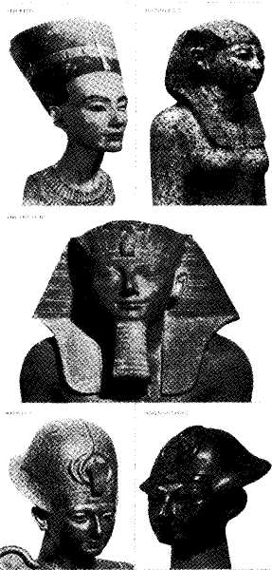
Amenhotep II — 1450. Many believe that he was the pharaoh of the Exodus. They claim that Hatshepsut was the "daughter of Pharaoh" who saved the infant Moses.
Thotmes iv — 1420.
Amenhotep iv — 1415. He built up the glory of the empire without the military prowess of his predecessors, so that under him Egypt lost her Asiatic Empire. He tried to establish monotheism throughout Egypt, and endeavoured to force the people to worship one god, Ra. Opposed by the priests of Thebes who supported the polytheism of Egypt, he removed his capital to Amarna.
Semenka — 1362. A weak ruler.
Tutankhamen — 1360. Son-in-law of Amenhotep iv. He restored the old polytheistic religion, and moved the capital back to Thebes. One of the lesser rulers of Egypt, reigning at the close of a most brilliant period for the empire. He died at the age of about 18 years. He is unique to Egyptian archaeology, inasmuch as his tomb was discovered intact by the archaeologist, H. Carter, in ad1922. The fantastic wealth revealed in the tomb of this comparatively obscure and lesser ruler of Egypt, is indicative of the tremendous glory that must have been manifested by the nation during its heyday, and of the fabulous wealth that must have been found in the tombs of greater pharaohs before they were robbed.
Ay; Setymeramen — 1350. Two weak rulers.
Horemheb — 1340. A religious reformer who restored the worship of Amon.
Rameses I — 1320.
Seti —-1319. He extended the influence of Egypt by again conquering Palestine which had slipped from Egyptian control. He commenced the building of the Great Hall at Karnak.
Rameses ii — 1308. One of the greatest of the pharaohs, and certainly one of the most pompous and dictatorial, ruling for 65 years. He was a great builder, a propagandist, and, according to some, a great liar! It is said that he sometimes claimed credit for the accomplishments of his predecessors; but that he was a great ruler is beyond dispute. He re-established the might of the empire from Ethiopia to the Euphrates, raiding and pillaging Palestine repeatedly. He completed the Great Hall of Karnak, and other vast works, including fortifications, canals and temples. He used slave labor for these projects, as he boasts upon monuments still standing. Among these slaves were included prisoners taken in war, negroes from the south, and local inhabitants of the working class. He forced them to toil in gangs in the quarries or brickfields, or in dragging great stone blocks over the soft earth. His mummy is in the Cairo Museum.
Merneptah — 1235. Probably the pharaoh of the Exodus. His throne-room at Memphis has been discovered.
Amenmeses; Siptah; Seti II — 1220-1200. Three weak rulers.

Controversy Over The Pharaoh Of The Exodus
Some favour Amenhotep II (bc 1450-1420); others (including ourselves) believe that it was Merneptah (bc 1235-1220). The dated reign of Amenhotep II favors the chronology of the Bible, whereas that of Merneptah does not. However, the facts concerning the reign of Merneptah suggest that he is the pharaoh of the Exodus, and as we have indicated that Egyptian chronology is open to doubt, we suggest it should rather be made to conform to that of the Bible. If Amenhotep were the pharaoh of the Exodus, then Thotmes (bc1500) would be the oppressor, and Queen Hatshepsut, his half-sister who reigned as co-regent, probably the daughter who saved Moses' life. As noted before, though Thotmes despised and hated her, she completely dominated him, and represented the real power of the throne. After her death, he ruled alone for thirty years. He was the greatest conqueror in Egyptian history. He subdued Ethiopia, and extended his rule to the Euphrates, establishing the first great empire in history. He accumulated great wealth, and engaged in vast building enterprises. His mummy is in the Cairo Museum. If Merneptah was the pharaoh of the Exodus, then Rameses would be the oppressor. He also was a great ruler, and re-established the empire brought into existence by Amenhotep. We believe that he was the pharaoh of the oppression because of the reference to the city named after him (Exo. 1:11), and Egyptian chronology should be made to conform to that of the Scriptures. In ad1883, the archaeologist Naville, identified the site of Pithon (Exo. 1:11). On the gateway he found an inscription of Rameses which read: "I built Pithon at the mouth of the east." In ad1905, Flinders Petrie discovered the city of Rameses. On a stele, discovered by Fisher at Bethshean in Palestine, Rameses claims that he "built Raamses with Asiatic Semitic (i.e. Hebrew ) slaves." Some scholars, however, claim that all he did was to rebuild or repair that which his predecessors had established before him with Hebrews who did not go out with Moses, and that the pharaoh of the oppression was Thotmes. This however, is mere supposition. The only reference to Israelites on the monuments and inscriptions of ancient Egypt, is that found on the stele of Merneptah, which today is located in the Cairo Museum. Portion of it reads: "I plundered in Canaan with every evil. Ascalon is carried into captivity. Gezer is taken. Yenoam is annihilated. Israel is desolated. His seed is not. Palestine is become a widow for Egypt. All lands are untied; they are pacified. Everyone who is turbulent has been bound by king Merneptah." The reference to Israel, and the claim that "his seed is not" could relate to the slaughter of the male children as recorded in Exodus, or even to the boastful but lying claim of the Pharaoh explaining to the people of Egypt the result of the attack on the Israelites at the Red Sea. Merneptah could have represented this as a victory, and have claimed to have driven the people into the wilderness to perish. Despite his boast, Merneptah's reign was of short duration,and full of disaster. Bible chronology has established the Exodus as taking place approximately bc1450, thus favoring the reign of Amenhotep; but again we emphasise that Egyptologists are at variance in their chronology of its history. Budge gives Rameses as reigning in bc135O; others set it at bc1292. In the face of such uncertainty and disparity, we must accept the statement of Exo. 1:11 as implying that the oppression took place in the era of Rameses.
Halley's Bible Handbook states about the unreliability of Egyptian chronology that: "Egyptian chronology is fairly well established back to bc1600; but beyond that it is very uncertain. Thus Menes, the first historical king, is dated by Egyptologists variously as follows: Petrie: BC55OO; Mariette: BC5000; Brugsch: BC4500; Chabas: bc4000; Lepsius: bc3900; Bunson: bc3600; Hall: BC35OO; Breasted: bc3400; Barton: BC3400; Meyer: bc33OO; Scharff: bc3000; Poole: BC2700; G. Rawlinson: bc2450; Wilkinson: bc2320; Sharpe: bc2000. Thus, Petrie and Breasted, two of the most famous Egyptologists, differ by more than 2000 years as to the beginning point of Egyptian history! These two "experts" differ by more than a thousand years on the date of the pyramids, and seven hundred years on the Hyksos period. Present tendency is to lower the dates, both of Egyptian and Babylonian chronology, placing the Great Pyramid at Bc2400 or 2500." In view of such uncertainty as to actual dating, it would be foolish to accuse the Bible of being incorrect as to its chronological outline.

Memphis: Capital of Rameses
The main capital of Rameses n, the seat of his government, was in Memphis, a name that signifies White Walls. It was situated fifteen kilometres (10 miles) north of modern Cairo. Today all that remains of Memphis "once the greatest city on earth is a colossus and a sphinx" (Historical Geography of the Bible). According to Herodotus, Memphis was built on land reclaimed by changing the course of the Nile under instructions of Menes "the first king of Egypt" (Book 2, Sect. 3). It became the headquarters of the worship of Ptah, and of his living symbol, the Apis bull. It was recognised as "the temple city of Egypt." As the headquarters of the empire, it would have been visited by Joseph and Moses. Perhaps the Lord Jesus, as a babe taken to Egypt, was in Memphis. It was a city of glory and triumph in the days of Israel's decline (Jer. 2:16), and was used as a place of refuge by Jews in the days of Jeremiah (Jer. 44:1). The prophets warned, however, that this place of refuge in Egypt, would become the grave of the refugees who sought its shelter (Hos. 9:6). Jeremiah predicted that
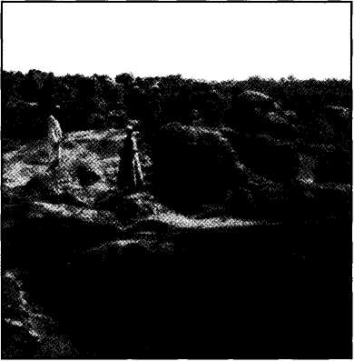
Ruins of the Ptah Temple, Memphis
Memphis (Noph) would be punished by Yahweh (Jer. 46:14), and warned that it would become "waste, desolate without inhabitant" (v. 19). Ezekiel declared that its very idols and images would cease to exist (Eze. 30:13), and that it would be subjected to continued, daily distresses (v. 16).
These prophecies in regard to the ancient capital of Egypt had amazing fulfilment. Memphis was sacked by the Assyrians under Esarhaddon and Ashurbanipal. It was attacked by Nebuchadnezzar. Cambyses, son of Cyrus, occupied it, and made Egypt a satrap of the Persian Empire.
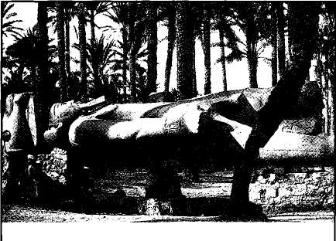
In spite of these attacks, however, Memphis still remained a city of considerable importance, despite the rivalry of Thebes. It challenged the supremacy of Alexandria in Greek and Roman times. It prospered until the time of the Emperor Theodosius (AD379-395) who ordered the destruction of its temples and the desecration of their statues, in an attempt to destroy paganism. From thence onward it commenced to decline rapidly. In ad640 it fell to Arab invaders, who, in the name of Islam, set up their capital in nearby Al-Fostat. In ad969, Al-Fostat was replaced by Cairo. Stones from Memphis were taken for building purposes, and the ancient capital was almost completely demolished. Its destruction, claims The Historical Geography of Bible Lands, is without parallel in the ancient world. The city has been completely demolished, and, unlike many other centres in Egypt, even its columns, statues and idols have gone. The ruins of Nineveh and Babylon remain for the archaeologist to excavate, but not those of Memphis. As the prophets of Israel foretold, they have completely disappeared. In the light of Bible predictions, the destruction of Memphis is looked upon by students as among the greatest wonders of the prophetic word.

A Summary Of Egypt In The Bible
The word Egypt in Hebrew is Mitsraim, a plural word signifying "Oppressors." The plural denotes the duality of the nation, being combined of Upper and Lower Egypt. Mitsraim is the plural of matsowr signifying "to limit, hedge in, distress," from a root tsuwr, "to cramp, confine," rendered "adversaries" (Exo. 23:22), "beset" (Psalm 139:5), "distress" (Gen. 35:3; 42:21). To Israelites, therefore, Egypt stands for the oppressors who have caused them distress. Mitsraim was a son of Ham and brother of Canaan, Put and Cush (Gen. 10:6). Ham (Heb. Kham) signifies "hot, dark," a symbol of spiritual ignorance. Egypt is identified with Ham in the poetical books of the Bible (Psa. 78:51; 105:23,27; 106:22). As types, the seductive aspects of worldliness are represented by Egypt; the corrupting ones by Babylon. Egypt would be a sterile desert land, if it were not for the Nile. It has an extremely small rainfall (Zech. 14:18), and depends upon irrigation for water (Deu. 11:10). So dependent is the country upon the waters of the Nile, that the Greeks called Egypt The Gift of the Nile. Apart from the area close to the river, Egypt is a harsh, barren desert waste, relieved by a few oases, and over most of its area, receiving no greater rainfall than a meagre fall of 26 mm (1 inch) per year. As life to the Egyptian was dependent upon the sun and the river, these were revered as the chief deities of worship; but their subordinate gods were multitudinous as those of unfaithful Judah, "as many as were their cities" (Jer. 2:28). Upon the multiplicity of their gods Yahweh poured out judgment (Exo. 12:12), thus providing signs by which all the pagan world might see and profit (Jer. 32:20). Throughout the Bible, travel to Egypt is described as "going down" to that country: a mark of spiritual decline, or moral deterioration (Gen. 12:10; Isa. 30:2-3). Egypt was noted for disease, and particularly that of leprosy (Exo. 15:26; Deu. 7:15; 28:27,60). It is described as the land of slavery and death (Deu. 4:20; 5:6, 13-15). The children of Israel were commanded never to forget the sabbath, for, among other things, it commemorated their deliverance from Egypt (v. 15). It was noted for idolatry (Exo. 12:12; Josh. 24:14), for reproach (Josh. 5:9), for fleshly wisdom (1 Kings 4:30; cp. Exo. 1:10; Acts 7:22), for luxury and plenty (Num. 11:5; Pro. 7:16; Heb. 11:26), for the proud war-horse (IKings 10:28-29; 2Kings 18:24; Exo. 15:1), and therefore, for that which is spiritually decadent (Rev. 11:8). Yahweh's sons are called upon to separate from associations with Egypt spiritually, that is, from the religious, political and social systems of civilisation, as a basis for their relationship to Him (Hos. 11:1; 2Cor. 6:17-18). This was exemplified by the Passover which separated Israel from Egypt whilst the former was in the land of the latter (Exo. 12:15); it was typified by Solomon taking his bride out of Egypt to a palace in Jerusalem (1 Kings 3:1; Song 1:9); it was shown by the declaration that Yahweh gained a Name by calling out His people from Egypt (Isa. 63:12; Neh. 9:10; Jer. 32:20; Exo. 15:3; cp. Acts 15:14; Exo. 7:5). The past foreshadows the future. Egypt is to be conquered by the Lord Jesus Christ as it was by Joseph, his type; it is to form a base from which Israel again will be restored to the land (Isa. 11:11; 27:12-13; Zech. 10:11). Prophecy predicted the decline of Egypt, from its previous pre-eminence of pride and glory, to one reduced to dependence and shame. It was to become "a base" nation (Eze. 29:14-15); no more to rule over others (ch. 30:13); to be brought into subjection to Judah (Isa. 19:17); to prove a broken reed to all who might lean on her (ch. 36:6; 30:2-3). Her revival was to be as the payment of a ransom for Israel (ch. 43:3). Prophecy also records that she is to be smitten, healed, and finally incorporated into Christ's realm (Isa. 19). Thus subdued she will be made submissive to him (Isa. 45:14). A new order of immortal rulers will be given her during the millennial reign of the Lord (Psa. 68:30-31).

Egyptian Rulers Mentioned in Scripture
Those mentioned by name in the Bible, are as follows:
Shishak (2Chr. 12:9) — He seized the shields of gold out of the temple in Jerusalem, in consequence of which they were replaced with shields of brass. Sheshonk ι was the founder of the 22nd dynasty.
So (2Kgs. 17:4) — Hoshea, the last king of Israel, conspired with him against Assyria, with disastrous consequences. He is identified with Sabaka of the 25th dynasty.
Zerah the Ethiopian (2Chr. 14:9-15). His army of one million men and three hundred chariots was defeated by Asa. He is identified with Osorkon I, Shishak's successor.
Tirhakah (2Kgs. 19:9). — He is connected with Ethiopia, and contested the dominion of the world in the days of Sennacherib. He is identified with Taharka, the last king of the 25th dynasty.
Νecho (2Kgs. 23:29) — An energetic ruler of the 26th dynasty who was defeated by Nebuchadnezzar. Josiah warred against him and was killed.
Hophra (Jer. 44:30) — The ruler of Egypt when Jeremiah was taken there. He is also known as Apries. Jeremiah predicted he would be defeated by his enemies, and the prophecy came true.
Unnamed pharaohs are referred to in Gen. 12; Exo. 1, etc.; 12:29; IKings 3:1; 11:14-22; 2Kings 18:21; lChr.4:18.

Cities of Egypt Mentioned in Scripture
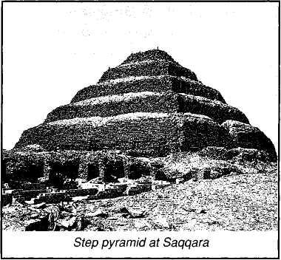
On or Hieropolis — Today a suburb of Cairo (Gen. 41: 45; Jer. 43:13). In the latter reference it is called Beth-Shemesh.
Memphis or Noph (Hos. 9:6; Isa. 19:13; Jer. 2:16; 44:1; 46:14,19). — The city was about sixteen kilometres (10 miles) north of Cairo. A step pyramid, accounted the oldest stone structure extant in Egypt (Pyramid of Djoser), is close by at Saqqara.
Zoan, Tanis or Raameses — Site of Israel's slavery (Exo.1:11; Num. 13:22; Psa. 78:12,43; Isa. 30:4; Eze. 30:14).
Pithom or Tahpanes — (Exo. 1:11; Jer. 2:16; 43:4-9; 44:1; 46:14; Eze. 30:18).
Pathros (Eze. 29:14) — A district, not a city. Its name indicates its situation, for it signifies Southland.

A Remarkable Testimony About Religion
According to the celebrated Egyptian archaeologist, Flinders Petrie, the original religion of Egypt was monotheistic — the worship of one God. But before the dawn of the historic period, a religion had developed in which each tribe had its own god, represented by an animal. The religion of Egypt, in the time of Moses, therefore, was polytheistic. The Egyptians had gods for everything. They worshipped the Nile, the beasts of the earth, the fowls of heaven, as well as the heavenly bodies themselves. As Paul wrote: "they changed the glory of the uncorruptible God into an image made like to corruptible man, and to birds, and four-footed beasts, and creeping things" (Rom. 1:23).

The plagues affected many of God's created things that the Egyptians worshipped, and this, partly, was the reason why they were sent. Yahweh declared: "Against all the gods of Egypt I will execute judgment" (Exo. 12:12).
Some of these gods are as follows:

Ptah (Apis) was god of Memphis, represented by a Bull.
Amon was god of Thebes, represented by a Ram.
Hathor, Egypt's leading goddess, was represented by a Cow.
Mut, the wife of Amon, was represented by a Vulture.
Horus, god of the sky, was represented by a Falcon.
Ra, the sun god, was represented by a Hawk.
Set (Satan), god of the east frontier, was represented as an animal headed with a long, curved, pointed snout, and was held to be the god of evil, darkness and violence.
Sebek, the Crocodile god.
Osiris, god of the underworld, was represented by a Goat.
sis, wife of Osiris, was represented by a Cow.
Thoth, god of wisdom, was represented by an Ibis.
Heka, a god of magic, was represented by a Frog.
Nekhebt, goddess of Upper Egypt, was represented by a Vulture.
Bast, the "mother-goddess" of Bubastis in the eastern Delta, was represented by a Cat.

There were innumerable other gods: a god of Night, a god of Death, a god of the Horizon, and so forth. The pharaohs were deified; the Nile was deemed sacred; and gods of all things elevated for worship.

Analysis
THE TELESCOPIC VIEW
The telescopic view provides an overall, general outline of a book, enabling its basic message to be comprehended in perspective. On the other hand, the microscopic view considers the meaning of words, phrases, and verses, providing a more detailed exposition. The former sets forth background and context; the latter provides depth and detail. Therefore before providing a detailed exposition of each verse in the book, we have set out a general analysis, so as to give an outline of Exodus in its simplest form.

Stages of Development in Exodus
Notice that each section contains a proposal or plan, an objection by which the proposal is resisted, and an accomplishment, in which the proposal is eventually achieved.
(1) Oppression:
This was first proposed by Pharaoh (1:10); then resisted by the Israelitish midwives and Moses' mother; but finally accomplished when Moses was forced to flee from the land.
(2) Visitation:
This was first proposed by Yahweh (2:24-25); then resisted by Moses who pleaded his inability (4:10-12); finally accomplished when the Israelites were visited by Moses, and the Egyptians visited with plagues.
(3) Invitation:
This was first proposed when Yahweh called upon the people to make preparation to leave (11:2-4); it was resisted when the Israelites were pursued by Pharaoh's army; it was accomplished when they accepted the provision of the Passover lamb.
(4) Separation:
This was first proposed when the command was given to Moses and Aaron to leave (12:31-33); it was resisted when the Israelites were pursued by Pharaoh's army; it was accomplished when they passed through the Red Sea.
(5) Sanctification:
This was first proposed by Yahweh as a condition for immunity from trouble (15:26); it was resisted by faithless murmuring on the part of the people (16:2); and it was accomplished when they accepted the Mosaic Covenant and committed themselves to obedience to the divine will (19:8).
(6) Dedication:
This was first proposed by the instructions given regarding the erection of the tabernacle; it was resisted by Israel's lapse into idolatry at the time of the golden calf; it was accomplished by the subsequent confirmation of the tabernacle worship.

There is a poetical symmetry in the literary construction of the book of Exodus illustrating the principle that, although that which Yahweh proposes might be resisted, His purpose will be accomplished ultimately.

LAYOUT OF THE BOOK OF EXODUS
(1) OPPRESSION: ch. 1:1 to 2:22.
(1) Proposed — ch. 1
Introduction: Death of Joseph ch. 1:1-6
A New King: A New Policy 7-14
The faithful defiance of the midwives 15-21
Pharaoh's ruthless decree 22
(2) Resisted - ch. 2:l-12
Moses hid in the ark ch. 2:1-4
Moses saved and named 5-10
Moses seeks to save his people 11-12
(3) Accomplished — ch. 2:13-22
Moses forced to flee 13-15
Moses marries a Midianitish woman 16-22
(2) VISITATION - ch. 2:23 to 10:29
(1) Proposed - ch. 2:23 to 4:9
God recalls His covenant 23-25
God reveals Himself at the bush ch. 3:1-6
Moses instructed to return to Egypt 7-10
Moses seeks to know the Divine Name 11-13
The Memorial Name proclaimed 14-15
Moses given his commission 16-18
God proclaims His intention of revealing
His power before Egypt 19-22
The sign of the serpent rod ch. 4:1-5
The sign of the leprous hand 6-8
The sign of water turning to blood 9
(2) Resisted - ch. 4:10 to 5:23
Moses' reluctance to return 10-13
Aaron appointed as spokesman 14-17
Moses commences his return 18-23
The rite of circumcision re-confirmed 24-26
Moses and Aaron meet 27-28
The people convinced 29-31
Moses interviews Pharaoh ch. 5:1-4
Pharaoh increases Israel's workload 5-9
Israel's miseries increase 10-14
Pharaoh refuses to relieve the burden 15-19
Moses blamed by the people, pleads Yahweh's help 20-23
(3) Accomplished - ch. 6:1 to 10:29
Yahweh proclaims His intention to deliver ch. 6:1-8
The people are discouraged 9-13
Genealogy of Moses and Aaron 14-27
Yahweh confers His authority upon Moses _{ν} .28 — ch. 7:9
Moses' contest with the magicians 10-13
• First Plague: water into blood 14-21
Miracle imitated: heart hardened 22-25
• Second Plague: frogs multiply ch. 8:1-6
Miracle imitated—but Pharaoh seeks Moses' intercession ... .7-11
Respite—Pharaoh's heart hardened 12-15
• Third Plague—Dust into lice 16-17
Magicians thwarted 18-19
• Fourth Plague —Flies—Goshen Immune 20-24
Pharaoh stubbornly refuses to honour his promise 25-32
- Fifth Plague: Murrain on Egyptian beasts ch. 9:1-7
- Sixth Plague: Ashes into boils and blains 8-12
Pharaoh warned of the next plague 13-21
• Seventh Plague: hail and storm 22-26
Moses intercedes for Pharaoh 27-35
Pharaoh warned—his servants plead in vain ch. 10:1-11
• Eighth Plague: Locusts darken sky 12-15
Moses intercedes for Pharaoh again 16-20
• Ninth Plague: Darkness over the land 21-23
Pharaoh pleads for relief—but remains obstinate 24-29
(3) INVITATION - ch. 11:1 to 12:28
(1) Proposed -ch. 11:1-8
Israel borrows from the Egyptians ch. 11:1-3
The firstborn threatened 4-8
(2) Resisted - ch. 11:9-10
Pharaoh remains stubborn 9-10
(3) Accomplished - ch. 12:1-28
Beginning of the year changed ch. 12:1-2
Passover instituted 3-14
The Feast of Unleavened Bread 15-17
When it was to be kept 18-20
The Elders instructed to keep the Passover 21-28
(4) SEPARATION - ch. 12:29 to 15:21
(1) Proposed - ch. 12:29 to 14:4
• Tenth Plague: Firstborn slain 29-30
The people urged to leave 31-36
At Succoth 37-39
The night of observations 40-42
Who shall eat the Passover 43-51
The firstborn in Israel to be sanctified ch. 13:1-2
The Passover memorial explained 3-4
How to keep the Passover in the Land 5-7
Children to be taught its significance 8-10
The firstborn to be set apart 11-16
Yahweh's careful supervision of His people 17-18
They take the bones of Joseph with them 19
Yahweh's protection of them 20-22
They journey to Pihahiroth ch. 14:1-4
(2) Resisted - ch. 14:5-18
Pharaoh pursues the Israelites 5-9
The people panic 10-12
Moses' faith 13-14
Yahweh answers Moses' prayer 15-18
(3) Accomplished — ch. 14:19 to 15:21
Israel walks through the Red Sea 19-22
The Egyptians destroyed in the Red Sea 23-31
Moses' Song of Deliverance ch. 15:1-21
(5) CONSECRATION - ch. 15:22 to 24:18
(1) Proposed (in type) — ch. 15:22-27
From the Red Sea to Shur 22
Bitter waters at Marah healed 23-26
Refreshment at Elim 27
(2) Resisted (by faithlessness) — ch. 16:1 to 17:16
The people complain of hunger ch. 16:1-3
Flesh and bread promised 4-8
Glory of Yahweh manifested 9-12
Quails and manna supplied 13-14
Instructions regarding manna 15-21
Instructions regarding the Sabbath 22-26
Penalty of sabbath breakers 27-30
Manna described 31
The Memorial Pot of manna 32-36
The people complain of thirst ch. 17:1-3
Water from the smitten rock 4-7
Victory over Amalek 8-16
(3) Accomplished - ch. 18:1 to 24:18
Moses' family united to him ch. 18:1-6
Moses preaches the gospel to Jethro 7-12
On Jethro's advice Moses delegates his labor 13-26
Jethro leaves Moses 27
Yahweh proclaims His covenant to Moses ch. 19:1-6
The people accept the terms 7-9
Moses instructed to sanctify the people 10-13
The people are sanctified 14-15
The trembling people and awe-inspiring God 16-25
The ten commandments ch. 20:1-17
Moses the mediator 18-21
The Yahweh Altar—sole means of approach 22-26
Laws concerning masters and servants ch. 21:1-11
Laws concerning physical injuries 12-36
Laws concerning property rights ch. 22:1-15
Laws concerning evil practices v.16—ch..23:9
Laws concerning Sabbaths and Feasts 10-19
Laws concerning angelic supervision 20-33
Moses called into the mount ch. 24:1-2
The covenant endorsed by blood 3-8
The glory of Yahweh manifested 9-11
Moses ascends the mount to receive the covenant 12-18
(6) DEDICATION — ch. 25:1 to 40:38
(1) Proposed (the tabernacle designed) — ch. 25:1 to 31:18.
The ark, table, lampstand ch. 25:1-40
Curtains, boards, veils ch. 26:1-37
Brazen altar, hangings, oil ch. 27:1-21
The priests and their garments ch. 28:1-43
The consecration of the priests ch. 29:1-35
Sanctification of the altar 36-37
The continual burnt offering 38-44
Yahweh's promise to dwell with Israel 45-46
Altar of incense ch. 30:1-10
The ransom of souls 11-16
The laver 17-21
The holy anointing oil 22-33
Composition of incense 34-38
Workmen of wisdom appointed ch. 31:1-11
The sabbath sign 12-17
The Tables of stone 18
(2) Resisted (The Tabernacle Delayed) - ch. 32:1 to 34:35
Israel lapses into idolatry ch. 32:1-6
Moses' intercession 7-14
The return of Moses and Joshua 15-18
The anger of Moses—tablets broken 19-24
Levi slays the disobedient 25-29
Moses returns to intercede 30-35
Yahweh refused to go with the people ch. 33:1 -3
Moses again intercedes 4-13
Moses given reassurance 14-17
Moses is promised a revelation of divine glory 18-23
Moses again invited into the mount ch. 34:1-4
The Glory revealed in the Name 5-9
The separateness demanded of the people 10-17
Feast of unleavened bread to be kept 18
Firstborn must be Yahweh's 19-20
Sabbath must be observed 21
Harvest Festivals must be maintained 22
Three annual feasts must be celebrated 23-24
Leaven must be excluded from sacrifice 25
Seething a kid prohibited 26
The ten commandments 27-28
The shining face of Moses 29-35
(3) Accomplished (Tabernacle Completed) — ch. 35:1-3 to 40:38
The spiritual obligations of the people ch. 35:1-3
Free gifts solicited for the tabernacle 4-19
The people's willing response 20-29
Workmen called to labor 30-35
The work commenced ch. 36:1-4
The people restrained from giving 5-7
Curtains-coverings-veils-hangings for the door completed . . .8-38
The tabernacle furniture completed ch. 37:1—38:31
The priestly garments completed ch. 39:1-31
The work inspected and approved by Moses 32-43
The command to set up the tabernacle ch. 40:1-8
The tabernacle anointed 9-11
The priests are sanctified 12-16
The tabernacle is set up 17-19
The most holy set in order 20-21
The table of shewbread set in order 22-23
The lamps are lit 24-25
The altar of incense put in place 26-27
The hangings and altar of burnt offerings 28-29
The laver and court set up 30-33
A cloud covers the tabernacle 34-35
The cloud leads the people 36-38


The above analysis of The Book of Exodus gives the general outline of its contents, and provides a basis for a verse by verse exposition of its message. With the above thoroughly mastered, we can put aside the "telescope" and take up the "microscope," in order that the hidden wisdom of Yahweh might be more completely revealed. To do so, we now commence our verse by verse exposition of Exodus.

Exposition
Exodus: A Pattern of Redemption
In Exodus, Israel's history as a nation really begins. The book covers a period of some 145 years, from the death of Joseph, where Genesis ends, reaching to the erection of the tabernacle in the wilderness at the foot of Mount Horeb. It is a book revealing the principle of deliverance from oppression, recording the manner in which Yahweh visited His people to redeem them as a nation unto Himself.

The account begins with Moses recording the causes and motives of the persecution levelled against the Israelites in Egypt, at the order of Pharaoh who "knew not Joseph." His objective was the permanent suppression of the Israelites, and therefore his decree against them constituted the first planned national policy of antiSemitism.
We have headed the first section of the book: Oppression.
It can be divided into three parts:
- Proposed: by Pharaoh's policy of extermination (ch. 1).
- Resisted: by the mother of Moses who hid her child from Pharaoh's servants; and, later by Moses, when he refused to conform to the demand of Pharaoh's daughter (ch. 2:1-12).
- Accomplished: when Moses was forced to flee from Egypt and set up home in Midian (ch. 2:13-22).
Every subsection of the book can be divided according to this threefold pattern.

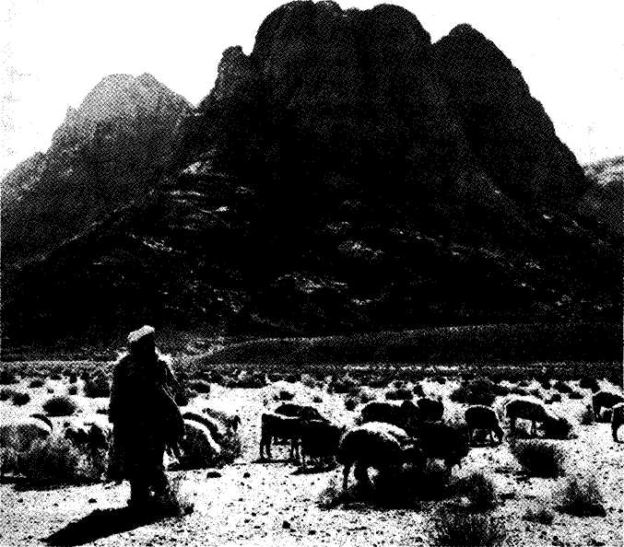
A shepherd grazes his flock in the shadow of Mount Horeb with Sinai in the background. It was here that Moses came after he fled from Pharaoh in Egypt. It was here that, later, the Israelites assembled to receive the law of Yahweh, and to commit themselves to a national covenant of obedience.

Exodus: A Pattern of Mi SECTION ONE
OPPRESSION PROPOSED
Chapter 1:1-21
(1) Proposed — ch. 1
Introduction: Death of Joseph ch. 1:1-6
A New King: A New Policy 7-14
The faithful defiance of the midwives 15-21
Pharaoh's ruthless decree 22
(2) Resisted-ch. 2:1-12
Moses hid in the ark ch. 2:1-4
Moses saved and named 5-10
Moses seeks to save his people 11-12
(3) Accomplished — ch. 2:13-22
Moses forced to flee 13-15
Moses marries a Midianitish woman 16-22
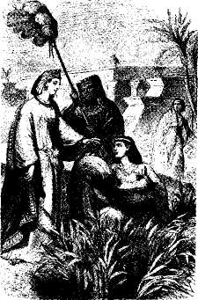

REFERENCE LIBRARY
The Christadelphian Expositor, Exodus, G, Mansfield
The Exodus of Israel, T. R. Burke
Light From The Ancient Past, J. Finegan
The Romance of Bible Chronology, Martin Anstey

QUESTIONS & LESSONS FOR US
Our previous books have always included both sections on ‘lessons for us’ and ‘questions to ask’. Having reached this point you will have completed over 500 lessons. At this advanced stage it is anticipated that you will be ready to pull your own lessons out of the course text and begin asking your own questions. For this reason the lessons from this point forwards do not contain either ‘lessons for us’ or ‘questions to ask’.

