___________________
EXODUS CHAPTER TWO
THE ADVENT OF MOSES THE DELIVERER
From every point of view according to the flesh, the edict of Pharaoh spells the extinction of Israel. However, the oppression proposed by Pharaoh is resisted by the parents of Moses, whose stratagem succeeds to the point that, in spite of the decree, Moses is saved, and is brought up in the very house of Pharaoh. Nevertheless, having come to manhood, and manifesting a tendency to assist his Hebrew associates, Moses is forced to flee from Egypt. He makes his way to the desert of Midian where he marries the daughter of the local prince. Meanwhile, the oppression in Egypt intensifies, and the cries of the people are heard in heaven.
(2) OPPRESSION RESISTED Chapter 2:1-12
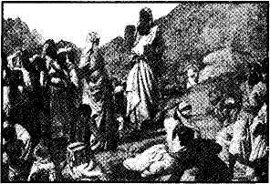
Moses is born of God-fearing parents who hide their son from the prying eyes of their Egyptian enemies. When this becomes no longer possible, his mother, convinced that God has a purpose with her son, devises a plan that she feels can succeed. She prepares an ark for him, and places it in the river where she knows the daughter of Pharaoh regularly visits. The ark is found and the crying babe excites the sympathy of the Egyptian princess who decides to keep him for her own. The scheme of Moses' mother succeeds to the point that she is actually employed to care for her son. She not only nurses him, but educates him in the principles of the true worship in relation to the hope of Israel. Brought up in Pharaoh's palace, Moses, on reaching manhood, realises that God has a purpose with him in the deliverance of His people, and seeks means to further it.
Moses Hid In The Ark — vv. 1-4.
A faithful woman, Jochebed, respecting the will and purpose of God, resists the decree of Pharaoh, by first hiding her son in the house, and afterwards in the ark, which is strategically placed in the river where she knows it must be seen by the daughter of the monarch. She realises that her son will only find safety if sheltered by his enemies.
VERSE 1
"And there went a man of the house of Levi, and took to wife a daughter of Levi" — The word "man" is the Hebrew word ish (upright; strong), not the usual adam (earthy, mortal), implying that this man was of high repute among the people.
The actual names of the couple are not here given, but are later revealed as Amram and Jochebed (Exo. 6:20; Num. 26:59). Why are their names here withheld? Possibly because originally they may have differed from the form in which they are subsequently recorded.
Jochebed signifies The Glory of Yah-weh. It is the first occurrence in Scripture in which the divine Name is incorporated in that of an individual. From this some conclude that the announcement of the Yahweh name, was earlier than when He revealed Himself in a special manner to Moses in the burning bush, and proclaimed the divine Name to him. But who gave this name to Jochebed? We believe that Yah-Thy-Glory was the remarkable name that Moses later gave to his mother as he looked back upon all that she had done for him, and he owed to her. Accepting that proposition, the significant fact of this being the first occasion when the name of a person is compounded with Yah, its abbreviated form, argues for its revelation in the time of Moses, for thence after such usage was quite common.
Jochebed's faith and courage were recognised by Moses as a manifestation of the glory incorporated in the Name of Yahweh, he later revealed to Israel.
Apart from her faithfulness, humanly considered, Moses would not have developed as he did, so that her actions illustrate the name she was given.
But it would appear that it was given to her subsequently, for in the important verse before us she is nameless. This suggests that her original name has not been retained in the record.
VERSE 2
"And the woman conceived, and bare a son" — This was actually, at least, her third child (cp. v. 4). Aaron was three years older than Moses (7:7), whilst Miriam was older than both. She evidently was several years senior to Aaron, who, apparently, had been born prior to Pharaoh's decree.
"And when she saw him that he was a goodly child" — Her newborn baby was an extremely well-formed and outstandingly beautiful child, and this caused her to conclude that God had a purpose with him. As a godly mother in Israel, she would recall the declaration of Joseph relating to the promised visitation by God (Gen. 50:24), and in view of the extremity into which the nation had been brought, would be awaiting the advent of the promised deliverer.
As Stephen observes (Acts 7:25), Moses certainly grew up with the conviction that he was appointed to deliver his people, and this belief could have been the result of his mother's instruction, as well as by divine revelation. Stephen comments that the young child "was exceeding fair" which the Diaglott renders as "divinely beautiful," and which can be rendered as "comely to God" or "fair to God" as in the margin of Acts 7:20. This certainly implies that Jochebed perceived a divine purpose in the birth and appearance of her son. Paul comments that it was "in faith" that the parents of Moses took the course they did. He defines faith as "the confidence of things hoped for, the evidence of things not seen" (Heb. 11:1, cp. v. 23). He records that they "saw he was a proper child; and they were not afraid of the king's commandment," which suggests that in defying the decree of Pharaoh, Moses' parents risked their own lives. They were prepared to do this because of their love of God and their confidence in His promise.
"she hid him three months" — A significant period of time, and representative of the three days that the Lord Jesus was "hidden" in the grave before appearing to accomplish his divinely directed mission of salvation.
VERSE 3
"And when she could no longer hide him" — The growing child could not always be kept inside the house; and the danger of being detected was such as to put the lives of all members of the family in jeopardy.
"She took for him an ark of bulrushes" — The Hebrew word tebah, "chest" or "box," is used only here and for Noah's ark. The drama of Noah's day was again to be enacted on a smaller scale, and the elect of God again saved through water. Jochebed made her chest (ark) of bulrushes. The papyrus reed is a strong-growing reed, with a triangular stem, which attains a height of 3 to 4'A metres (10 to 15 feet). It was used by Egyptians for making paper, mats, rope and boats, and provided excellent material for Jochebed's purpose.
"And daubed it with slime" — "Slime" is bitumen (Gen. 11:3; 14:10), and was frequently used in boat-building.
"And with pitch" — This was probably a vegetable substance, which was coated over the intertwined reeds to make the little ark watertight.
"And put the child therein" — We might imagine with what trepidation and anxiety Jochebed resigned her young son to an unknown destiny. Being a woman of great faith, she would have gone undoubtedly with a prayer in her heart.
"And she laid it in the flags by the river's brink" — The word suph, rendered "flags," is better translated "reeds." This was a different specie of reeds from the "bulrushes" mentioned above. They grow in profusion on the banks of the Nile to this day. Tourists in Cairo, are shown the traditional spot where the ark was placed in the water!
VERSE 4
"And his sister stood afar off, to wit what would be done to him" — Miriam, the sister of Moses (15:20), was probably set to watch by her mother. The context implies that she was carefully instructed in what to do and say in the event that someone from the palace might discover the basket in the river.
Moses Saved and Named — vv. 5-10.
Pharaoh's daughter, coming down to bathe, sees the ark. She secures it and is attracted to the beautiful baby inside. Her sympathy is won by the helpless cry of the child. She perceives that he is one of the Hebrew children, and, according to Jose-phus, is so attracted by his outstanding beauty, that she decides to adopt him as her own. Interceding at this moment, Miriam is instructed to seek for a Hebrew mother who could tend the child, and in the amazing ways of Providence, Jochebed, who, a short time previously had been in fear and dread of her son's life, is now employed and paid to care for him! How inscrutably wonderful and just is Yahweh in all His ways.
VERSE 5
"And the daughter of Pharaoh came down to wash herself at the river" — As "herself is in italics in the AV, some have concluded that she was there to supervise the washing of clothes, and not for the purpose of personally bathing. However, the river Nile was considered sacred to the Egyptians, and there is nothing improbable in the princess bathing in its waters in a place reserved for women. Indeed, Egyptian monuments depict women bathing at specific places set aside for that purpose.
Who was this daughter of Pharaoh, whose action on this occasion helped to change the course of human history? She could have been a daughter of Pharaoh Setii, and a sister of Rameses the Great.
"And her maidens walked along by the river's side" — They did so as attendants to the princess.
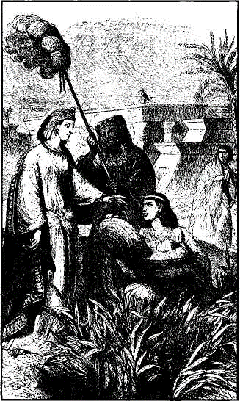
"And when she saw the ark among the flags, she sent her maid to fetch it" — Her curiosity was aroused by the
appearance of the little ark bobbing up and down upon the water, so she sent one of her attendants to fetch it.
VERSE 6
"And when she had opened it, she saw the child: and, behold the babe wept"— The beautifully formed child doubtless appealed to the motherly instincts of the princess, and her heart was drawn to the infant by helplessness emphasised by its weeping. One can imagine how the group of women would laughingly try to calm the beautiful little baby, probably taking it up in their arms, and snuggling it close in order to do so. The more this was done, and responded to, the more the princess would be attracted to it (cp. Psa. 106:46).
"And she had compassion on him" — The word "compassion" is chamal which means to commiserate so as to spare. The Hebrew word has frequently been rendered to spare, though this is its first occurrence in Scripture. Thus as sympathy and compassion took possession of the heart of the princess, she sought for means to save the child, in spite of the decree demanding its death.
How wonderful are the ways of Providence! Here is another example of how, through weakness, there came strength. At that moment, Israel's mighty deliverer was a helpless babe, crying in the arms of one of the nation's oppressors. That instance of abject weakness, produced circumstances through which the nation was saved and redeemed, to yet grow in power so as to ultimately conquer Egypt itself (Isa. 19:17-25). Thus faith triumphed (Heb. 1 1:23) through the courage and compassion of women: first the midwives, then Jochebed, then Pharaoh's daughter, finally Miriam. In a sense, therefore, Moses became a type of the "seed of the woman" who bruised the serpent's head; the latter being a symbol of Egypt.
"And said, This is one of the Hebrew's children" — Pharaoh's daughter recognised that only a desperate Hebrew mother, trying to save her child from destruction, would thus expose it to the dangers of the river. However, her statement evidently was uttered meditatively, as she pondered the problem.
VERSE 7
"Then said his sister to Pharaoh's daughter, Shall I go and call to thee a nurse of the Hebrew women, that she may nurse the child for thee?" — Evidently Miriam had been carefully schooled by her mother as to how she should act, and what she should say. Even so, she conducted herself with admirable skill, carefully hiding her own emotion, and tactfully speaking up at the crucial moment.
VERSE 8
"And Pharaoh's daughter said to her, Go. And the maid went and called the child's mother" — Proverbs declares "A word in season, how good it is!" Miriam's proposal (if it was Miriam, for concerning this we are not specifically told) was of God. Pharaoh's daughter instantly grasped it. It solved every problem. It relieved her of the burden of the child, and at the same time preserved the child to her. So Miriam was commanded to do as she had suggested.
"And the maid went and called the child's mother" — We can imagine with what bounding steps Miriam flew on her mission; her excitement as she told her mother the joyous news, the wondering response of Jochebed whose heart would fill to overflowing with love for God as she hastened with her daughter to the spot where her son was in the arms of Israel's oppressors!
VERSE 9
"And Pharaoh's daughter said unto her, Take this child away, and nurse it for me, and I will give thee thy wages" — What feelings of wonder must have flooded the heart of Jochebed when she heard those words. Wages! Wages for doing what she would have been glad to pay any amount of money to be permitted to do! How exquisitely beautiful are all the ways of God (see further comments in The Ways of Providence, p. 76).
"And the woman took the child and nursed it" — Now, more than ever before, she would perceive that her son was a "goodly child," that God had a purpose with him, and perhaps would wonder whether he might therefore be the promised deliverer of her people. Under such circumstances, with what loving care would she have nursed him; how faithfully and carefully she would have instructed him!
In this, the early experiences of Moses typed those of the Lord Jesus who, likewise, had the benefit of a godly mother, who carefully supervised his early instruction. How important is the training and instruction of children by their mothers in the early days of their lives. It is claimed that the "learning curve" is extremely high in the first ten years of a child's life. Frequently, a foundation for future character can then be laid.

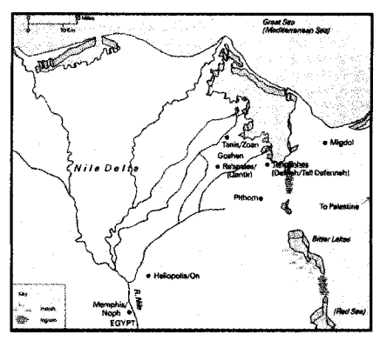
VERSE 10
"And the child grew, and she brought him unto Pharaoh's daughter" — It would have been with sorrow of heart that Jochebed did this, but also with faith and confidence in God, recognising that He doeth all things well, and that her sacrifice was for the ultimate benefit of the child.
"And he became her son" — Stephen comments: "When he was cast out, Pharaoh's daughter took him up, and nourished him for her own son" (Acts 7:21). The child Moses had evidently been taken back to the home of his parents and, at least, remained there until he was weaned, and perhaps longer. Josephus suggests that he was about twelve years of age when he was given up to the care of Pharaoh's daughter, but supplies no proof for his suggestion.
During those most impressionable years of his life, his mother must have instilled into him a firm belief in the God of Israel, a knowledge of His acts in creation, and an outline of the revelation of His purpose to Abraham, Isaac, Jacob and Joseph, an understanding of the divine promise of deliverance from Egyptian bondage.
When Moses went to the palace, he was further educated in "all the wisdom of the Egyptians" (Acts 7:22). At the time, Heliopolis was the centre of Egyptian learning, and Moses may have been sent there to be instructed in accordance with the education given to boys of the highest rank. Egyptian culture was of an extremely high order, and Moses would have been taught many things, which, from a Hebrew point of view, were extremely undesirable for him to know. The attractive sciences and learning of Egypt included belief in many gods; in the benefits of the Egyptian way of life; in the privileges and glory of the palace.
But the early training and teaching of his mother stood him in good stead, and equipped him to withstand the effect of the sophisticated environment into which he was now plunged. In spite of all attempts to the contrary, he remained a true Hebrew. Therefore it is obvious from Stephen's comment in Acts 7:22, that what he learned, helped to equip him for the work that God had yet in store for him. In the Egyptian court, he received the instruction essential for a leader of men, that would equip him to later effectively oppose those who then trained him, and so lead his people away from their influence.
How inscrutably wonderful are the ways of Providence! The early instruction of his parents during childhood enabled Moses to withstand the sophistication of Egyptian education based upon idolatry; while his upbringing in Pharaoh's court, protected him from the oppressive and enervating influence of slavery which affected many of the Hebrews at this time.
"And she called his name Moses" — The Hebrew form of the verb, masha, gives the meaning as "drawn out," and this is explained in that he was "drawn out of water." But in the Egyptian language, Mose signifies "the child," and is preserved in such composites as "Ah-mose": Son of Ah, the god of light; "Thutmose": Son of Thot, and so forth (A. H. Gardner, Journal of Egyptian Archaeology, 1918).
Pharaoh's daughter called him The Son, because he was "drawn out of water" to be her child, even as a babe is born from its mother. The unusual combination of pronunciation and circumstances, however, connected the name Moses in the Hebrew mind with his remarkable deliverance from death through water, and, later, his leadership of the nation to safety by the same means.
Pharaoh's daughter, therefore, in naming the baby "Moses," testified that he had been called to sonship by being drawn out of water. What a remarkable type of baptism!
"And she said, Because I drew him out of the water" — Pharaoh's daughter saw him as born to her by such means; but the divine revelation uses the circumstances as signifying a new birth through the waters of baptism. As a child, and as the leader who drew the people to safety and to a new life through the baptism at the Red Sea (ICor. 10:1), Moses qualified for the name he was given.

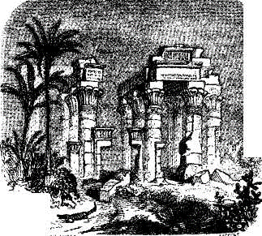
Moses Seeks To Save His People - vv.11-12.
The Egyptian education Moses receives, as well as the glory of Pharaoh's court, fails to influence him away from his people. He remains a Hebrew in heart, though he appears as an Egyptian in dress and mannerisms. On coming to manhood, he makes a crucial decision. He has been trained as a prince of the realm, and is now expected to take his place as such. But he refuses to do so, which leads to arguments and recrimination. With great courage, Moses is determined to identify himself with his people, then in abject slavery. He realises that there is no eternal future in Egypt, and has pondered long and earnestly upon the hope set before all those who seek to do the will of God (Heb. 11:26). Therefore he rejects the offers of honor and glory set before him, and does so courageously, entirely indifferent to the wrath of the king. One of the great terminal points in the history of both Moses and the nation has been reached.


A beautiful and graceful plant, with a large and very heavy root that protects it from being swept away in the floods. From this root grow triangular stems reaching a great height and branching out at the top into a plume of fine stalks resembling feathers, upon which grow clusters of little brown, rushlike flowers that produce the seeds. From this plant the ark was made (Exo. 2:3).
VERSE 11
"And it came to pass in those days when Moses was grown" — At the age of forty years, Moses decided to seek out the children of Israel (Acts 7:23), in such a manner as to negate his position as prince of the realm (Heb. 11:24-25). The Hebrew word gadal, in addition to growth in age, signifies to become great in body, mind, honor, ability. Josephus declares that Moses was renowned in Egypt for his prowess in war, as well as for other abilities. The "goodly child" had become the "goodly man" and was recognised as one eminently equipped to rule.
"That he went out unto his brethren" — This is evidence of the true greatness of Moses. The natural tendency of a man who becomes great, is to avoid his brethren, particularly if they occupy a lower strata of society than those among whom he has become accustomed to dwell. Not so Moses. He went out of the palace into the brickfields, where his brethren toiled in agonising bondage, to consider what should be done to relieve their state. The expression he went out implies a complete change in the life of Moses, such as Stephen and Paul describe in the references quoted above. Moses boldly demonstrated that he was going to completely change his way of life.
"And looked on their burdens" — He set aside the court of Egypt with its attractions and glory, its riches and pleasures, its status and opportunities, to assist his brethren, then in abject slavery. In this way he acted typically as did the greater Mediator, the Lord Jesus, in order to "bear our griefs, and carry our sorrows" (Isa. 53:4). In this action, Moses identified himself with the oppression felt by the people of Israel as he inspected their circumstances for himself.
In fact, this was an act of defiance, in the face of the expectations of his adopted princess-mother, and of Pharaoh, and was performed in courageous faith, "not fearing the wrath of the king" (Heb. 11:27).

"And he spied an Egyptian smiting an Hebrew, one of his brethren" — He probably witnessed one of the taskmasters applying the lash to an Israelite, such as are depicted upon monuments. Perhaps for the first time, Moses saw a poor Hebrew flogged. This was normal punishment for an idle slave, but often taskmasters grossly abused their power, and such a circumstance evidently excited the anger of Moses.
His feelings were aroused as he considered the relationship of himself to the sufferer, and he saw that the Egyptian had gone beyond the bounds of what was normal in those cases. Stephen declares: "Seeing one of them suffer wrong, he defended him and avenged him that was oppressed" (Acts 7:24).
It was not merely natural feelings that motivated Moses, but a deep-seated conviction stemming from divine revelation, that he was the one appointed to deliver his people (v. 25).
VERSE 12
"And he looked this way and that way" — Moses did not act recklessly, but exercised due and proper caution.
"And when he saw that there was no man" — So that his action would not be observed, and bring unnecessary retribution upon himself.

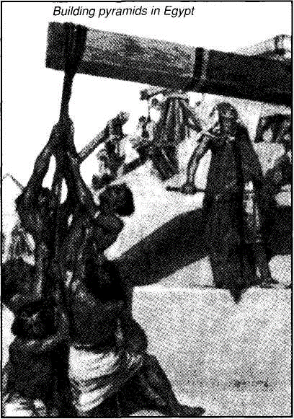
"He slew the Egyptian, and hid him in the sand" — It is probable that Moses did not intend this, but the circumstances induced it. His action was hasty, and its immediate results fruitless, though it did ally Moses definitely with his brethren. Brother Roberts comments: "His conclusion was right as events ultimately showed, but he was premature in the way he attempted to give his conclusion practical effect. He did not wait for God himself to use the situation thus providentially prepared. He began to act without directions. Of his own motion, he smote an Egyptian who wronged a Hebrew. He did the thing secretly, and supposed it would remain secret. Such things do not remain secrets. The matter was soon reported, and, fearing the consequences at the hand of Pharaoh, he found himself under the necessity of absconding" (The Ways of Providence, p. 78). God used this humanly provided circumstance to further Moses' education to equip him to become a more effective deliverer of his people.
Meanwhile, Moses buried the slain Egyptian, to hide his action from the authorities, in order that he might more effectively organise Hebrew resistance to Egyptian authority. But that was not the way Yahweh intended the deliverance of His people.
Both Moses and the people had further lessons to learn.
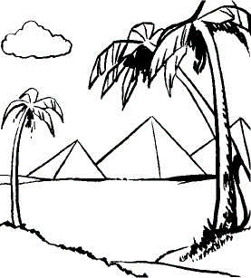
(3) OPPRESSION ACCOMPLISHED Chapter 2:13-22
Moses' action in slaying the Egyptian is reported to Pharaoh, who determines to destroy him. Moses is forced to flee from Egypt, and finds himself a wanderer in the wilderness of Midian. Through an act of courtesy, he obtains an introduction to Reuel, a leading man of the country, and a flockmaster. He obtains employment from him as chief herdsman, and ultimately marries one of his daughters. Meanwhile, this act of defiance on the part of Moses who had been brought up in Pharaoh's court, arouses the worst suspicions of the king. He increases the oppression of his Hebrew slaves. Thus the oppression proposed in the beginning, but resisted by the midwives, by Jochebed and Moses, is now accomplished by the ruthless violence in which the Israelites are treated. In these transactions, Moses types the Lord, the prophet promised, "like unto him" (Deu. 18:18): he first appears before his people as deliverer, is rejected by them as such; and appears the second time to effect it. The fulfilment has been and yet will be manifested by the Lord Jesus.
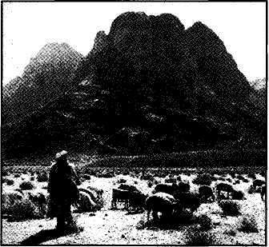

Moses Is Forced To Flee — vv. 13-15
Moses' attempt to free his people has proved premature. There is still much he has to learn before he is properly equipped to lead his people as a shepherd. Therefore, though his own actions led to his retreat, God used it to his benefit.
VERSE 13
"And when he went out the second day" — Moses indicates a keen zeal to assist his people. But on this occasion he faces a distressing scene: conflict between his own people.
"behold, two men of the Hebrews strove together"— The sight of Hebrews quarreling, when they should have been united against their common enemy, deeply concerned Moses. Strife between brethren is always a matter of deep concern to those spiritually minded (ICor. 3:3; Phil. 2:3).
"And he said to him that did the wrong, Wherefore smitest thou thy fellow"— Moses evidently examined the evidence to see who was in the wrong. Stephen declares (Acts 7:26-28) that he endeavoured to reconcile them on the grounds that they were brethren, and in doing so, discovered that one was in the wrong more than the other.
The word "fellow" is raiah, neighbor, friend, so that by its use, Moses tried to bring home to the more belligerent the incongruity of him harming his "friend" or "neighbor" — particularly in such a hostile environment, as Egypt presented. How foolish for brethren today to engage in unnecessary strife, in view of the hostile pressures of modern "Egypt" (2Tim. 2:14).
VERSE 14
"And he said" — In reasoning with the one in the wrong, Moses evidently gently placed his hand upon him to smooth away his anger, but, according to Stephen (Acts 7:27), the belligerent Jew angrily thrust him away, as he repudiated Moses' claim to authority over the Hebrews. His contemptuous repudiation of Moses' intercession is significant. It illustrated to Moses that the Hebrew who had wronged his brother did not fear any punitive action that Moses might threaten, even though he was a prince of the realm, and the harshest treatment could be meted out to Hebrews by their taskmasters. Instead, his angry retort revealed that Moses' secret was common knowledge, and that it would be only a matter of time before it came to the ears of Pharaoh himself.
A similar retort was made by the Jews against the Lord Jesus, in rejecting his judgments (cp. Jn. 8:59).
"Who made thee a prince and a judge over us?" —This rejection of Moses' mission by an angry, belligerent Hebrew, foreshadowed the rejection of the Lord Jesus by those Jews who, in effect, declared: "We will not have this man to reign over us" (Luke 19:14) and "We have no king but Caesar" (John 19:15). Indeed, Stephen cites this incident in the life of Moses, to illustrate to his accusers the significance of their rejection of Christ. Stephen declared: "This Moses whom they refused, saying, Who made thee a ruler and a judge? the same did God send to be a ruler and a deliverer by the hand of the angel which appeared to him in the bush" (Acts 7:35).
The implication of this statement is, that, as Moses was first rejected but afterwards, on returning from a time of absence, was acknowledged as ruler and deliverer, so also was his antitype, the Lord Jesus Christ rejected, but will return to assert his authority and position.
"Intendest thou to kill me, as thou killedst the Egyptian?" — There was an implied threat in these bold, defiant words of the Hebrew. The man knew that Moses had the power to put him to death, but indicated that if that were done, the crime of the previous day would be revealed.
"And Moses feared, and said, Surely this thing is known" — In Hebrews 11:27, Paul states that Moses "by faith forsook Egypt, not fearing the wrath of the king," but here the allegation is made that he did fear the king. Sometimes the two statements are advanced as a contradiction. But there is no real contradiction.
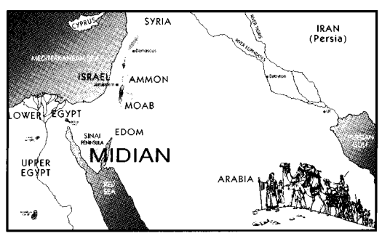
Moses, having "refused to be called the son of Pharaoh's daughter," had already "forsaken Egypt" as far as being identified with its power and glory, and had made the fact well-known to Pharaoh and his court, in spite of the anger of the king.
According to Josephus (see also Stephen's partial endorsement of the evidence — Acts 7:22), Moses was a popular and powerful prince in Egypt; skilful in war, as well as in culture. Therefore, Pharaoh would have hesitated to discipline him, for fear of a public reaction. But the killing of the Egyptian could not be defended by public feeling. By this action, Moses had placed his life in jeopardy, providing Pharaoh with a legitimate excuse to put him to death. Moses now had real cause to fear the king's authority.
VERSE 15
"Now when Pharaoh heard this thing" — If we are correct in assuming the Pharaoh of the original oppression to have been Seti i, the present Pharaoh to be Rameses n. Rameses reigned for sixty-five years, the only ruler of the New Empire whose reign exceeded forty years. As Moses fled when he was "full forty years old" (Acts 7:23), Rameses would have still been living until shortly before Moses, returned to deliver the people, at eighty years of age. He is the only monarch of that period who fulfils these requirements, made necessary by Stephen's speech in Acts.
"He sought to slay Moses" — Thus typically representing the action of the authorities of Judah who, combined with the Roman power, sought the death of Jesus (Jn. 5:16; Mt. 26:59; Lk. 19:47).
"But Moses fled from the face of Pharaoh" — Stephen implies that Moses forestalled the attempt of Pharaoh to slay him. He fled "at the saying" of the Hebrew aggressor. He anticipated the accusation and retaliation of the monarch, and left Egypt before he could be apprehended.
"And dwelt in the land of Midian" — Midian is the fourth of the six sons of Abraham named in Gen. 25:2. The Midi-anites were mostly nomads, wandering from place to place, mainly along the Arabian Gulf. At the time of his call, Moses was at Horeb, in the peninsula of Sinai (Exo. 3:1), probably only as a temporary station for pasturage.
"And he sat down by a well" — The Hebrew word yashab, rendered "sat down," also signifies dwelt, and the definite article is given to "well" as "the well." It is impossible to identify the well, but it was adjacent to the dwellingplace of Jethro, who in this chapter is called Reuel.
Moses Marries A Midianitish Woman -vv. 16-22.
Through an act of courtesy, Moses is introduced to the leading man of the district, Reuel, also known as Jethro, a shepherd-priest, with whom he subsequently obtains employment as chief herdsman, and ultimately marries one of his seven daughters.
VERSE 16
"Now the priest of Midian had seven daughters" — The word kohen, priest, seems correctly interpreted rather than prince, as in the margin, for later Jethro is described as exercising priestly functions (Exo. 18:12).
"And they came and drew water, and filled the troughs to water their father's flock" — A normal procedure on the part of the women in ancient times. See also Gen. 29:9.
VERSE 17
"And the shepherds came and drove them away" — The shepherds roughly and crudely drove the daughters of Reuel away from the water they had drawn for their flocks, and selfishly used it for their own animals. They certainly showed no respect for the priest or his daughters.
"Moses stood up and helped them and watered their flock" — It was characteristic of this great man to help the oppressed, so he stood up in defence of these women so thoughtlessly and discourteously treated by the local shepherds. He was of such commanding appearance that the shepherds succumbed to his demands to leave the girls alone.
VERSE 18
"And when they came to Reuel their father" — Reuel signifies a Friend of El (God). He is elsewhere named Jethro signifying Excellence or Pre-eminence. One of these names is evidently a title used for the Priest of Midian. If the former is his title, and the latter his name, it would imply that he worshipped the One God. As he was a descendant of Abraham through Keturah, this was not at all unlikely. His priesthood then assumes a matter of greater importance, and the fact that he had seven daughters is also significant, for seven is the number of a covenant.
He is called Jethro in chs. 3:1; 4:18; 18:12, but Reuel here and Hobab in Num. 10:29-32, where his conversion to the Hope of Israel is recorded. His descendants entered the land, and became associated with the Kenites (Jud. 1:16).
The Kenites are found throughout the records of Israel as a minority group who refused to be assimilated with the nation. As Rechabites they were later commended by Jeremiah (Ch. 35). They were Gentiles in the midst of Israel, who provided an example of faith to their contemporaries and lived as pilgrims without a settled abode throughout their sojourning in the land. Their descendants shall be found in the Kingdom when it is set up by Christ, and will be appointed as priests before Yahweh (Jer. 35:18-19). Therefore Moses' presence in that family, and their kindness to that great man of faith, not only drew the family of Jethro to the Israelites, but did and will provide lasting benefits to its descendants.
"He said, How is it that ye are come so soon today?" — Reuel was surprised at the early return of his daughters from a task that normally took them so much longer.
VERSE 19
"And they said, An Egyptian delivered us out of the hand of the shepherds, and also drew water enough for us, and watered the flock" — Moses appeared to them as an Egyptian, probably because of his dress and mannerisms. The account of Moses delivering his future bride from the violence of antagonistic shepherds, and watering the flock provides a pastoral scene, and typifies the work of the Lord Jesus Christ as the shepherd prince providing for his flock (John 10).
A literal translation of the expression used by Reuel's daughters would read: "also drawing he drew for us." This contains an element of wonderment: "He actually drew water for us!" They experienced unexpected kindness from their deliverer: a characteristic of Moses that also foreshadows that of Christ his great antitype.
VERSE 20
"And he said unto his daughters, And where is he? why is it that ye have left the man? call him, that he may eat bread"— Reuel was concerned that his daughters had failed in hospitality towards a stranger who had befriended them in such a manner. He accused them of being remiss in so doing.
VERSE 21
"And Moses was content to dwell with the man" — The Oxford Gesenius renders "content" as "willing." Moses had fled from the wrath of Pharaoh without any definite plan in mind. He was drawn of God to the land of Midian, and to the dwelling of Reuel, to prepare him for the great revelation he was to receive. This, of course, he did not know at the time. His main objective was to obtain a living. Accepting the invitation of Reuel to enjoy his hospitality, a mutual regard sprang up between the two men. Subsequently, Moses agreed to continue with Reuel and enter his service as shepherd, as had Jacob for Laban earlier ( Gen. 29:15-20). So the prince became a shepherd (Exo. 3:1), as did the Lord.
As a shepherd, Moses was further educated in principles that would later assist him in the great work that God had in store for him. In Egypt, he had learned to command men; in Midian he learned to lead them. Both aspects of leadership were necessary for the one who was to both command and lead God's flock out of Egypt (Psalm 77:20).
"And he gave Moses Zipporah his daughter" — Zipporah signifies A Little Bird; a Sparrow. It is from a root signifying to chirp. In marrying Zipporah, Moses threw in his lot with the Midianites. Thus: "Moses, after a life of elevation and Egyptian education, had to have zeal and his general views sobered by adversity. He had to be prepared by quietness and humiliation for the mighty work which God had in reserve for him. So here he was, in the unexciting wilderness in a monotonous occupation, perplexed perhaps by the inexplicable delay, and discouraged by the total absence of direct tokens of God's promised interference on behalf of Israel... We can easily imagine that, as month after month rolled by in the routine of a shepherd's life, without witnessing any token of the promised visitation, the sickness of deferred hope crept over him and reconciled him to the idea of spending his days where he was." (The Ways of Providence, p. 79).
VERSE 22
"And she bare him & son, and he called his name Gershom" — The name signifies A Stranger Here.
"For he said, I have been a stranger in a strange land" — This not only explains the meaning of the name of Moses' elder son, but also suggests that Moses had fallen into a depressed state of mind.
Drake's Reference Bible states that "Following this verse, in a number of Mss we find, 'And the name of the second he called Eliezer, for God of my father has been my help, and delivered me from the hand of Pharaoh'" (see Exo. 18:4).
Eliezer signifies My God (El) is My Help. The names of Moses' two sons, therefore, reveal that he did not abandon hope. Together they signify that though he was a stranger in Midian, God was still his ready help in time of trouble.
One strange, unaccountable omission, is the neglect of Moses to circumcise his younger son. This has been attributed to the opposition of Zipporah to the rite, but there is no indication of that in the text. In any case, Moses should have overruled his wife. Perhaps it is indicative of his despondency that he omitted to carry out this rite of the Abrahamic covenant; perhaps he imagined that God had repudiated him as the promised deliverer, and believed that deliverance would come from another source; perhaps Moses felt that he had failed God, and therefore did not feel justified to perform this rite. The reason is not recorded.
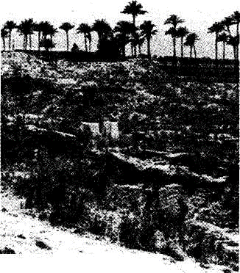
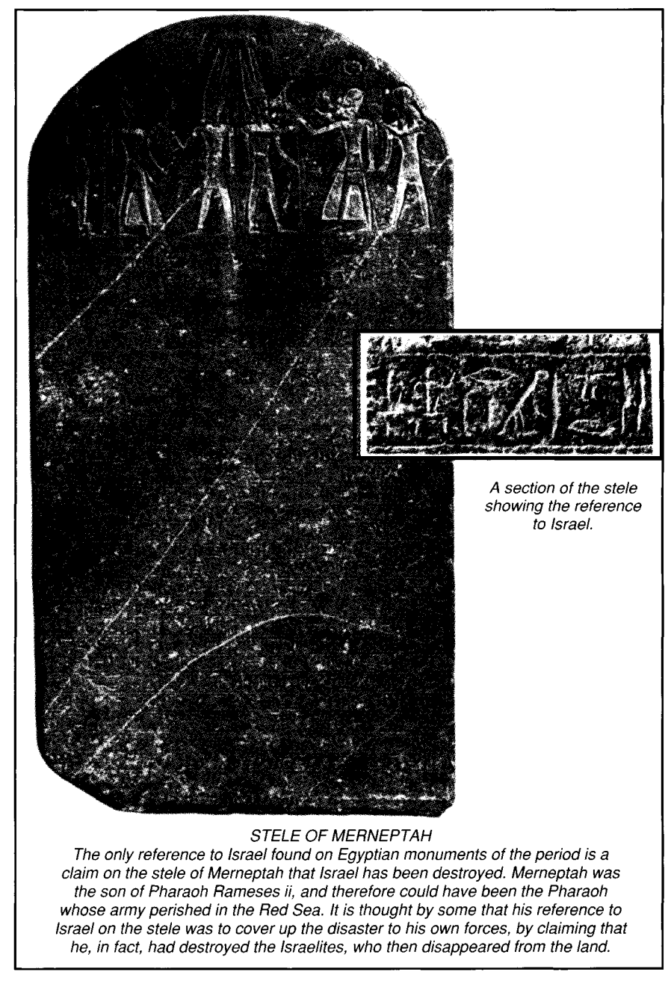
STELE OF MERNEPTAH
The only reference to Israel found on Egyptian monuments of the period is a claim on the stele of Merneptah that Israel has been destroyed. Merneptah was the son of Pharaoh Rameses ii, and therefore could have been the Pharaoh whose army perished in the Red Sea. It is thought by some that his reference to Israel on the stele was to cover up the disaster to his own forces, by claiming that he, in fact, had destroyed the Israelites, who then disappeared from the land.

Exodus: A Pattern of Redemption

SECTION TWO VISITATION
Chapter 2:23 to 10:29
Having introduced Moses, and recorded the circumstances that drew him out of Egypt to the land of Midian, Exodus now moves on to the second division of the book, recording the visitation of God to His people. As in the previous section, this is divided into three parts:
- Proposed — ch. 2:23 to 4:9
- Resisted — ch. 4:10 to 5:23
- Accomplished — ch. 6:1 to 10:29
The first sets out the great revelation of God to Moses at the bush, and proclamation of the covenant Name, presenting the commission and signs given to Moses and endorsing his credentials of divine authority.
The second reveals Moses' reluctance to return to Egypt; how the people's work load is increased by Pharaoh who refuses to relieve them of their burdens.
The third records Yahweh's proclamation to deliver the people; how plagues are poured out upon Egypt; and the preparations made for the infliction of the final plague which ends Pharaoh's resistance.
The section is an extremely significant one in the divine record. First of all, it shows that God always watches over His own, even though they may imagine that He has deserted them. He does so in Egypt. In His wisdom he postpones the deliverance of Israel until the "set time," in order that both Moses and Israel are made ready. Moses needs the discipline of shepherding in the wilderness; Israel's desire to leave Egypt for the liberty that Yahweh holds out to them needs to grow. Thus God hearkens to the cries of His people, but waits until "the fulness of time" before effecting their deliverance.
Finally, the deliverance proves to be of so mighty a nature that it is ever afterwards recalled in the yearly feast of Passover, at which time Yahweh "made Himself an everlasting Name," in the outpouring of judgment on the one hand, and the deliverance of his people on the other (Isa. 63:12).
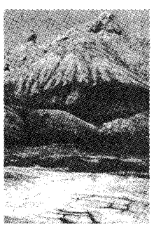
(1) VISITATION PROPOSED Chapter 2:23-4:9
God hearkens to the cry of His people, and decides to deliver them. He reveals Himself to Moses at the a: bush, proclaims unto him His covenant Name, delivers to Moses his commission, providing him with signs to demonstrate the divine authority vested in him.
God Remembers His Covenant - vv. 23-25.
The bitterness of bondage in Egypt increases, causing the people to cry unto God for help. He determines to do so on the basis of the covenant made with Abraham, Isaac and Jacob.
VERSE 23
"And it came to pass in process of time" — This important statement reveals that God is never in a hurry, but awaits the proper moment to act. There is such a thing as the "patient waiting for Christ" (Rev. 1:9), who, at the set time appointed, will return. In the meantime, God's workmen must be prepared for apparent delay. Moreover, they need time in order that they may be thoroughly prepared for the duties He has for them to perform. In the case of Moses, a further forty years were required to properly prepare him for the great work God had in store for him (cp. Acts 7:30).
We, too, must learn the lesson that thorough preparation is necessary to perform the work of God properly. For that reason, Paul warns against a "novice" being given a position of prominence in ecclesial activities. Time should be provided for the development of those who aspire to any office of responsibility (lTim.3:6).
Similarly, it is important to realise that while the "longsuffering of God" (2Pet. 3:9) may wait, He has determined "a set time to favor Zion" (Psa. 102:13), and His purpose of intervening in the affairs of mankind will inevitably be accomplished, according to His wisdom. This was now to be revealed in the seeming "natural" circumstances of life in Egypt.
"That the king of Egypt died" — The long reign of Rameses n came to an end, and his son Merneptah ascended the throne. The only direct reference to Israel discovered upon Egyptian monuments of the time, has been found on the stele of Merneptah, today in the Cairo Museum.
"And the children of Israel sighed by reason of the bondage"— The people experienced the difficulties of life in Gentile lands, and manifested their distress in a continual "sighing." Yet, the drama of the Exodus revealed that the sighing of the Israelites would ultimately turn into singing when they were finally led out of Egypt (Exo. 15:1). The same principle is experienced by those under sin and death (Rom. 8:26), who are relieved of their distress by the knowledge of saving truth (vv. 18-19).
"And they cried, and their cry came up unto God"— Three different Hebrew words are used to describe the "cries" of Israel at the time. In the phrase before us the word is zciaq, and it signifies to shriek from anguish or danger, and, by analogy, "to announce or converse publicly." This suggests a public convocation to loudly call upon God to deliver them from their burdens. The second word in this verse is shavah, to cry for help, signifying the purpose for the public convention and cry. The third word, found in ch. 3:7, is tsaaqah from tsaaq, signifying to shriek, to proclaim, an assembly. As the trouble deepened, so the cry became more urgent, and assemblies were called by the Hebrews for the purpose of considering their lot, and beseeching the help of God in their misery.

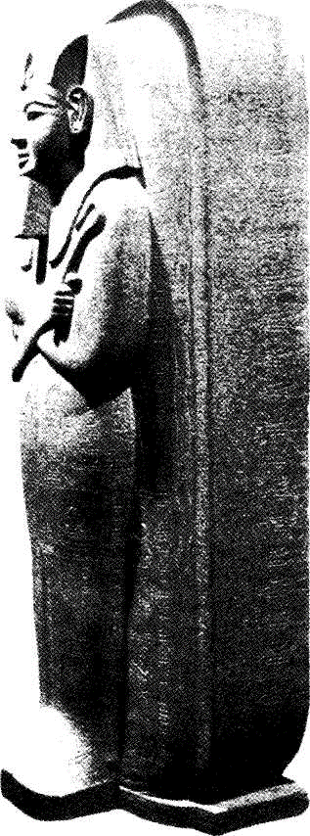
Merneptah: Pharaoh of the Plagues.
"By reason of the bondage" — The Hebrews had probably imagined that with the death of Rameses, their miseries would cease, or at least, be reduced. Instead, they found them increased by the new ruler, and so their cry became more bitter and desperate.
It was obvious that the regime of ruthless oppression toward Israel, inaugurated by Rameses, had now become the national policy. Those who waited for Rameses' death, expecting that it would be followed by some alleviation of their state, now realised the hopelessness of their position, and "cried unto God."
VERSE 24
"And God heard their groaning" —
See also ch. 6:5. Four acts of God on behalf of Israel were: [I] He heard their groaning; [2] He remembered His covenant; [3] He took heed to their sufferings (v. 25); [4] He had respect unto them (v. 25).
"And God remembered His covenant with Abraham, with Isaac, and with Jacob" — Cp. ch. 6:5. The covenant with Abraham is the binding principle of God's dealings with man; around which His whole purpose revolves. It includes the provision: "I will curse him that curseth thee" (Gen. 12:3). It promised the deliverance of Israel from their oppressors (Gen. 15:13-21).
VERSE 25
"And God looked upon the children of Israel" — He made them the object of His special regard.
"And God had respect unto them" — The margin renders the verb literally, "God knew them." The R.V. has: "God took knowledge of them." He bore in mind their sufferings, their despair, their cries for help, and felt for them. See Isa. 63:9. He did not act openly for the moment, but laid the foundation of future activities for their help and release.

