SECTION SIX DEDICATION
Chapter 25:1 to 40:38
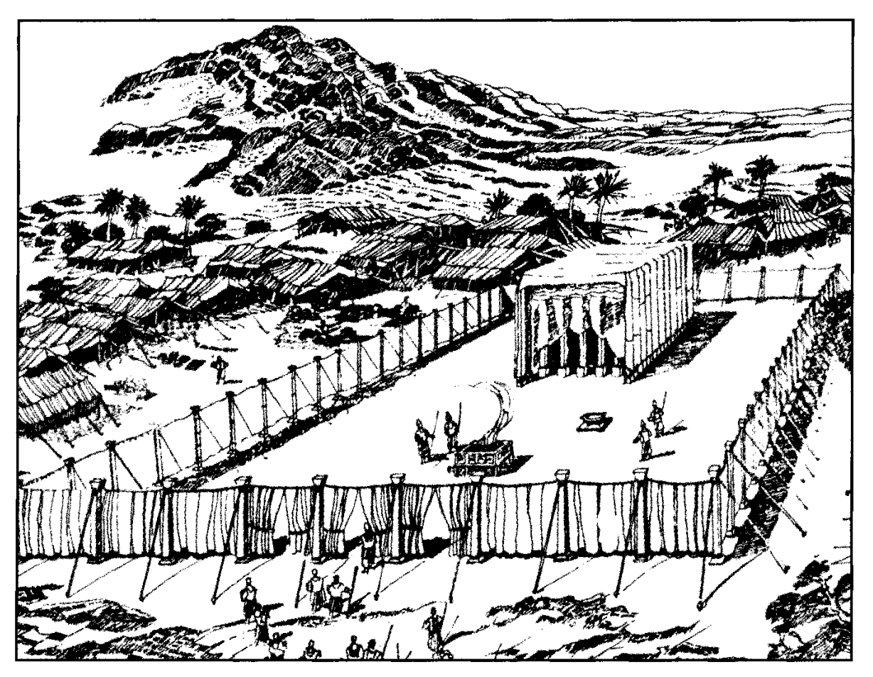
The various steps of Redemption portrayed in The Book of Exodus reach the fifth stage in the construction of the tabernacle which provided a centre of divine worship in the midst of Israel. There are three sections in it. First, the pattern of the tabernacle is revealed to Moses during his forty days in the mount. Then, in the episode of the golden calf, the execution of the plan is delayed through Israel's lapse into idolatry, during which interval a temporary substitute for the tabernacle is provided in a tent pitched “without the camp" (Exo. 33:7). Finally, the tabernacle is completed and erected, and the divine glory descends upon it, so that, in this way, Yahweh dwells in the midst of Israel.
As in the other divisions of the book, therefore, this one, also, is divided into three parts: [1] The tabernacle proposed: [2] The tabernacle resisted; [3] The tabernacle accomplished.
The sections are divisible as follows:
[1] — Designed: by the pattern revealed to Moses (chs. 25-31);
[2] — Delayed: through the idolatry of Israel (chs. 32-34);
[3] — Completed: by its construction when Moses returns the second time (chs. 35-40).
The scriptures devote more room to the description of the tabernacle and its appurtenances than to any other single subject. Its details are described minutely in the Old Testament, whilst the New Testament writers draw upon it largely in setting forth the principles of redemption in Christ. It was designed not merely for architectural beauty, but as a symbolical and typical expression of wonderful spiritual truth: as a parable of God-manifestation in three developments: Preparation (the court); Application (the holy place); Glorification (the Most Holy Place).
Finally, the three sections of this part of Exodus, from the planning of the tabernacle until its construction, when the glory of Yahweh was revealed therein and God dwelt thus in the midst of His people, provide a parable of the divine purpose in the gospel: first proclaimed, then delayed during the absence of the Son, and finally accomplished in the earth when ”the tabernacle of God will be with men" (Rev. 21:3).
[1] THE TABERNACLE DESIGNED (Proposed) Ch. 25:1 to 31:18
In the mount, Moses is instructed concerning the tabernacle, to be provided as a place of meeting between Yahweh and the people of Israel (Exo. 25:22). The materials of which it is to be built, and the various aspects of both the tent and the furniture, are described in great detail. A solemn charge is given Moses that he should make all things according to the "pattern" which is shown him "in the mount," and this instruction is seven times repeated in scripture (Exo. 25:9, 40; 26:30; 27:8; Num. 8:4; Acts 7:44; Heb. 8:5). The word used implies that Moses is shown a vision of the actual tabernacle already constructed, and not merely a blueprint of it or a series of measurements. In the mount, he was probably able to walk around what was shown to him, and so could examine it in detail, as Ezekiel later was able to do in relation to the temple of the future (Eze. 40). Every detail of the tabernacle is significant, and worthy of the closest attention. But, in large measure, we must leave this to the student, for to attempt anything like an exhaustive commentary of it, with its many symbolical and typical meanings, would be beyond the scope of this exposition. However, we will set down guidelines of study in relation to this wonderful theme.
452. CHAPTER TWENTY-FIVE
THE OFFERING, ARK, TABLE, AND LAMPSTAND
This chapter describes the opening directions concerning the tabernacle. First, the materials out of which it is to be constructed are described, and the people are asked to provide such materials. Then specific direction is given that it must be made according to the "pattern" revealed to Moses in the mount. Finally, its details are outlined.
It is significant that the instructions commence with the ark in the Most Holy. It is as though Yahweh, from His throne in the midst of Israel, invites worshippers to fellowship with Him; and sets before them the incentive of striving to attain unto the Most Holy state.
However, this is only possible through the "new and living way" revealed by the Lord Jesus Christ (Heb. 10:19-20).
The People's Offering — vv. 1-9.
The willing-hearted among Israelites are to supply materials as listed by Yahweh, in order that a suitable sanctuary is constructed, in which He may dwell among them. The design of it must strictly conform to the pattern then revealed to Moses. The materials supplied are from the wealth obtained in Egypt, as well as from the spoil of the Amalekites.
VERSE 1
"And Yahweh spake unto Moses, saying" — High up on Mount Sinai, remote from the people below, Moses received detailed instructions regarding the tabernacle to be constructed as a centre of worship in the midst of Israel (cp. v. 9).
VERSE 2
"Speak unto the children of Israel, that they bring Me an offering" — The word in Hebrew is terumah, and signifies "heave offering" as in the margin. It is derived from a root ruwm, "to be high; to be lifted up," and denotes something taken up from the bulk for a special purpose: in this case, the items listed are lifted up for Yahweh's use.
The "heave offering" was actually lifted up by the offerer, in a ceremonial action, as though presenting it to Yahweh on high. In this it differed from the "wave offering" that was waved from side to side to indicate the activity of the worshipper before God. In the case before us, the people were to select an offering from the substance that they had received in Egypt (see Exo. 12:35; Psa. 105:37), and offer it unto Yahweh for use in the tabernacle. In this it differed from most heave offerings as specified by the Law, for usually the exact amount to be given was stated. Here it was left to the judgment of the individual. Ultimately the people responded with such goodwill that in a short time ample was supplied, and, finally, they had to be restrained from giving (Exo. 36:5). There will be a repetition of this in the future in regard to the temple at Zion (Isa. 60:5, 9; Hag. 2:8-9).
"Of every man that giveth it willingly with his heart" — The literal Hebrew is "whose heart impels him." An Israelite would feel impelled to respond in gratitude, and so give of the abundance he had received. This is well-pleasing to Yahweh who "loveth a cheerful giver" (2Cor. 9:7). A person can give himself, his heart, or of his possessions to God. See references to such in the following places, and apply the exhortation: Judges 5:2; IChr. 29:5-6, 9, 14, 17; Ezra 1:6; 2:68; Neh. 11:2; 2Cor. 8:12. The virtuous woman is represented as "working willingly with her hands" because she is keenly interested in what she is doing and sees the benefit of it.
"Ye shall take My offering" - That is, "Ye shall accept the offering given unto Me."
VERSE 3
"And this is the offering which ye shall take of them" — Again the word is terumah, heave offering.
"Gold"— Heb. z.ahab, denoting pure, highly polished gold, such as would shine like glass (see Rev. 21:18).There are a number of words in Hebrew for "gold," each of which defines the metal in a particular state. Here the word denotes the best and most expensive gold. Such gold is a symbol of a tried faith (see 1 Pet. 1:7; Rev. 3:18). The figure of I Pet. 1:7 is that of a goldsmith of ancient times who placed his crude gold-ore in a crucible, and subjected it to intense heat in order to liquify the mass. By such means the impurities rose to the surface, and were skimmed off. It is said that when the metal worker was able to see the reflection of his face clearly mirrored in the surface of the liquid, he would take it off the fire, for he knew that the contents were then pure gold. So it is with Yahweh and His people. The purpose of trial is to purify them as gold for the kingdom (see Job 28:1, 19-23; Pro. 17:3; 25:4; Lam. 4:2; Heb. 5:8; I Pet. 4:12-13). The gold of faith is a divine quality, pleasing to the Father (Heb. 11:6). He sees in the faith of worshippers a reflection of His own excellent character.
The gold was required to cover the boards of the ark; pure gold was required for the crown of gold that surmounted it (v. 11); the rings (v. 12); the mercy-seat (v. 17); the cherubim (v. 18); the dishes, spoons, covers, bowls (v. 29); the lamp-stand (v. 31); the tongs and snuff-dishes (v. 38); the hooks and taches (ch. 26:6,32); the covering of the table of shewbread (ch. 25:24); the staves and pillars (chs. 25:28; 26:32, 37); as well as for parts of the dress of the high priest (ch. 28:6-14).
We, too, can become vessels of honour for the use of Yahweh in His spiritual tabernacle (2Tim. 2:20-21).
"And silver" — Whereas gold, by its very colour, is suggestive of the glory of the sun, the white of silver speaks of the glory of the moon, reflecting the light of the sun. Silver is the metal of redemption (see Exo. 30:13). As such, it is particularly appropriate to the Bride of Christ whose symbol is the moon. As the moon gleams in the darkness of heaven's vault, so the redeemed of Yahweh should shine in the darkness of the Gentile night that encompasses us today (Isa. 60:1-2).
The silver was obtained mainly as the price of redemption (Exo. 30:12-16). It was required for the sockets that supported the boards of the tabernacle (Exo. 26:19), as well as for the hooks and fillets of the pillars of the court (Exo. 27:10).
"And brass" — The "brass" mentioned in the A.V. was either bronze or copper. Bronze is a combination of copper and tin, and was used extensively in ancient times. Some copper has been found with an admixture of zinc, suggestive of brass, which is an alloy of copper and zinc, but bronze was more frequently used. It is supposed that the tin used in manufacturing it, came from Cornwall, and was brought to the Middle East by the Phoenicians. Bronze or copper was required for the taches which coupled together the curtains of the tent (Exo. 26:1 1). It was also required for the sockets of the pillars (v. 37), the external coating of the altar (ch. 27:2), the covering of its staves (v. 6), the sockets of the pillars of the court (v. 10), the pins of the court (v. 19), and its vessels (v. 19). In the symbology of the tabernacle, brass, bronze or copper represented the flesh purified by fire (Num. 16:37-38; 31:22-23). The Judgment Seat of Christ will play a part in the final purification of flesh as far as individuals are concerned (1Cor. 3:13), whilst the Lord's fiery judgments on the nations (Mai. 4:1) likewise will purify them. In the tabernacle, "brass" was found only in the outer court, whilst the further one penetrated into the holy and Most Holy, the more precious became the metals used.
VERSE 4
"And blue" — This dye was obtained from a shellfish called Helix Ianthina, found on the coast of Phoenicia. Josephus Ant. 3:7:7) states that it was emblematic of the deep, dark hue of the mid-eastern sky. The A.V. in Est. 1:6 (mg.) has rendered it as "violet." It was the colour used by royalty (Eze. 23:6), and in the tabernacle, as representing the blue vault of heaven, it symbolised the principle of God manifestation (Num. 15:38; Deu. 22:12).
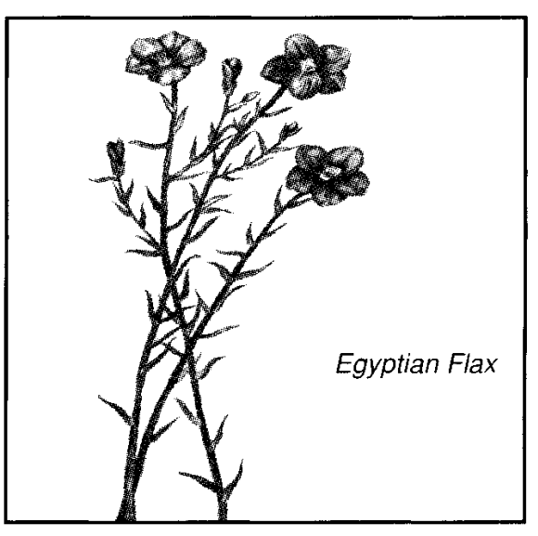
"And purple" — This was a brilliant red-blue colour, prized by the ancients for dyeing (Pro. 31:22; Jer. 10:9). The chief source for the best of this colour was from a tiny mollusk (murex) found along the coast of Phoenicia. Great labour and skill were required to extract the dye, so that only royalty or the rich could afford it (cp. Luke 16:19; John 19:2; Acts 16:14).
Being a blending of blue and scarlet, purple is the colour of God manifest in flesh.
"And scarlet" — The Hebrew is tola'ath shani, or "the worm scarlet" (see Psa. 22:6). The tola is a small insect, about the size of a pea. The females, called coccus illicis (and here the word is in the feminine gender), are collected and dried, and from them is obtained the dye known as crimson and cochineal.
Wherever our word scarlet occurs as relating to the tabernacle, in Exodus, these two Hebrew words appear together. The first of these is rendered "worm" in Psa. 22:6, and is there related to the sacrifice of the Lord. The other word is rendered scarlet in Josh. 2:18; Pro. 31:21; Song 4:3; Isa. 1:18, etc. From references such as 2Sam. 1:24, Pro. 31:21 and Lam. 4:5, it is obvious that the colour was used as one of honour or glory in some particular: an emblem of royalty. For example, when the Lord Jesus was, in mockery, hailed as king, the soldiers of imperial Rome clothed him with a scarlet robe (Mat. 27:28), in addition to the purple one described by Mark and John. (According to the Greek, the garment described by John is a different one from that described by Matthew).
The scarlet of the tabernacle, therefore, seems to typify the human kingly glory of the Lord Jesus. He was of the royal line of David, and, therefore, born King of the Jews (Mat. 2:2), though his royalty was not merely a matter of inheritance, but of personal conquest. He demonstrated his right to rule by his victory over self (Pro. 16:32). The "scarlet," therefore, represents the right to rule by the conquest of sin's flesh.
The word tola, rendered "worm" in Psa. 22:6 indicates one dedicated to sacrifice, and therefore one who could not escape death. In this verse the Lord is represented as contrasting the deliverance from death that the fathers experienced when they sought the help of Yahweh, with his own state, as delivered unto death. Why? Because he was "a worm," being given over to sacrifice, and "no man." The word for "man" in this verse is ish, denoting a great and honoured man. The Lord did not assert his authority as a great man, but instead took the lowest place, and submitted to the "death of the cross." This, however, became his badge of royalty, for Paul continues, "therefore God also hath highly exalted him, and given him a name which is above every name" (Phil. 2:8-9). Thus the "scarlet," spoke of sin's flesh, in that the Lord partook of our nature, yet was never dominated by it.
It is significant that the order of the colours, blue, purple, scarlet, repeated at least twenty-four times in Exodus, is never varied. The scarlet and the blue was next placed in juxta-position with each other throughout the fabrics of the tabernacle. The order is expressive of the thought: the commandments of Heaven (blue) will reveal God Manifest (purple) in the Flesh (scarlet).
"And fine linen" — There are various Hebrew words used to define linen, and each seems to have special significance. Here the word is shesh and appears to be of Egyptian origin similar to the Coptic word shens used to describe an importation of Tyre from Egypt (Eze. 27:7; 16:10, 13), and therefore is appropriate to describe the garment of Joseph (Gen. 41:42), as well as that thread which the Israelites evidently brought with them out of Egypt. The Egyptians were famous for their fine linen. The flax was planted in Egypt in November and gathered about four months later, around Passover time. It had to be separated from its seeds, bunched, retted, laid in the sun and immersed in water to bleach and soften for crushing. The flax fibres were beaten out of the woody portions and it was drawn by a comb-like implement into thread for weaving on looms. Of Rahab it is said that she had dried flax on the top of her roof (Josh. 2:6), and the virtuous woman of Proverbs 31 is described as "seeking wool and flax, and working willingly with her hands" at the spindle and distaff (vv. 13, 19). In the wilderness, the women of Israel did the spinning and embroidering (Exo. 35:25), assisted and supervised by Aholiab who was specially skilled in this art (Exo. 38:23).
As we will find when we come to consider the linen breeches of Exo. 28:42, other Hebrew words are used to describe variations of shesh, the fine linen of Egypt.
As a symbol, fine linen represents righteousness (Rev. 19:8). There is need of beating, careful preparation, and elaborate and skilful weaving to produce the best quality linen. So also to reveal those works of righteousness in which Yahweh delights.
"And goats' hair" — Goats' hair was black in colour, and was woven into a form of canvas to provide a covering. The goat was used as a sin-offering (Lev. 16:15), and therefore was appropriate to form the inner covering of the tabernacle.
VERSE 5
"And ram's skins dyed red" — There is no word for "dyed" in the Hebrew, so the reference is to red rams, or to skins tanned red. This draws comparison with the sacrificial heifer described in Num. 19. The heifer was to be without spot or blemish; ungalled by any yoke; marked in its very birth, by its colour, for sacrifice. As a sacrifice it cleansed from the defilement of contact with death. And as a remarkable foreshadowing of the Lord's offering, its efficacy remained long after it was put to death for that purpose.
Therefore, the reddened skins of the tabernacle suggest the humanity of the Lord, the antitypical tabernacle. The Hebrew term is oroth aylim meod'amim, the latter words signifying "from Adam." The word for "rams" (aylim) signifies strength. The ram was the protector of the flock, so that the type points to one from Adam who would be of sufficient strength to protect the flock: a wonderful foreshadowing of the Lord Jesus (Psa. 80:17).
The word for "skins" is oroth from uwr to be bare, made naked. Hence the rams were made naked to provide a covering for naked man. They were appointed as a covering above the tent, or curtains of goats' hair (Exo. 26:14; 36:19). The rams' skins being reddened by tanning, would speak of the Lord's suffering because of his obedience to God (Heb. 5:7; cp. 2Sam. 7:14). Isaiah prophesied that he would be esteemed of men as "smitten of God and afflicted" (Isa. 53:4). That was certainly the outward aspect of the Lord.

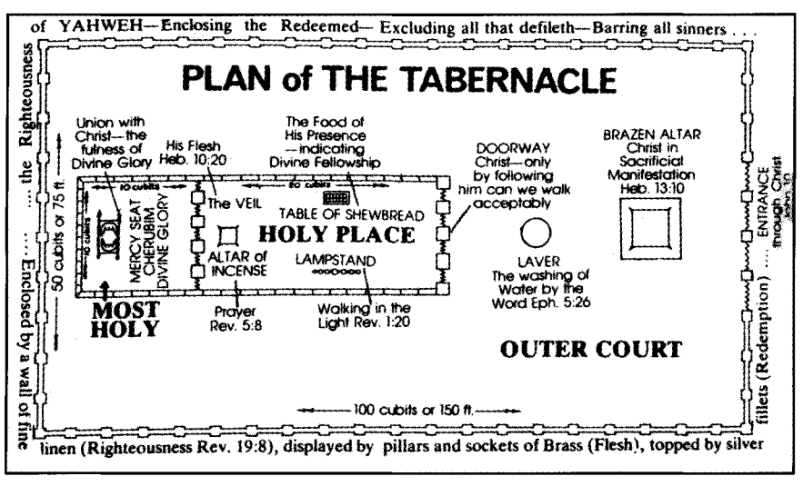
"And badgers' skins" — It has been objected that badgers' skins would not be suitable for the outer covering of the tabernacle, nor for sandals with which they are associated in Eze. 16:10. What, then, were the "badgers' skins?" Some suggest that reference is to the skins of seals, identifying the Hebrew term tahash with the Arabic word tuhas. G. H. Cansdale, in Animals of Bible Lands, suggests that reference is to the dugong, a species of seal found in the coastal waters of the Red Sea. Others, however, see the reference as relating to the colour of the skins used. Burckhardt contends that it defines a deep blue colour. The Septuagint renders the term as blue skins; the Vulgate has, skins dyed violet. Perhaps this outer covering of the tabernacle was formed of skins of the dugong coloured blue. This would mean that the outer appearance had a colour that emphasised the divine origin of both the nation and its worship (see Num. 15:38; Deu.22:12).
It also would mean that the Israelite who obeyed the instruction of the Law in wearing a ribband of blue upon his garment would identify that colour with the covering of the tabernacle, and would see himself as a living representation of it.
Moreover, if, indeed, the covering was of the skins of the dugong (although we cannot be sure of this), it means that this outer covering had been drawn from out of the Red Sea for the purpose of worship: an excellent reminder of the national baptism of Israel by which the people were separated from Egypt, as a people for the Name.
"And shittim wood" — The word "shittim" is rendered acacia in the R.V. Strong derives it from a root signifying to pierce, to flog, and hence to punish. Others see it as signifying that which is despised. Its presence in the tabernacle points to human nature, that is, human nature that has "learned obedience by the things it has suffered" (Heb. 5:7-9).
The acacia is a desert tree, thriving in the wadis of Sinai and the Dead Sea, but not found in upper Israel. It is of thorny growth, such as may pierce the unwary; it bears sweet-smelling, yellow, golden flowers like the Australian wattle. It grows to the height of a mulberry tree, has a gnarled, rough, black bark and angular spreading branches. It is indestructible by insects, and on piercing, yields a medicinal gum.
The Septuagint renders the term as "incorruptible wood." When the bark is removed, the shittah tree provides a beautiful, close-grained wood, orange in colour, and very heavy. It darkens with age, and is long lasting. It is a wonderful type, both of him who was pierced that we might live, as well as of those incorporated "into him."
The Israelites would have had to search for and select the trees to be used; then to cut them down, or humble them to the dust; then shape them according to divine requirements; cover them with gold; finally cause them to stand upright, shoulder to shoulder, as the prefabricated walls of the tabernacle, God's dwelling place. So with saints. They are selected (Acts 15:14), humbled, shaped, and caused to stand upright, coated with the gold of faith, to shine forth in all their glory as the walls of Yahweh's habitation among men. That transformation symbolises the change that takes place in a saint, in consequence of the call of Yahweh (cp. Eph. 2:21-22).
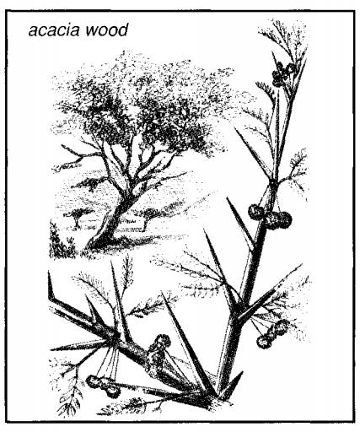
VERSE 6
"Oil for the light" - This was to be of the finest quality so as to ensure a clear, bright light. It was to be "pure oil, olive beaten." This was obtained by gently pounding immature olives in a mortar and then straining the oil. This was fed to the lamps (the word "light" in this place is ma'or, "light-bearer," as in Gen. 1:16), and the resultant light represented the expression of truth (see Psa. 119:105; Zech. 4:1-3, 13-14; Phil. 2:13-15). Every Israelitish household was invited to contribute oil for the lamp, which meant that every family could be represented in the Holy Place through the oil supplied to illuminate it through the seven-branched lampstand.
"Spices for anointing oil" — See Exo. 30:23 for the various spices required for this purpose. The spices were designed to add to the fragrance
"And for sweet incense" — See Exo. 30:34 for the ingredients of the incense, to be offered daily, a symbol of prayer.
VERSE 7
"Onyx stones" — The word signifies finger-nail stones, so called because of the layers of different colours which alternate with each other and bear some resemblance to the white and flesh coloured bands of the finger-nail. For their use see Exo. 28:9,12. The Hebrew word is shoshaom which signifies, according to Soltau, To shine forth with the lustre of fire. Specific reference to the stone is given in Gen. 2:12, whilst in Exo. 28:12 those placed in the ephod of the high priest are described as "stones of memorial." In the breastplate, the onyx stone represented the tribe of Asher whose name denotes Blessed. Blessings are derived from an upright walk before Yahweh (Psa. 1:1), or from the forgiveness of sins committed through weakness (Psa. 32:1).
"And stones to be set in the ephod" — This would imply that further onyx stones were to be set in the ephod, which was not the case, as only one was used therein. The literal Hebrew is: "Stones of onyx and stones of setting for the ephod and for the breastplate." Two large onyx stones were used for the ephod of the high priest, and other large stones of various kinds were used for the breastplate which formed part of his dress.
"And in the breastplate" — Described in ch. 28:15-21. It contained twelve gems representative of the twelve tribes of Israel.
VERSE 8
"And let them make Me a sanctuary" — The word "sanctuary" is mik-dash, and is derived from kadash, "to be sanctified," that is, set apart for exclusive divine use. It defines the tabernacle proper. It was to be set up in the centre of the tents of the tribes, with a space intervening between both, to denote separation. The sanctuary, therefore, represented separation, sanctification and unity, leading to God manifestation.
It was divided into three parts: the court, the holy and the Most Holy, answering to the three developments in God manifestation: preparation (doctrine), application (walk), and glorification (divine nature). Separation is the keynote of a true life in Christ (see John 1:12-14; Acts 15:14; 2Cor. 6:16), but it must be a separation as unto God, with the object of God manifestation, leading to the possession of divine nature (John 17:21; Rev. 21:3). Thereby, believers become sanctuaries of Yahweh, through the indwelling of His Spirit-Word (Rom. 8:9; John 6:63), thus becoming "an habitation for God" (Eph. 2:22). The sanctuary was to be made exactly after the details revealed in the pattern given in the mount, and no deviation from it was permitted (Exo. 25:9,40). Therefore, when it was completed, each article was submitted to Moses for inspection: foreshadowing the coming judgment (Exo. 39:33-43). Thus Yahweh was the Architect of the Sanctuary. It was His work, as the development of a righteous character through His Word in a believer is His work. As the Potter, He has the right to inspect such and reject any that may be faulty, if necessary (Jer. 18:4-6). In the antitype, the characters of believers are treated as "His workmanship" (Eph. 2:10; Rom. 8:29).
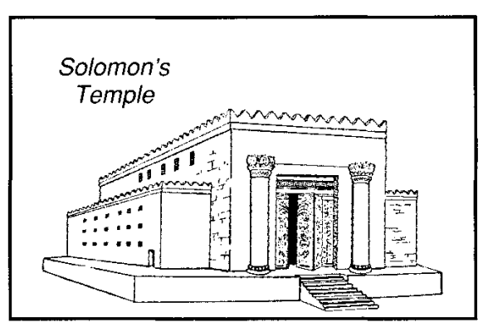

In the sanctuary set up in the midst of Israel, no embellishment was left to Moses. Workmen were endowed with special skills and qualifications to construct that which was necessary, and therefore, like the apostles and other endowed men, they became "workers together with God" (2Cor.6:1).
"That I may dwell among them" — The Hebrew for "dwell" is shakan, and signifies "to dwell permanently," which was Yahweh's intention. From it is derived the word shekinah, used to describe the indwelling divine glory.
The tabernacle, therefore, became the symbol of Yahweh's presence in the nation (Exo. 29:45-46), the token of God-manifestation such as the people were called upon to reveal, and a prophecy proclaiming that ultimately the glory of Yahweh shall fill the earth as the waters do the sea (see Num. 14:21; 1Cor. 15:28; Rev. 21:2-3). Accordingly, any defiling element was to be removed therefrom (cp. Num. 5:3; 35:34), so that it became the ideal of holiness and righteousness in the midst of the nation. Once the Israelites reached the Land of Promise, a special place was selected by God as the place where He would "cause His name to dwell," as the centre of divine worship (Deu. 12:11). When that time came, the temporary structure of the tabernacle was to be exchanged for the permanent building of the temple (I Kings 6:12-13). But even then, the fulness of glory was hidden (lKgs. 8:12; 2Chr. 6:1), for, in fact, it was not Yahweh's purpose to dwell merely in a building of stone, but in an abiding place of living stones. Therefore, although the temple was subsequently destroyed, and Yahweh's dwelling place is now in the temporary abode of the ecclesia, it is His purpose to again dwell at Jerusalem (Jer. 3:17; Psa. 68:16-18), in a "house of prayer for all nations" (Isa. 57:15; Zech. 2:10-11; 8:3,8).
Meanwhile, He is calling out a people for His Name (Acts 15:14) to comprise the living stones in the permanent building to
be manifested on earth (2Cor. 6:16). Such "living stones" (1Pet. 2:5) must be shaped according to the pattern revealed in the Word (John 17:17).
The sanctuary, in the midst of Israel, witnessed to the dwelling of Yahweh in the hearts of His people, called out of Egypt for that purpose (Deu. 4:5-8). Yahweh called the people of Israel out of Egypt, not merely to save them, but to make them worth saving, by revealing Himself in them. "God manifestation, not human salvation" was the primary purpose of the call then, as it is today. Israel had to become "a holy people unto Yahweh," the channel of His manifestation to other nations (Jer. 13:11), that all peoples might see that Israel "was called by the name of Yahweh" (Deu. 28:9-10). The sanctuary in the heart of the nation witnessed to the divine requirements. Unfortunately, the people "profaned His holy Name," and brought discredit upon it (Eze. 36:19-23); and so He turned to the Gentiles.
VERSE 9
"According to all that I shew thee" — Moses is instructed that there must be no deviation from that to be shown to him in the mount, no seeming "improvements" designed by the flesh. The tabernacle must be made exactly according to the specifications given, even as the spiritual temple of living stones must conform to the laws and instructions set down by God in His Word.
"After the pattern of the tabernacle, and the pattern of all the instruments thereof, even so shall ye make if“ — The word "pattern" is from the Hebrew tab-niyth which denotes the structure of a thing, and by implication a model or a resemblance. It is from a root banah, "to build." Moses evidently saw in vision an actual representation of the tabernacle set up before him, and probably was able to move throughout its sections: Court, Holy Place, Most Holy, as Ezekiel was to do in his vision of the future temple.
Later, Moses was told: "Thou shalt rear up the tabernacle according to the fashion thereof which was shewed thee in the mount" (Exo. 26:30). From this it would appear that, in vision, Moses saw the completed tabernacle erected on the mount, in order to equip him for supervising the erection of the literal tabernacle when it was built. It is said, that some of the furniture would be beyond the ability of men to construct according to the requirements of the Law, but Bezaleel was specially endowed with the Spirit to do so (Exo. 31:2-4). The demonstration given Moses in the mount would have enabled him to confer with Bezaleel and his associates in the construction of any of its more difficult parts, if such were necessary.
The Ark — vv. 10-16.
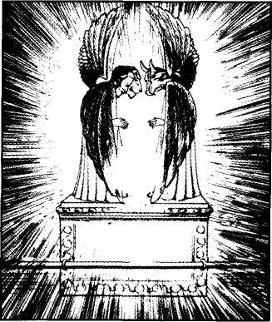
In practice, a worshipper, on approaching the tabernacle, would first see the wall of linen; whilst the ark itself would be the last of the objects revealed. But Yahweh commenced at the very heart of His sanctuary, beginning from within to without, thus describing the hidden ark first of all. This is characteristic of His revelation to man.
In prophecy, the final consummation is first revealed, and then are the steps by which it will be attained. Typical examples are found in Isa. 2 and Rev. 11:15, 18. In Isa. 2, the future glory of Jerusalem is first described, and then the means by which it will be brought about is outlined. At the beginning of creation, God proclaimed that man was designed for dominion (Gen. 1:28), but Paul adds "but now we see not yet all things put under him" (Heb. 2:8). Thus the final picture is given first. Similarly, a believer is transformed by "the renewing of his mind" (Rom. 12:2). The metamorphosis commences from within.
In size, the ark was 1.5 metres (3 feet 9 inches) long, 0.68 metres (2 feet 3 inches), both deep and wide. It contained the tables of stone inscribed with the ten commandments, and therefore was known as the Ark of the Covenant, or the Testimony; it also contained Aaron's rod that budded, and a golden pot of manna that was miraculously preserved. It was covered with a sheet of gold called the "mercy seat," which constituted Yahweh s throne and meeting place in the midst of Israel.
Cherubim formed both ends of the mercy seat. The ark, mercy seat and cherubim represented the multitudinous Christ-Body. That Body contains within it the Law of God as the basis of the covenant (the "ten words"), the principle of divine selection and hope of resurrection, symbolised by Aaron's rod that budded (see Num. 17), and the promise of life eternal exhibited by the golden pot of manna (see John 6:51; Rev. 2:17).
VERSE 10
"And they shall make an ark" — The Hebrew word is aron derived from the root arah, "to pluck, to gather." As such, it is appropriate as a type for the multitudinous Christ, the members of which have been "plucked" out of the nations (Acts 15:14). The same word is translated "coffin" in Gen. 50:26 relating to the container in which was placed the body of Joseph. As Joseph represented Christ, the Israelites, in carrying his "coffin" throughout the wilderness wanderings, constantly bore with them the tokens of his death and his hope of a resurrection (illustrated by his desire to be buried in the Land of Promise). In this they typed the Israel of God (Gal. 6:16) who bear with them the tokens of the death and resurrection of their Lord.
The ark, constructed under the supervision of Moses, is also called The Ark of the Testimony (Exo. 25:22; 26:33; 40:3), the "testimony" being the Ten Commandments (Exo. 25:16, 21) which formed the basis of the covenant (Exo. 34:28). In Hebrew, "testimony" is eduth, the feminine form of ed, "witness." Those whose lives are governed by the principles of the Ten Commandments constitute the multitudinous Bride, for their lives witness and testify to the truths believed by them.
In Ezekiel 16:8-14 and Isaiah 54:5, the Mosaic covenant is likened to a marriage contract between Yahweh and the nation. He is represented as drawing Israel out of Egypt to constitute His Bride. The ark is also described as The Throne of Yahweh (Psa. 80:1), because it was there that He met His people (Exo. 25:22) in order to commune with, or direct its leaders as to what should be done (Num. 7:89).
The ark contained the golden pot of manna symbolising the hope of life eternal; Aaron's rod that budded, representing the principle of divine selection and resurrection; and the tables of the covenant, testifying to the need of obedience. Thus it was covered by mercy on the basis of sacrifice, and was overshadowed by the cherubim representing the principle of God manifestation. It was linked to the Holy Place by prayer through the golden censer (Heb. 9:4), and was only personally reached by the priest walking therein by the light of the lamps, and so moving to and beyond the veil.
There are many other titles given to the ark. It is called merely the ark some fifty-three times (e.g., ch. 25:2, 22); the Ark of the Covenant of the Adon [Ruler] of the earth (Josh. 3:11); the Ark of Yahweh, the Adon of all the earth (Josh. 3:13); the Ark of the covenant of God (Jud. 20:27); the Ark of the Covenant of Yahweh of Hosts (ISam. 4:4); the Ark of the God of Israel (ISam. 5:7); the Ark of Adonai Yahweh (I Kings 2:26); the Ark of Yahweh Elohim of Israel (IChr. 13:6; 15:14); the Ark of Thy Strength (2Chr. 6:41; Psa. 132:8); the Holy Ark (2Chr. 35:3).
Like all other divine titles in scripture, these are most significant. When Israel sought for Yahweh to manifest Himself belligerently against the enemy, it is called the Ark of the Covenant of Yahweh of Hosts (1Sam. 4:4); when it was triumphantly conveyed across the Jordan, it was named the Ark of Yahweh Lord of all the Earth (Josh. 3:13). It is the Ark of Testimony because of the witness of the Law inside it; the Ark of the Covenant because the covenant was established on sacrifices associated with it; the Ark of Thy Strength, because it represented what Yahweh was to Israel in power and blessing; the Holy Ark because of the separateness and sacredness of the worship connected with it.
In describing the ark, David declared that Yahweh's "name is called on it" (1Chr. 13:6), hence the various titles used in conjunction with it, expressing as they do, divine principles exhibited by the ark. It was covered by mercy, set forth the principle of God manifestation, and is associated with prayer, through the golden censer (Heb. 9:4).
"0f shittim wood" — See note v. 5. The basis of Yahweh's purpose of God manifestation in human nature. It must be humbled, shaped, and beautified by divine means, found in the Word. Therefore, the thinking of the flesh must be supplanted by the thinking of the Spirit-Word (Rom. 8:6) in order that the character formed may be fit for eternity. Such characters constitute God's workmanship (Phil. 2:13; Eph. 2:10). Hence we must yield ourselves to His control and guidance.
"Two cubits and a half shall be the length thereof — "Cubit" is from the Hebrew ammah, and literally denotes a mother, as the basis for all measure. It is derived from the root em, the common Hebrew word for "mother," but according to Gesenius, it is always used metaphorically for the beginning, head, and foundation of a thing. Particularly it signifies the mother of the arm, i.e. the fore-part of the arm. As the length from the elbow to the hand is approximately 45cms (18 inches), this is considered the measure of the cubit. The length of the ark of the tabernacle, therefore, was approximately 113 cms (3'9").
"And a cubit and a half the breadth thereof — The breadth of it was approximately 113 cms(3'9").
"And a cubit and a half the height thereof — It was approximately 68cms (2'3") deep. The ark, therefore, was not noted for its size, but for its significance and glory.
VERSE 11
"And thou shalt overlay it with pure gold" — See note, v. 3. Acacia wood covered with gold represents human nature shaped according to the divine pattern, covered with the gold of a tried faith, immortalised.
"Within and without shalt thou overlay it" — Not merely an outward manifestation of faith, but one that springs from within. Cf. Psa. 45:13. The wood of the ark was entirely hidden by the gold: so with human nature in regard to Christ and the Redeemed: faith overcomes completely the weakness of human nature (Rom. 8:3).
"And shalt make upon it a crown of gold round about" — A crown of solid gold represents the victory of faith. Men crowned the Lord with thorns, but Yahweh crowned him eternally with glory and honour. A crown (Gr. Stephanos) of glory can also be the possession of the Redeemed (1Pet. 5:4; Rev. 2:10; 3:11).
Brother Roberts comments: "The crown (or ornamental border) all round the top of the ark, is an intimation of the royal character of the whole organization. It is a kingly institution that is contemplated in the finished work of God on the earth. Christ and his brethren, manifesting the glory of God, will be a community of kings and priests, exercising power, receiving honour, and conferring blessedness — on the basis of God exalted in sacrificial vindication, and honoured by a tried faith (gold) in previous times of evil (wood)." (The Law of Moses, p. 115).
VERSE 12
"And thou shalt cast four rings of gold for it, and put them in the four corners thereof — As Israel was divided into four encampments (Num. 2), so the ark had its four rings of gold, representative of the Israel of God (Gal. 6:16).
"And two rings shall be in the one side of it, and two rings in the other side of it" — These rings were to be fixed, not at the upper, but at the lower corners of the ark. The Hebrew for "corners" is pa yamot, and is derived from a root signifying to hit or tap regularly, indicating the "feet," and thus pointing to the lower part of the ark. Most likely the object was to ensure it was perfectly balanced without coming into contact with the persons of the priests (cp. v. 14). Covered with gold, as it was, and with the golden mercy seat and cherubim on top, it would have had considerable weight. This is appropriate when bearing in mind the objects it symbolised.
VERSE 13
"And thou shalt make staves of shittim wood, and overlay them with gold" — As the ark was borne aloft by two staves, so the true Israel has been drawn from the two great families of humanity (Jew and Gentile), sustained by two great covenants of law and of grace (Heb. 8:13). The Hebrew word for "staves" is badiy, and denotes "separation; something separated." The word is rendered "by themselves" in Exo. 26:9, and the meaning of the word indicates the purpose of the staves: not merely to carry, but also to keep the holy furniture apart from contact with flesh when Israel was on the move. The principle of holiness, of separation, is essential to true worship, whether the nation was stationary, or moving from place to place. The ark, mercy seat, table of shewbread, and so forth, must be treated circumspectly wherever found: whether at the meeting or conducted in the home.
The sacred furniture was not only carried by staves, but also hidden from the curious view of the public. When on the march, it was carried by Levites with the aid of the staves, after first being overspread by special coverings (see Num. 4:4-5 onwards).
The staves were placed in "the sides" of the ark. Here the word is tsaloth, the feminine form of tsela rendered "rib" in Gen. 2:21. As the ark represented the glorified Redeemed, the use of this term, points to the part of Adam that was taken from him to form his bride, an appropriate representative of the Bride of Christ in glory.
VERSE 14
"And thou shalt put the staves into the rings by the sides of the ark, that the ark may be borne with them" — The purpose of carrying the ark was not for processional display, but to convey it from place to place. Nevertheless, because the rings were placed on the lower position of the ark, it would have been borne aloft whilst on the march, higher than the other furniture. When the Truth has been proclaimed, the principles of mercy, sacrifice and salvation have been prominently displayed as was foreshadowed by the lifting up of the ark as it was conveyed from place to place (see Gal. 3:1).
VERSE 15
"The staves shall be in the rings of the ark: they shall not be taken from it" — In the wilderness the tabernacle had no permanent abiding place; it was so constructed as to be always ready for the move. So true believers are "strangers and pilgrims on the earth" (Heb. 11:13), having no permanent abiding place. More-over, the Truth has found temporary lodgment in many places: first in Palestine through the work of the Lord, afterwards in Asia, then in Europe by medium of the apostles, and today through believers, mainly within the English-speaking world. When the tabernacle finally arrived in the Land, an abode was appointed it of Yahweh (Psa. 132:4-14). With the emplacement of the ark in the temple of Solomon, the staves were withdrawn, yet placed by the ark, indicative of it having reached the resting place designed for it by Yahweh (1Kgs. 8:8).
VERSE 16
"And thou shalt put into the ark the testimony which I shall give thee" — This comprised the two tablets of stone bearing the ten commandments. See note, v.21.
The Mercy Seat — v. 17.
Brother Roberts comments: "The cover-lid or mercy seat was all of gold. This is an intimation that the Mediator (who is the antitypical propitiatory or mercy seat) should be without fault, and would exercise his function as intercessor in the immortal state."
VERSE 17
"And thou shalt make a mercy seat of pure gold" — The word "seat" is not in the Hebrew, but is appropriate to the work of mercy completed by Christ. Unlike the priests who ministered under the Mosaic dispensation, and who continuously "stood" to accomplish this, the Lord, having accomplished his work, "sat down" (Heb. 10:11-12). He thus became the Alpha (author) or Brazen Altar, and Omega (finisher) or Mercy Seat of faith (Heb. 12:2; Rev. 1:8). The word in the Hebrew rendered "mercy seat" is kap-poreth, and is, according to H. Spence, derived not from kaphar, "to cover," but from kipper, the Piel form of the same verb, which has never any other sense than that of pardoning, or forgiving sins. In this sense it is used in the O.T. some seventy times.
The mercy seat is so described in places such as Lev. 16:2 and IChr. 28:11 as to imply that, in some ways, it transcended the importance of the ark itself. It was of pure gold, whereas the ark was wood overlaid with gold. Atonement (as the covering away or forgiving of sins) was made through the sprinkling of the blood of expiation upon it (Lev. 16:14-15). It comprised the golden lid of the ark, the Seat or Throne of Yahweh in Israel from whence He spoke to the people (Num. 7:89). In the N.T. the word "mercy seat" is the Gr. hilasterion (Heb. 9:5) which is also rendered "propitiatory" (Rom. 3:25; Heb. 9:5), and is identified with Yahweh's work of mercy in the Lord Jesus Christ. He provides a cover for sins (Rom. 4:7), and believers are required to "put him on" in the way appointed (Gal. 3:26-28), as a "garment of salvation" (Isa. 61:10). In 1Chr. 28:2 (see also Psa. 99:5; 132:7) the ark is described as the "footstool of God."
The Hebrew verb kaphar is connected with kapporeth (mercy seat) and is rendered "atonement." It is used in connection with the burnt offering (Lev. 1:4; 14:20; 16:24), the trespass offering (Lev. 5:16, 18), the sin offering (Lev. 4:20, 26, 31, 35), the sin offering and burnt offering together (Lev. 5:10; 9:7), the meal offering and peace offering (Eze. 45:15, 17), as well as in other respects. It is used of the ram offered at the consecration of the high priest (Exo. 29:33), and of the blood which God gave upon the altar to make propitiation for the souls of the people. Because "the life of the flesh is in the blood" (Lev. 17:11), it is the blood that maketh atonement by reason of the life.
The term "propitiatory" (mercy seat) is used of Christ in Rom. 3:25; Heb. 9:5 (see also John 2:2; 4:10). The mercy seat, all of gold, therefore is emblematic of the justice and mercy of Yahweh as exhibited in the work of salvation He effected through Christ (Rom. 3:25-26).
"Of pure gold" — Unlike the ark which was constructed of wood and overlaid with gold, the mercy seat was a sheet of pure gold, purified with fire, and beaten into shape according to divine specifications. The perfect obedience of the Lord Jesus Christ set him apart from the rest of humanity, and emphasised his divine origin (John 1:14).
"Two cubits and a half shall be the length thereof — It was 118cms (33'9") long.
"And a cubit and a half the breadth thereof — It was 70 cms (2'3") wide.
The Cherubim — vv. 18-22.
The shape of the cherubim is not given in this place, but from Ezekiel 1, it appears that there were two cherubim with four faces, answering to the four divisions of Israel. From Rev. 5:9-10 it is obvious that the cherubim typified the Redeemed in glory. In the tabernacle they were formed of the same slab of gold as the mercy seat, expressing the antitype of saints being "one with Christ Jesus." The faces of the cherubim symbolised the principle of God manifestation exhibited first in the Lord Jesus, and afterwards in the glorified Redeemed.
VERSE 18
"And thou shalt make two cherubims of gold" — The word should be rendered "cherubim" for the "im " on the end of a Hebrew word denotes the plural number. The first mention of cherubim is in Gen. 3:24, where see our notes thereon.
In Phanerosis, Bro. Thomas writes: "We believe that the word is derived from the root rachav, 'to ride,' whether on an animal or in a vehicle. By transposing the first two letters, and heemantively inserting wav before the last, we have 'cherub' or that which is ridden — in the plural, 'cherubim.' This convertibility of the verb rachav into the noun 'cherub' is illustrated in Psalm 18:10."
According to this derivation, the cherubim comprise the chariots of Yahweh, in which He rides by His spirit, and through which He manifests Himself. In 1Chr. 28:18 the phrase "the chariot even the cherubim" occurs according to the R.V., supporting the contention of Phanerosis. It is further supported by the expressions of 2Kings 2:12 and 13:14 identifying Yahweh's prophets as vehicles in which He manifested Himself to the people.
However, W. Brown in Antiquities Of The Jews provides another meaning. He states that the word signifies Resembling the majesty. This derivation is obtained by dividing the word "cherubim" into kay as a particle of "resemblance," and rab as signifying "majesty."
Either definition emphasises the doctrine of God manifestation. The former suggests that the cherubim are those who are taken possession of, and are driven and guided as a charioteer would his vehicle. In that meaning of the word, a cherub is a person, whether mortal or immortal, of whom Yahweh takes hold, in order to manifest Himself. The latter emphasises the purpose of taking such possession: that the one so used might resemble the Majesty on high, and so reveal in flesh some of the royal qualities of God.
The cherubim were made entirely of gold, for faith must dominate the lives of all such (Heb. 11:6).
"Of beaten work shalt thou make them" — The word is miqsha and signifies "hammering." It is from a root (kasha), denoting to be hard, stiff, difficult. The term speaks of the moulding influence of trial, the hammering into shape of a character that it might honour Yahweh. The "hammer" used for that purpose is the word of Yahweh, which Jeremiah likened to "a hammer that breaketh the rock in pieces" (Jer. 23:29). When David pleaded the mercy of God he declared: "The sacrifices of God, are a broken spirit: a broken and a contrite heart, Ο God, Thou wilt not despise." The Hebrew is lev nishbar venidkah, and Adam Clarke derives the latter term from dakar, "to beat out thin." By such hammering, masses of metal are beaten into thin plates that are easily bent to any desired shape.
This introduces us to one of the most significant names of God: that of Yahweh Yatsar rendered "Maker" (Isa. 45:9). The word is from a root signifying to press, and so signifies to squeeze or mould into shape. Yahweh is introduced to Israel as both the "Creator and the Former" of His people (Isa. 43:1). The former word signifies to bring into being; the latter denotes moulding into shape. Believers are spiritually brought into being, and formed into new creatures when they accept Christ in the way appointed (2Cor. 5:17). But that is not the end of the process. They must be beaten into shape. This is accomplished by the trials of life and the hammer of the Word. The former will "soften" the hard metal of the heart, make it malleable; the latter will shape it into the desired form. The combined influence will mould a character so that it is pleasing to Yahweh, and fit for life eternal. That was the lesson that the hammers of the goldsmiths beat out upon the precious metal before them, for all who had ears to hear.
"In the two ends of the mercy seat" — They were thus one with the mercy seat actually arising therefrom. In like manner, believers are to be "one with Christ," owing their spiritual existence to him, so that it can be said that they are "out of him. There were two cherubim, for they were representative of those who have been drawn out of the two great families of humanity: Jew and Gentile. They are identified with the "four living ones" of Rev. 5:9-10. Though only two cherubim they had four faces as revealed in Eze. 1.
VERSE 19
"And make one cherub on the one end, and the other cherub on the other end: even of the mercy seat shall ye make the cherubims on the two ends thereof — The preposition "of is from the Hebrew min, signifying "out of (see A New Old Testament). Thus the two cherubic figures rose from out of the two ends of the mercy seat, as the true ecclesia is one with Christ.
VERSE 20
"And the cherubims shall stretch forth their wings on high, covering the mercy seat with their wings" — The four wings (see Eze. 1:6) answer to the four extremities of Israel: the four camps into which it was divided (see Num. 2). The wings were lifted high above the figures, and over the mercy seat, so as to form a protective arch. This is in contrast to the larger cherubim with wings outstretched which were placed in the Most Holy of the temple of Solomon. In the present dispensation, mercy is limited to those called out of the nations, but in the millennium, as foreshadowed by the rule and worship of the kingdom under David and Solomon, the influence of the cherubim will be worldwide.
"And their faces" — A description of the faces of the cherubim is not given here, but it is supplied by Ezekiel (ch. 1). There were four faces: that of a lion, an ox, a man, and an eagle. They represented the emblems of the four leading tribes of the fourfold division of the nation: the lion for Judah; the ox for Ephraim; the man for Reuben; and the eagle for Dan. Yahweh is revealed fourfold as Light (Un. 1:5), Fire (Deu. 4:24) and Spirit (Jn. 4:24), and His characteristics are manifested through the Man (Jn. 1:14). The ancients selected the animals referred to as representative of these things. The shining eyes, tawny, gold-like colour, flowing mane, and resistless strength of the lion is held as being descriptive of fire, whilst the lofty skimming of the eagle, and its speedy flight are suggestive of the Spirit.
Typically, the lion speaks of royalty, the ox of service, the man of flesh, and the eagle of spirit. As such the cherubic faces proclaimed an exhortation to those exercised in such matters: If you would rule (lion), you first must serve (ox), and as you are flesh (man), you can only do it effectively through the power of the Spirit- Word (eagle).
The four major prophecies, and the four gospel records seem to answer to the four faces of the cherubim. Thus Isaiah and Matthew speak of the royal majesty of the Lord; Jeremiah and Mark depict him as Yahweh's suffering servant; Ezekiel and Luke emphasise his humanity (the term "Son of man" frequently being used in the former prophecy, whilst Luke traces his origin back to Adam — see ch. 3); Daniel and John demonstrate his divine origin and power.
Can we be sure that the faces of the cherubim in the tabernacle were as those described by Ezekiel? We believe so on the authority of the prophet's statement in ch. 10:20: "This is the living creature that I saw... and I knew that they were the cherubim." How did he "know" this? As a priest he would be familiar with the subject of the cherubim and would instantly recognise the four faces as identified with those found in the Most Holy.
"Shall look one to another" — Again this presents a powerful exhortation for believers. As the faces of the cherubim looked towards one another, so the faces of true Israelites should be turned one to another to their mutual profit and assistance. The positioning of the faces in that particular speaks of agreement and fellowship (1Cor. 1:10; Phil. 3:13-17). This idea is further enforced by the Hebrew. The phrase ish el-achiv rendered "one to another" is derived from ach (brother), and literally "a man towards his brother." So brotherly love and fellowship were demonstrated in the positioning of the faces of the cherubim one towards the other.
Bro. Thomas commented upon the cherubim (Elpis Israel pp. 149): "Being made out of the same piece of gold as the mercy-seat, upon which they looked down, beholding, as it were, the blood sprinkled upon it; it is evident, they were symbols connected with the institution of atonement for sin through the shedding of blood. But they were still more significative. They were God's throne in Israel. Hence, the psalmist saith, 'The Lord reigneth; He sitteth between the cherubim.' This throne was erected upon mercy: and for this reason it was, that the covering of the ark containing the testimony, the manna (Exo. 16:33; John 6:33), and the resurrected rod (Num. 17:8; Isa. 11:1), was styled the Mercy-seat or throne, where where the Lord covered the sins of the people. It was also the Oracle, or place from which God communed with Israel through Moses. 'There,' said the Lord, 'will I meet with thee, and I will commune with thee from above the mercy seat, from between the two cherubim which are upon the Ark of the Testimony, of all things which I will give thee in commandment unto the children of Israel."
"Toward the mercy seat shall the faces of the cherubims be" — The figures were constructed so that the faces were turned towards each other, but also looking down upon the mercy seat upon which was placed the blood of the atonement (Lev. 16:14). The exhortation is powerful. The cherubim were so constructed that their faces were always directed towards the blood of the sacrifice. As the antitypical cherubim, believers should ever bear in mind the offering of the Lord, the means by which mercy is extended to us, and the dedicated life that we should offer unto Yahweh in imitation of that of the Lord, who is our representative, our example, and not a substitute. There must be a complete identification; a merging of one into the other.
VERSE 21
"And thou shalt put the mercy seat above upon the ark" — Moses was carefully instructed as to where the mercy seat was to be placed. The Hebrew expresses a point of emphasis: above upon, similar to that of Heb. 2:14, "he also himself likewise..." In type Moses was shown that mercy transcends justice, that mercy is higher than law. If it were not for divine mercy we would be without hope. James wrote, that in the Day of Inspection, "mercy will rejoice against judgment." The word used, katakauchaomai signifies "to speak loud against," thus "to drown out by noise." Whereas, strict judgment of law would demand condemnation, mercy will provide for forgiveness. Hence the power of his exhortation: "He shall have judgment without mercy, that hath shewed no mercy," and the significance of the request. "Forgive us our sins as we forgive those who sin against us." To emphasise that salvation is dependent upon divine mercy, Moses was required to place the golden mercy seat above upon the ark containing the tables of stone. The mercy seat covering the tables of stone, suggests a combination of mercy and truth. These qualities are frequently linked together in the Word (Psa. 25:10; 57:3; 61:7) for the provisions of divine worship (see Psa. 85:10-11) - Mercy and truth are met together; Righteousness and peace have kissed each other. Truth shall spring out of the earth; And righteousness shall look down from heaven.
Though the word for "mercy" in these places is not that used to describe the mercy seat, the latter is expressive of the lovingkindness of Yahweh, which is the meaning of the word used in the Psalm.
"And in the ark thou shalt put the testimony that I shall give thee" — The "testimony" was on the two tablets of stone on which were inscribed the ten commandments, the basis of the Mosaic covenant (Heb. 9:4). The Hebrew word eduth, translated "witness" or "testimony," expresses the idea of an attestation, or formal affirmation. It therefore denotes a solemn declaration of God's will, especially on points of moral or religious duty, or against the deviation of human propensity therefrom (see Cambridge Bible, and note Deu. 4:45; 6:17, 20, etc.). So the Psalmist declared: "Blessed are they that keep His testimonies" (Psa. 119:2).
It is significant that at this place reference is made only to the tablets of the Law, and not to the other items placed in the ark. The obvious reason is that the other items had not yet been manifested. The Law came first, and was given to be kept (Psa. 119:2), but as it is beyond the ability of flesh of itself, to keep it perfectly (Rom. 8:3), the mercy seat was provided as a cover for the forgiveness of sins, when, through weakness of human nature, man transgressed.
VERSE 22
"And there I will meet with thee" — This became the appointed place where Yahweh would meet with Israel. An example of this is provided in Jud. 20:28. In addition to times of urgency when divine direction was needed, there were specifically appointed times when it was required that the high priest should appear before Yahweh on behalf of the nation (see Exo. 23:14-17; 29:31 -46; 34:22-24).
Though not a priest, Moses had privilege of access into the Most Holy (Num. 7:89). In this he typed the Lord Jesus Christ (Deu. 18:18; Heb. 9:21). The high priest, also a type of Christ, likewise had access (Lev. 16:2). In this holy spot the divine glory shone forth as the shekinah light (Psa. 80:1; Exo. 25:22; 29:24-43), foreshadowing that manifested by the Lord Jesus (John 1:14). As Christ is our mercy seat (Rom. 3:25; John 2:1-2) we are able to commune with the Father through him by prayer (Eph. 2:13). He is the meeting place between God and man. In the days of his flesh he proclaimed God's word (John 7:17; 8:28, 38; 12:45-50; 14:10), and manifested the glory of the Father as a light in a dark place: the antitype of the divine light in the darkness of the Most Holy (John 1:9).
"And I will commune with thee from above the mercy seat" — The mercy seat, representing the throne of Yahweh in Israel, it was appropriate that thence He should issue His directions to Moses as his prime minister. Thus the theocracy was to be a government by Yahweh in reality, and not in name only. There were to be constant instructions from God to the earthly ruler of the nation: and Moses or the High Priest would appear before His invisible presence whenever necessary, to learn His will or to receive His directions.
The word "commune" is dabar in Hebrew, and is rendered logos in the Greek Septuagint. It expresses the idea of instruction or command. The Ten Commandments are described as "ten words" (dabarim, Deu. 4:13). The instructions of Yahweh were at times audibly expressed in the most holy, in consequence of which it is sometimes called The Oracle (Heb. debir. See 2Sam. 16:23; 1Kings 6:5, 16, 20; 7:49; 8:6, 8). The Psalmist prayed (Psa.28:2) - Hear the voice of my supplications, when I cry unto Thee, When I lift up my hands toward Thy holy oracle.
In the New Testament reference is made to the "holy oracles of God," as to the commands that issued forth from Him to Israel through the Word (Acts 7:38; Rom. 3:2; Heb. 5:12; 1Pet.4:11).
"From between the two cherubims which are upon the ark of the testimony, of all things which I will give thee in commandment unto the children of Israel" — The word "commandment" is the Hebrew tsavah, and denotes a definite command imposed by authority. It expresses the requirement of a king.
The Table of Shewbread — vv. 23-30.
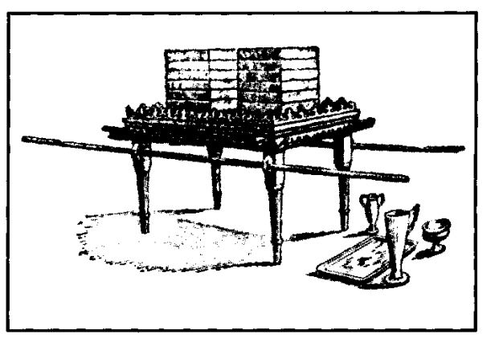
Moses is commanded to construct a table of acacia wood, and overlay it with pure gold. It is to be 115cms (3ft) long, 50cms (18in) wide, and 70 cms (2’3") high. It has to be decorated with a crown of gold around its top edge, and a border about 100mm (4in) wide probably placed between the legs, just below the crown of gold. This also is to be finished off with a crown of gold. Various dishes are to be made to be used in conjunction with it, and upon it is to be displayed the shewbread which is to be replaced every sabbath, and eaten by the priests.
VERSE 23
"Thou shalt also make a table of shittim wood" — The word "table" is shulchan from shalach "to spread forth," thus indicating its purpose: to spread out a meal. It is indicative of fellowship with Yahweh through eating the bread of life: "consuming" the hope of Israel.
"Two cubits shall be the length thereof, and a cubit the breadth thereof, and a cubit and a half the height thereof" — As the cubit was approximately 18 inches, the table was about 90cms (3 ft.) long, 48cms (18 in.) wide, and 70cms (2 ft. 3 in.) high. As a table, therefore, it was not large. In fact, the very measurements imply limitation, suggesting exclusiveness in fellowship. Fellowship implies endorsement. When David declared: "Thou preparest a table before me in the presence of mine enemies," (Psa. 23:5), he expressed his gratitude that Yahweh would openly manifest His acceptance of His servant in the sight of those who opposed him.
Attendance at the table of Yahweh implies personal responsibility to conform to the spiritual etiquette required of those invited to partake thereof. Paul taught that when engaged upon the solemn privilege of partaking of the Lord's memorials, "Let a man examine himself, and so let him eat of that bread, and drink of that cup. For he that eateth and drinketh unworthily, eateth and drinketh condemnation to himself" (1Cor. 11:28-29).
VERSE 24
"And thou shalt overlay it with pure gold" — see note v. 11.
"And make thereto a crown of gold round about" — The ordinary priests were not permitted into the Most Holy where was the crown of gold (v. 1 1), expressive of the ultimate victory of faith; but they could see this crown of gold, and so in prospect look forward to the final victory, as they partook of the bread, and enjoyed the fellowship of Yahweh.
VERSE 25
"And thou shalt make unto it a border of an hand breadth round about" — An hand breadth is about 100mm (4in.), so there was a border of approximately that size around the table.
The word "border" is micgereth and denotes an enclosure, from the root signifying to shut up, to enclose. But we are not told where this border was placed. It is claimed that the border on the table depicted on the Arch of Titus is placed below the table-top, so uniting the legs together, as they supported it. This is certainly appropriate to the symbolism. A border, acting as a shelf, below the level of the table, would both unite and strengthen the legs, and would constitute a most convenient ledge upon which to place the plates, dishes, bowls and flagons associated with the table.
We say that this is appropriate, for the meal of fellowship which is the apex of spiritual experience enjoyed by believers at the present time, is dependent upon those who minister to that end: the presiding brother, the exhorting brother, those who prepare the bread and the wine, or the hall where the meeting is held. These are all necessary appendages to the communion that takes place: they are comparable to the vessels associated with the table of shewbread, and though on a lower level than it, nevertheless lead to it, and support it.
"And thou shalt make a golden crown to the border thereof round about" — The Hebrew word for "crown" is zare and implies wreathen work, such as the Stephanos or coronal wreath of the Apocalypse. It speaks of the rewards of victory (Rev. 2:10; 3:11). There will be rewards for those who minister at the table as for those who fellowship around it.
VERSE 26
"And thou shalt make for it four rings of gold" — Cp. v. 12.
"And put the rings in the four corners that are on the four feet thereof — Here the Hebrew word is different to that rendered "corners" in v. 12. It is pe'ath signifying "to blow," and thus suggesting the four quarters from whence the wind blows. Whereas, on the march, the ark was lifted high as indicated by the placing of its rings, the table of shewbread was as was appropriate. The rings were at the four corners, placed on the feet, or legs, of the table, close to the border as the following verse states.
VERSE 27
"Over against the border shall the rings be" — As the border was probably a little lower than the level of the table, the rings would be immediately below it. Not on the lower part of the legs, but just below the table top.
"For the places of the staves to bear the table" — The word "places" is the Hebrew bayith, denoting "houses," and so suggesting a dwelling place for the staves. See Exo. 26:29; 30:4; 36:34; 37:14, 27; 38:5. As the staves, and those bearing the sacred furniture by their means, represent believers throughout the ages, whether from Israel or the Gentiles, the use of bayith is quite significant. It suggests that in "the Father's house are many abiding places" (John 14:2; Heb. 3:6).
VERSE 28
"And thou shalt make the staves of shittim wood, and overlay them with gold, that the table may be borne with them" — See notes vv. 3, 5.
VERSE 29
"And thou shalt make the dishes thereof — The word "dishes" is from the Hebrew kearoth, and signifies a vessel as hollowed out (Strong). These were probably used for the bread on the table. It is suggested by some, that they were made in the exact shape of the loaves, and that there were twelve such dishes, on each of which was one of the twelve loaves. Nothing is said of this arrangement, however, except that the loaves were placed one on top of the other in two rows (Lev. 24:6). They could well have been in twelve dishes that would fit one inside the other.
"And spoons thereof — Heb. kap-poth from kaph, the hollow of the hand, and thus denotes cups. As a similar word is used to describe the vessels that held incense, it is presumed that these "spoons" or "cups" held the frankincense which was offered each sabbath as a memorial to Yahweh (Lev. 24:7).
"And covers thereof — The Hebrew kasvoth signifies "to be round," suggesting a jug. The purpose of these jugs is not specifically stated. Probably they contained wine, and in that regard were associated with the "bowls."
"And bowls thereof, to cover withal: ofpure gold shalt thou make them" — In this statement the explanatory note "to cover withal" should be placed in conjunction with the "covers" and not the "bowls" (see Exo. 37:16). The margin would then give the meaning as "pourers to pour out withal." The wine in the pourers was poured out into the "bowls." The word is a translation of menakkivoth defined by Strong as sacrificial basins, such as held blood. Significantly, the word is from a root nakah signifying "to be or make clean."
The wine poured out from the pourers into the bowls represented the blood of sacrifices given in dedication to Yahweh. On each sabbath a public ceremony was observed by the priests that dramatised principles of acceptable worship before the people of Israel. The shewbread was eaten in the Holy Place, the frankincense was burnt on the altar of incense, and the wine was probably drunk by the priests (Lev. 24:5-9). This action emphasised fellowship between God and man on the basis of sacrifice, pointing forward to the offering of the Lord. It thus proclaimed the same principles as do the memorials of eating bread and drinking wine today.
VERSE 30
"And thou shalt set upon the table shewbread before Me alway" — The Hebrew is lehem panim, literally "bread of the faces," or "of the presence." The name reminded the priests, and through them, the people, that they were in the presence of Yahweh, and of His ministering spirits, the angels. Cain was cut off from "the faces" (panim) of Yahweh (Gen. 4:14), because he was denied access to the cherubim who were stationed east of the Garden of Eden, and whose faces "turned every way" to preserve the "way to the tree of life." The faces of cherubim looked down from the veil in the Holy Place, giving a further significance to the name of this bread; whilst, behind the veil, the shekinah glory that shone forth from between the cherubim over the mercy seat gave further emphasis to the reality of the divine presence, and the significance of the name of the bread.
Other names by which it was known are: lehem ha-tamid, or bread of continuance (Num. 4:7; 2Chr. 2:4), because it was always to be in evidence; lehem ham-maakareth, or bread of the ordering (1Chr. 9:32), because it was to be placed in ordered rows; lehem kodeth, or holy bread (ISam. 21:5-6), because of its sacred use.
Twelve loaves of unleavened bread (see Jos. Ant. 3:6:6) were placed in two rows upon the table, details of which are found in Lev. 24:5-9. The number twelve identifies them with the true Israel of God, and the division into two suggests that such are drawn from the two great families of humanity: Israel and the Gentiles.
Unleavened bread suggests the "bread of life" (John 6:35, 48), the Lord Jesus Christ who was free of the "leaven of malice and wickedness" (1Cor. 5:8). To eat of that bread is to absorb his teaching, and to manifest his characteristics. This will be done more effectively when the believer is conscious of Yahweh 's presence, hence the name of the unleavened bread in the Holy Place. Specific instructions were given for the baking of the unleavened bread, and for its disposal at the end of each week. On that occasion, when the old bread was replaced by new, the former was not thrown out, but was eaten by the priests on the sabbath that it was removed (Lev. 24:5-9). This demonstrated that the shewbread was not food intended for God, but a symbol of the spiritual bread by which Israelites were to be nourished (see John 6:56-58). It was representative of that necessary spiritual bread "that proceedeth out of the mouth of Yahwen" (Deu. 8:3), and which believers must eat, the need of which was brought home so vividly to the people by the provision of manna each day.
The twofold division of the loaves was duplicated in each loaf. Each had two tenth deals of flour (about 3.5kgs; or 8 lb), and, according to Vine, formed a loaf about the thickness of the thumb. The eating of the shewbread each sabbath was an act of communion that witnessed to the fellowship that existed between Yahweh and the people. The bread thus pointed to Christ as the "living bread" (John 6:35), who forges the bond of fellowship between God and His people today.
The instruction to set the shewbread upon the table before Yahweh always, taught that He is ever ready to enter into communion with His people through the revelation of His Word, which was made "bread" in Christ.
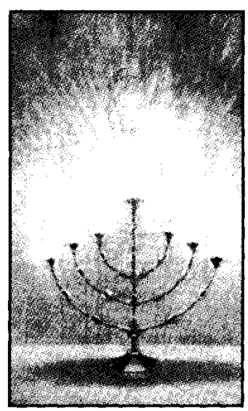
The Golden Lampstand - vv. 31-39.
There were no windows provided in the tabernacle, so that the only light was that which came from the seven-branched lampstand which stood on the south side of the Holy Place, on the left hand of the priest as he entered that sacred apartment. It, therefore, was opposite the table of shewbread. Its light was kept brightly burning by priestly ministration each morning and evening, being fed with oil supplied by all Israel (Exo. 27:20-21; Lev. 24:1-4; Num. 8:1-4), and particularly illuminated the bread upon the table. It is identified with the central stem (v. 34) which had four bowls, knops, flowers, and a branch, whilst the six other branches that came out of its side had only three bowls, knops and flowers. It represented the light of truth, personified in the Lord Jesus Christ and the elect, without which darkness reigns supreme (Isa. 60:2). The lampstand typified the active ecclesia (Rev. 1:20).
VERSE 31
"And thou shalt make a candlestick of pure gold" — The reference is to a lampstand, not a candlestick. The use of candles found no place in the true worship of Yahweh. The word is menorah from nerah, "to glisten," referring to the light that it gave forth. The word is in the feminine gender which is appropriate to its symbolic significance, for the menorah symbolised both Christ and his Bride-ecclesia as the co-operative lightstand of Truth (Zech. 4:2-14; Rev. 1:12).
"Of beaten work shall the candlestick be made" — The lampstand, the most beautiful, ornamental, and most elaborate of all the pieces of furniture, was not cast in a mould, nor made in sections and assembled together, but was beaten into its form and beauty out of a solid piece of gold. It is claimed that this is beyond the skill of man to do, and this we can well believe, for Bezaleel was specially endowed with the Spirit to perform the work set him to accomplish. So Christ declared, "I am the light of the world" (John 8:12), a light that shone forth in a dark place (John 1:5-14); and the glory he revealed was divine in origin (John 1:14). As the divine Light-stand, he was "beaten into shape," learning "obedience by the things that he suffered" (Heb. 5:8); and by those very means he provided the pattern upon which the ecclesia was formed. It, too, must be beaten into shape. Paul taught that "we must through much tribulation enter into the kingdom of God" (Acts 14:22).
The word "tribulation" signifies "pressure," and by such pressures, characters are moulded into the shape desired of Yahweh. The problems of life are a challenge to faith, and comprise a very necessary challenge, for they constitute the beating of the divine hammer by which individuals are changed for the kingdom. Such then become "His workmanship" (see Eph. 2:10; Psa. 100:3; 138:8; 1Cor. 3:9; 2Cor. 5:5), beaten by tribulation without and influenced by the Word within, to conform to the pattern revealed in Christ Jesus. Believers thus "fellowship his sufferings" (Phil. 3:10), and so develop a fellow feeling for those who suffer (see Heb. 4:15; 5:1-2). Gold is representative of the trial of faith, and not faith in the abstract (I Pet. 1:7).
It was very important that the lamp-stand should be "beaten" into shape. One of the titles of Yahweh is that of Yatsar, rendered as "Maker" (Isa. 45:9). The word comes from a root signifying to squeeze into shape. Hence Yahweh is described as both Creator and the Maker of Israel: "Thus saith Yahweh that created thee, Ο Jacob, and He that formed thee, Ο Israel" (Isa. 43:1). The word "formed" is yatsar, and the statement teaches that Yahweh both created and shaped Israel — created him as Jacob, and shaped him into Israel. This transformation is symbolised by the changed shape of the piece of gold that, under the skilful hammering of Bezaleel, gradually formed into the lampstand of the Holy Place: a beautiful piece of furniture designed to illuminate the prevailing darkness.
The word "beaten" is from the Hebrew miqshah and denotes rounded work, referring to the rounding branches and stem of the lampstand. This was obtained by hammering, and, in the case of the lampstand, out of the one piece of gold.
"His shaft" — The Hebrew word is yarek and signifies "thigh." Twenty times the word is translated "thigh," twice "loins," four times "side," and once "body." In such places as Gen. 46:26 and Exo. 1:5, yarek is connected with birth, defining "the souls that came out of the loins of Jacob," etc. Its application to the Lord Jesus as the Father of Eternity (Isa. 9:6) is admirable. Isaiah 53, which speaks of the manner in which he submitted to the "hammering" he received, also says: "When Thou shalt make his soul an offering for sin, he shall see his seed" (Isa. 53:10). And in Heb. 2:13, the ecclesias are presented as "the children" which God granted the Lord Jesus. His sufferings constituted the birth-pangs by which the ecclesia was brought to life, even as, in Eden, Eve was formed out of Adam when he submitted to the "deep sleep" that came upon him.
The shaft was vital to the lampstand, for it supported the various branches. Of themselves they were useless. A branch broken off from the shaft would not give light. The importance of the shaft is presented in Christ's figure of himself as the Vine, and his followers as the branches (Jn. 15:1-2,5). Observe the vine. Notice the main shaft, the vine proper. This is the all-important part of the plant. The branches spread out like a lampstand, but they can be pruned, even removed and replaced without harm to the vine itself. So with the spiritual lampstand: the shaft supported the whole. The shaft, therefore, represented Christ personal, from whom all others, as Christ multitudinous, derive their spiritual being and strength (Rev. 1:13; John 3:5; 15:6-7).
"And his branches" — Two important features are seen in this item. Firstly, the Hebrew word is kaneh, and signifies "a reed" for measure (Eze. 40:3; Rev. 21:17), and so the branch becomes the measuring reed of Yahweh's purpose with His people. Secondly, the word in this verse is singular in the Hebrew, in contrast to the same word in the next verse, but which is in the plural. Note that in Exo. 37:17, which repeats the wording of this verse, the word is given in the singular number, as it should be here.
This is most significant, for it shows that the shaft has a branch peculiar to itself. This would suggest that the central branch was higher and more dominant than the other branches that came out of the side of the shaft. It divided the number of branches into 6+1 making 7 in all. "Six" is the number of flesh, but the seventh completes the covenant number.
This seventh branch was more distinctive than the others. Moreover, it had the specific title of "his branch," representing the Lord in glory. The pre-eminence of Christ is expressed in the statement: "Thou hast loved righteousness, and hated iniquity: therefore God, even thy God, hath anointed thee with the oil of gladness above thy fellows" (Heb. 1:9).
"His bowls" — Strong gives the Hebrew as gebiya, from a root signifying "to be convex," and hence a cup, or by analogy, the calyx of a flower. The word is elsewhere rendered as "cup" (Gen. 44:2, 12, 16, 17), and "pots" (Jer. 35:5). Calyx is a botanical term, and denotes a cup-shaped organ or cavity: the outer covering of leaf-like envelope of a flower. The principal function of the calyx is to enclose and protect the other parts of the flower while in bud. Those on the lampstand were "made like almonds" (v. 34), the symbol of divine selection and resurrectional life. There is divine protection for those in Christ who walk after the light of the Spirit-Word, for "if the Spirit of Him that raised up Jesus from the dead dwell in you, He that raised up Christ from the dead shall also quicken your mortal bodies by His Spirit that dwelleth in you" (Rom. 8:11). Such is the divine protection afforded them, that nothing can "separate them from the love of God, which is in Christ Jesus" except their own folly in repudiating Him (Rom. 8:38-39).
"His knops" — Here the Hebrew is kaphtor, and signifies "to encircle," hence the word "knop" or "knob." It indicates a ball of some kind. Josephus, and other Jewish writers, claim that they were shaped in the form of pomegranates, which are ball-like in shape, and which formed an important part of the dress of the high priest.
The pomegranate is a most significant fruit when considered in the light of the Truth. Its skin is purple in colour, suggesting God manifestation. Cut it open and an abundance of red wine-like juice flows out, whilst inside, the fruit is packed with white seeds as no other fruit. Pomegranate literally means apple with grains, the reference being to the closely packed seeds within. The fruit is a very refreshing delicacy to dwellers in a hot and thirsty land. It is a wonderful symbol of Christ: "When Thou shalt make his soul an offering for sin (by shedding of blood as in the cutting of the fruit), he shall see his seed" (Isa. 53:10). The seed will be crowded withinthe multitudinous Christ: "Lo, a great multitude which no man could number, out of all nations, and kindreds, and people, and tongues" (Rev. 7:9).
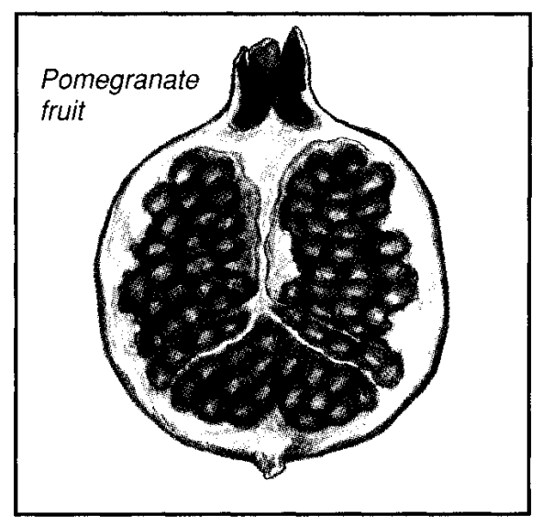
There were pomegranates around the hem of the high priest's garment (Exo. 28:33-34), and on the pillars of the temple (1 Kings 7:18-20). The packed seeds are suggestive also of the fruit of the Spirit (Gal. 5:22).
"And his flowers" — The flowers speak of beauty: a beauty that the Word will create in all true students (cp. Psa. 45:11; 90:17; Eph. 5:26-27). It is generally accepted that these were lilies, the anemone of the Promised Land. In The Song of Solomon, the lily is used to describe the beauty of the Bride (ch. 2:1-2, 16), as well as the lips or speech of the Bridegroom (5:13). The "lily of the field" is probably the anemone coronaria, a beautiful wild flower which paints the countryside with great splashes of purple-scarlet, suggesting the principle of God manifest through the flesh. See notes in Expositor: Song of Solomon. The ornamentation of the lampstand in this particular, therefore, follows a pattern of development. The almonds speak of divine selection and resurrection; the pomegranates, of the multiplicity of the seed brought to the birth through the sacrifice of Christ; and the lilies, their future divine glory (see Mat. 6:28).
"Shall be of the same" - This is literally "from it shall be." They form part of the lampstand, not being merely attached to it. This speaks of complete unity with Christ (John 17:21).
VERSE 32
"And six branches shall come out of the sides of it" — Here the Hebrew kaneh is in the plural: kanehim, branches, and relates specifically to the six branches that spread out from the two sides of the central stem, but not to the single branch, styled "his branch" that was on its top.
"Three branches of the candlestick out of the one side" — The Hebrew for "the side" in this verse is tsad, a different word to that translated "sides" in v. 14. It means to sidle off, thus to branch out from the side.
"And three branches of the candlestick out of the other side" — The lamp-stand was symmetrical in appearance: divided into two parts with three branches on each side, making six in all; whilst the upper, central branch, made a total of seven. Six is the number of flesh; Two, the number of division (Israel and Gentile); and Seven, the number of covenant. Therefore the lampstand figuratively set forth the two great divisions of humanity (flesh), united in the bonds of the covenant.
VERSE 33
"Three bowls made like unto almonds, with a knop and a flower in one branch" — Each of the branches had three almond-shaped protrudences, in succession followed by a pomegranate and a lily-flower. This contrasts with the shaft that had four such knops and flowers.
Why more almonds than knops and flowers? The word for "almond" is shaqad, and comes from a root signifying "to awaken." The almond, one of the earliest of trees to bloom, is considered a herald of spring (see Jer. 1:11-12), and therefore a symbol of the resurrection. But of all who rise from the dead, only the righteous will attain unto the kingdom; hence there was but one pomegranate and one flower to three bowls made like almonds.
"And three bowls made like almonds in the other branch, with a knop and a flower" — So the perfect symmetry of the lampstand is preserved.
"So in the six branches that come out of the candlestick" — It is significant that the six branches are specified, leaving the seventh, styled "his branch," on its own. Obviously, that branch, standing above all the others, represents the Lord Jesus "in the midst of the ecclesias." Moreover, these six branches are represented as coming "out of the side" of the lampstand, again a significant expression.
In Elpis Israel, Bro. Thomas writes: "Believers, so disposed, are the begotten of God, and have become as little children. They believe 'the exceeding great and precious promises,' together with the things testified concerning the sufferings and resurrection of Jesus. He fell into a deep sleep; and, while thus unconscious and insensible, his side was opened by a spear, and forthwith rushed blood and water (John 19:33-34). Being awakened out of his sleep, he was built up a spiritual body of flesh and bones; and, by his ascension, presented to the Father as the federal representative of his church [ecclesia]... A community of such individuals as these constitutes the mystical body of Christ... and, therefore, the beloved Eve of the last Adam, the Lord who is to come from heaven, and make her of the same holy spiritual nature as his own... figuratively taken out of the side of her Lord" (pp. 53-54).
Similarly, in the symbology of the lampstand, the branches are said to "come out of the lampstand.
VERSE 34
"And in the candlestick shall be four bowls made like unto almonds" — The reference in this verse is obviously to the central shaft or stem. This had twelve ornaments in all, the series of bowl, knop and lily, being repeated four times; once in connection with each pair of branches, and a fourth time at the summit from whence extended the seventh branch.
"With their knops and their flowers" — Hence making twelve in all.
VERSE 35
"And there shall be a knop under two branches of the same, and a knop under two branches of the same, according to the six branches that proceed out of the candlestick" — The branches were to extend from the shaft of the lampstand at the point of junction between the pomegranate, or knop, and the lily.
VERSE 36
"Their knops and their branches shall be of the same" — They were to be constructed out of the one piece of gold. There was both unity and diversity in the lampstand, as there should be in ecclesial life, and will be in the kingdom.
"All it shall be one beaten work of pure gold" — This is better rendered: "all of it shall be beaten work of one piece of pure gold." The lampstand represents the ecclesia today, and the multitudinous Christ-body of the age to come. When the glorified redeemed are all associated together in one, it will be found that there is only one member thereof who has been without sin, Christ, but not one who has not been subjected to trial. They will all have "fellowshipped the sufferings of Christ," being able to say that "it is through much tribulation that we have entered the kingdom of God." To illustrate this, the lampstand was carefully, meticulously, painstakingly, and skilfully beaten into shape, as is each character that shall find approval at the Judgment Seat: the "hammer" being the Word of Yahweh (Jer. 23:29).
VERSE 37
"And thou shalt make the seven lamps thereof — The word for "seven" is shibah the masculine form of sheba. It is from a root that signifies to be complete. Hence to seven oneself is to swear, because an oath binds the one making it, to complete that which he sets out to do. Seven, therefore, is the number of completeness, the covenant number. The seven lightstands of The Apocalypse (Rev. 1:20) represent the complete ecclesia. The lamp-stand with its seven lamps completely illuminated the dark interior of the Holy Place. Their appearance is not described.
"And they shall light the lamps thereof — The lamps were attended to every evening at sunset (ch. 27:21; 30:8; Lev. 24:3), and every morning at the time of burning of incense (Exo. 30:7). Without the lamps, the other objects in the Holy Place would have been mere ornamentation hidden in darkness. The light gave usefulness to the beauty of the lampstand. So also with the manifestation of the Truth. It is the duty of the ecclesia to radiate light (Mat. 5:16; Phil. 2:15), to attract others to the Truth. But inasmuch as the lamps were lighted "before Yahweh" (Exo. 40:25), personal ability must be subjected to the will of Yahweh, and the work of expounding and proclaiming the Word be done as "unto Him." In all of its labours, the ecclesia should be conscious of this fact, and lean heavily upon God in all its endeavours.
The word "light" in this place is from the Hebrew alah signifying "to cause to ascend," and it was the work of the priests to do this. The word does not signify that the lamps had gone out and had to be lit, but that they had to be tended in such a way as to cause the light to "ascend" or burn brightly. This was done by tending the wicks, or replenishing the oil.
In its need of light, the holy place differed from the most holy, for the latter was illuminated by the shekinah glory of Yahweh shining from above the mercy seat and between the cherubim, and, therefore, had no need to be replenished by human agency. But the lamps in the holy place needed such attention. This taught that there is no open manifestation of glory at present, such as there will be at the Lord's return (Rev. 21:22-23). There is light, but it is merely "the light of the knowledge of the glory of God radiated by the ecclesia as the symbolic lightstand.
Saints walk by faith which comes from understanding the Word (Rom.10:17). This provides the oil for the ecclesial lampstand, with its sevenfold lamps, indicating the proclamation of the covenant. This is a real light, though faint by comparison with that which is beyond the veil, being that which shall be manifested in the age to come. Then the symbolic "moon," the ecclesia, shall be "as the light of the sun" (Isa. 30:26). Though the light of the sun shall never fade, the light of the lampstand would if not constantly tended by the priests. This introduces the principle of personal responsibility to see that our lamps are "trimmed and burning." Concerning this, Brother Roberts observes in The Law Of Moses: "The light was caused by the combustion of oil supplied to the lamps morning and evening, without which the light would have gone out — whence we may gather the idea that the candlestick does not represent the word of the Lord in the abstract, but that word as incorporate in living believers, after the example of the seven apocalyptic light-stands which stood for seven light-bearing communities of saints. It is manifest that the word of the Lord can have no operative existence apart from living reflectors. Inspiration itself is but the intelligence of God apart from a living medium. And when this inspiration, acting through the prophets and apostles, had incorporated itself in writing, the writing was not in itself the light, but the mere means of the light when it enters into the knowledge and understanding of living believers... The only light we can have at present is the light of illuminated brains, and this is not a fixed light, but a light that requires constant renewal by daily supplies of the oil of the word. 'Order the lamps upon the pure candlestick from evening unto the morning before the Lord continually,' is the type. Nothing less than the daily reading of the Word can answer to this type." (pp. 127-128).

The light of the lamps illuminated the interior and furniture of the Holy Place: the table of shewbread, golden altar of incense, golden boards, multi-coloured veil, the cherubim wrought into the veil and ceiling-curtain, and so forth. These articles symbolised the hope of Israel, the need of prayer, the beauty of faith, the perfection of Christ, the incentive of being one with the multitudinous redeemed, denoted by the cherubim, all of which were illuminated by the Word.
"That they may give light over against it" — The word "light" here is a different word from the earlier word in this verse. It is owr and signifies "illumination," emphasising the result of the light of the lamps.
The word "it" in Hebrew is the plural panyim signifying faces. The lamps, therefore, comprise the faces of the ecclesia, and these faces, shining brightly with the illumination of the Truth, bring to bear their light upon the contents of the Holy Place.
VERSE 38
"And the tongs thereof" – The tongs were snuffers to trim the wicks and cause the light to burn better. This was done every morning and evening. During long hours of burning, the wicks would burn low, soot would accumulate thereon, and attention was required to bring up the wick or to remove the soot therefrom. The tongs did that.
The soot was not caused by the oil, for it was pure, but by the consumption of the wick itself, particularly after long hours of burning. So with ourselves. Things come into our lives that hinder our testimony, and cause the light to burn low. There is a need, then, for such ministration. This can come from co-operation with those of like precious faith, or from God himself who "chastens those whom He loves" (Heb. 12:6).
Constant attention was given to the lamps to cause the light to burn brightly, and it is important that we recognise that need in ourselves.
"And the snuffdishes thereof" — These were ash-pans into which any impurities of the wick might be placed whilst the lamps were attended and replenished with oil, after which all impurities were taken away. There is a need for us to remove from our lives those influences that will hinder the shining forth of proper light of the Word.
"Shall be of pure gold" — The "trial of faith" will trim the wicks, and faith itself will cause the light to shine more effectively. Hence, these instruments of the lampstand were of pure gold.
VERSE 39
"Of a talent of pure gold shall he make it, with all these vessels" — This is the first mention of the "talent" in scripture. It comes from the Hebrew kikkar signifying a circle, and therefore suggests the idea of eternity. The Berkeley Version renders the phrase: "use a circle of gold for it." In weight this represented, according to some, about 60 kgs (131 lb), and in money value, according to Berkeley, some $30,000 in 1945 (inflation would greatly add to this amount today).
According to Unger's Dictionary, some 6,000 drachmae went to the talent. This is remarkable, for six is the number of flesh, and the thousands suggest a multiplicity. It links the gold used with the sockets of silver that supported the boards of the tabernacle, for these were each made of a talent of silver, representing the redemption money of six thousand men (cp. Exo. 38:25-27). The talent, therefore, represented the measure of redemption in a multitude, and there is a significant application in regard to its use in Rev. 16:21, where the "weight" of the Redeemed is given as a talent. That being the case in respect to the silver talent, we can apply the same principle to the golden talent, which thus becomes the measure of faith, and was circular in shape, so representing the relationship of faith to life eternal.
VERSE 40
"And look that thou make them after their pattern" — See note, v. 9. This instruction is reiterated to Moses. As meticulous care had to be observed in the construction of the tabernacle and its furniture, so the greatest attention should be paid to the spiritual lessons developed therefrom. The characters of the Redeemed must conform to the "pattern" of Christ as revealed in the Word.

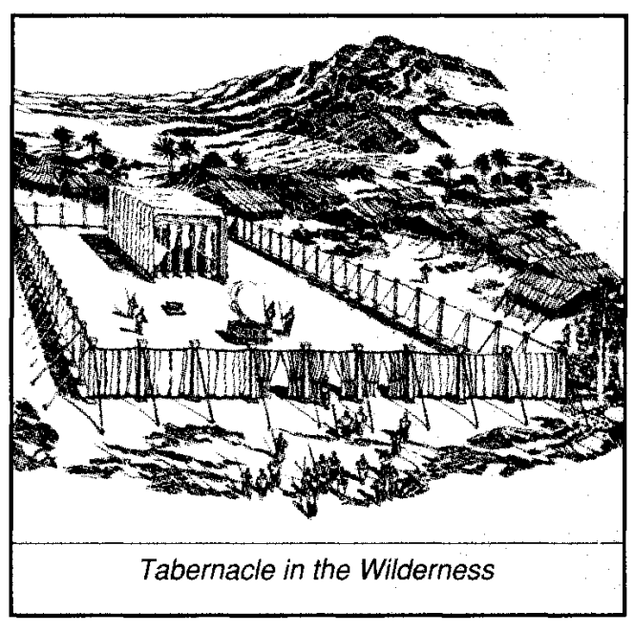
"Which was shewed thee in the mount" — The Hebrew is as the margin: "Which thou wast caused to see in the mount." In a very graphic vision Moses was shown the tabernacle, and invited to carefully inspect it, to enable it to be reproduced with the aid of the workmen appointed and endowed for that purpose. Though the pattern was divine, the workmen were of flesh, co-labourers with God. The tabernacle, therefore, was a prophecy of the relationship of those called to Yahweh and His future purpose in the earth to manifest divine glory in a multitude of the Redeemed.

