CHAPTER TWENTY-EIGHT
THE PRIESTS AND THEIR GARMENTS
Aaron and his sons are selected to serve as priests. Until this time Moses has been the only mediator, but now Aaronys family, rather than that of Moses, is chosen to minister before God for Israel. This had been previously implied from the instructions regarding the tending of the lamps. Now Aaron and his sons are to be set apart from the rest of Israel, being consecrated as priests. To that end, special holy garments for uglory and for beauty" are designed for their exclusive use. They are intended as an outward display of inward holiness and beauty of character which they represented. The appointment of priests through whom alone the people can approach Yahweh serves to again illustrate the exclusiveness of worship. Brother Roberts observes in (iThe Law of Moses" (p. 154): uThat God should dwell with men at all was esteemed by Solomon a great condescension on the part of a Being to whom it is humbling Himself Ίο behold the things that are in heaven, and in the earth' (Psa. 113:6)... Hence, familiar and indiscriminate approach was not invited: Ί will be sanctified in them that come nigh Me.' He would be approached in a consecrated and concealed recess, and that only once a year, and that only by blood shed, and that only presented by a man of His own choice, assisted by men of His own appointment, and attired in a way prescribed by Himself." Hence the appointment of a priesthood, and the provision of special garments setting them aside from all others.
Garments For Glory and Beauty — vv. 1 5.
Moses is ordered to separate Aaron and his successors unto the priesthood by a perpetual ordinance. Holy garments for glory and for beauty are to be made for them by workmen specially endowed with the skill to do so. Those garments would be a constant lesson to the people, directing them to the manifestation of the divine character, the holiness required for approach before the Deity, and the standards of appearance to be encouraged in the people. The nation was to observe in the priests, an example of their individual elevation in the presence of the Father.
VERSE 1
"And take unto thee Aaron thy brother, and his sons with him, from among the children of Israel" — To this moment, Moses had been the sole mediator between Yahweh and the people (Gal. 3:10), but now he is instructed that a portion of his functions will be delegated to others. Aaron and his sons are to be selected from out of Israel for special appointments as priests. Later, further instructions were given in regard to such. They were to be without blemish, and any disfigurement was to be a disqualification, though not for the eating of sacrifices (Lev. 21:17-23); they were to have no land inheritance, for Yahweh was to be their inheritance (Num. 18:12-20; 1 Chr. 23:13); they were to be custodians of the Law, teaching its precepts to the people (Mal. 2:7); they were to be taken out from among the Israelites as an exclusive class: an ecclesia from the larger national-ecclesia, whilst any unauthorised person obtruding upon the sacred office was to be put to death (Num. 18:7).
"That he may minister unto Me in the priest's office" — Only the father was to be high priest; whereas the sons were his assistants. Nevertheless the singular pronoun is used in regard to the whole body of the priesthood, for though subsequently there came many priests, they were required to act in unity on behalf of the family. In like manner, Christ's brethren are many, but constitute "one" in him.
"Even Aaron, Nadab and Abihu, Eleazar and Ithamar, Aaron's sons" — Their names are significant and denote their high office. Aaron means Very High, Nadab, Willing; Abihu, He is my Father; Eleazar, El is a Helper; Ithamar, Land of the Palm.
The meanings of these names can be paraphrased as follows: He who has been elevated will render willing service to He who is his Father; and because El is his helper, he will grow up as the Palm: producing fruit and providing shade in the desert (cp. Psa. 92:12). The names of Aaron's sons are always coupled together in pairs in the Pentateuch. Unfortunately the sin of the first two brought about their early death, and Eleazar subsequently became high priest.
VERSE 2
"And thou shalt make holy garments for Aaron thy brother" — Nakedness is a symbol of sin (Rev. 16:15). Special "holy garments" were designed, distinguishing the high priest from all other men in Israel. Their "holiness" consisted in them being set apart for God's exclusive use.
"For glory and for beauty" — The garments of the high priest were designed to illustrate the character he was called upon to manifest. Antitypical priests (1 Pet. 2:9) are likewise to strive for characters that reflect glory and beauty (Gal. 5:22), whilst they "keep their garments unspotted from the world" (Isa. 61:10; Rev. 3:18).
Bro. Roberts comments: "What do we see in this but the fact that glory and beauty are the attributes of divine wisdom, whether we regard it intrinsically or in its living expression in all experience." The "garments" of the Bride of Psalm 45:Π-Ι4 are so represented, as, among other things, she is described as being "all glorious within." The gospel is a call to "glory, honour and immortality (Rom. 2:7); and develops in believers the qualities illustrated in the garments of the high priest. See also Psalm 29:2.
The glory attributed to the garments exalted the priestly office in the eyes of the people, causing them to look with greater reverence on the priests themselves and their important functions, setting them and their work above the rest of the people and their activities. The beauty of the garments was revealed in their colorful richness, and appealing design. But their real significance is manifested in the characters of the ones wearing them. So with believers. Their labours in the Truth are higher and more onerous than those of worldly duties; their characters should conform to the nature of their call.
VERSE 3
"And thou shalt speak unto all that are wise hearted" — The Hebrew chakam leb signifies "intelligent, skilful, wise in mind, word and act." The word for "wisdom" (chokma) is from the same root. Moses was to confer with such, instructing them as to what they should make.
"Whom I have filled with the spirit of wisdom" — Moses was not to select workers merely because of their practical skill, but those who were prepared to allow their natural ability to be governed and directed by divine principles and influence. Such persons would recognise that their inherent gifts were to be used in the service of God in the way set out in 1 Pet. 4:10-11.
"That they may make Aaron's garments to consecrate him" — The word "consecrate" (Heb. kadash) denotes one set apart from all others for divine use. As the high priest represented Yahweh to the people and the people to Yahweh, he personified the setting apart of both for the purpose of the other. The sanctification, or setting apart, of the priest for God, illustrated that the people should likewise consider themselves as set apart for divine use, for he was their representative. But as he also represented Yahweh to them, it was necessary that they render to him the honour due to his great and holy calling. The Lord Jesus Christ, our high priest, declared concerning those whom he called to be his assistant priests (Rev. 5:9-10): "For their sakes I sanctify myself, that they also might be sanctified through the truth" (John 17:19).
"That he may minister unto Me in the priest's office" — Aaron was set apart that he might officiate as mediator on behalf of the people. The Hebrew word is kohen, and denotes to mediate or officiate. He represents the fulness of the mediatorial work found in the Lord Jesus Christ (Un. 2:1).
VERSE 4
"And these are the garments which they shall make" — For the order in which the garments were placed on the priest, see Lev. 8:7-9.
"A breastplate, and an ephod, and a robe, and a broidered coat, a mitre, and a girdle" — These six items of clothing were capped by the golden band upon the forehead of the high priest described in v. 36, making seven items in all. The numbers six and seven are significant. Six represents the flesh, which is to be covered by the garments of Yahweh determination; whilst seven is the number of the covenant, the binding contract between Yahweh and His people upon the basis of God manifestation.
"And they shall make holy garments for Aaron thy brother, and his sons" — The garments of the sons of Aaron differed from those of their father; inasmuch as the glory of Christ supersedes that of his sons (Heb. 2:13).
"That he may minister unto Me in the priest's office" — Notice the singular pronoun he used collectively for Aaron and his sons. Both father and sons were expected to work as a team, a unit, with the sons in complete subordination to the father. The garments symbolised the various powers, responsibilities and qualities attached to the important offices granted them. The antitype is in the co-operation which should be found in ecclesias, and the subordination of each member to the authority of Christ.
VERSE 5
"And thou shalt take gold, and blue, and purple, and scarlet, and fine linen" — The two materials here specified are gold and fine twined linen. The others are colours that were emblazoned upon the linen, and everywhere interlaced by the gold. For that purpose, the gold was beaten thin and cut into thread (see Exo. 39:3). In the garments designed, the strength and glory of the gold (a tried faith), was intimately blended with every part of the ephod, and gave firmness as well as brilliance, to the whole fabric. Gold formed part of the Bride's garments as described in Psa.45:13.
The significance of the colours is important, for blue represents God manifestation; purple portrays royalty; and scarlet speaks of sin. All those elements are revealed in the parable of the priesthood, for by this means is sin overcome, and God's authority upheld, to His honour and glory.
The Ephod — vv. 6-14.
The word "ephod"is the original Hebrew transliterated, and not translated into the English. Gesenius derives it from the root aphad, "to gird," so that the word actually defines any "vestment" or "garment." The ephod was a sort of waistcoat, consisting of two pieces, one to cover the chest and the other the back, joined together above the shoulders, set with precious stones, and united at the waist by a band, called "the curious girdle of the ephod." This band was of one piece with the ephod, being woven on to it, passed around the body, and so fastened. The ephod was worn over the tunic and robe (v.31).
VERSE 6
"And they shall make the ephod of gold, of blue, and of purple, of scarlet, and fine twined linen" — The materials of the ephod were similar to those used for the hangings at the entrance to the court, the door of the tabernacle, and the veil between the Holy and Most Holy. The typical significance of the materials and colours used, illustrated the "glory and beauty" of Christ's character. Their presence as part of the ephod, borne by the high priest, "prefigured the perfect qualification of Christ for the priesthood, as it prefigured his perfect qualification in the several aspects typified by the gate, and the door, and the veil" (The Law Of Moses, p. 162). Again: "The constitution of the ephod (gold, blue, purple, and scarlet, on a ground-work of white), is a typification of the method of the development of Christ as the great high priest, and of the principles that have become incorporate in him as the result of that method" (ibid. pp. 162-163). The placing of gold at the head of the list of materials used, emphasised that faith was a predominant characteristic of Christ. Then followed in order the blue, purple, and scarlet, the signification of which has been noted previously. And all this was inwrought into a colourful pattern on a background of white linen, emphasising righteousness in action.
The garment, therefore, denoted the development of faith unto works such as commended by James (ch. 2:14-18), and was exemplified to perfection by the Lord Jesus Christ.
"With cunning work" — This is rendered in the R.V. as "the work of a skilled workman." The Hebrew verb signifies to plait or weave, suggesting that the gold, blue, purple and scarlet thread were woven into the fine twined linen fabric. Thus the intricate pattern thus so patiently and skilfully wrought, symbolised the variegated aspects of Christ's perfect character.
VERSE 7
"It shall have the two shoulderpieces thereof joined at the two edges thereof; and so it shall be joined together" — The word for "shoulderpieces" is the same as that used for "side" in ch. 27:14-15, except that it is in the feminine plural as kaphethoth. The ephod, therefore, was in two parts, joined together at the shoulders. The word "joined," signifies to be united together, as in fellowship (cp. Psa. 94:20; 2Chr. 20:36-37; Hos. 4:17). The two pieces of the ephod, therefore, prefigure Christ in two aspects: individual and communal. The front with its breastplate representing the Lord himself as high priest; and the back, the ecclesia as a priestly community. The apostle refers to the latter as "that which is behind" (cp. Col. 1:24), which is as yet lacking the full manifestation of glory.
VERSE 8
"And the curious girdle of the ephod" — There is no word in the Hebrew for "curious" and yet the use of the adjective is very appropriate at this place, for it is difficult to ascertain both the pattern and the purpose of the girdle. This article of dress is distinct from the "girdle" mentioned in v. 4, which is a different word in Hebrew (ephowd), and is connected both there, and in v. 39, with the mitre. The word used here is chesheb, and signifies a belt or strap. It is derived from chashab which denotes "to plait," "interlace," and suggests a band plaited of the same materials as the ephod.
The word "ephod" in this verse is different from that in the previous verses, though related to it. Here is is ephuddath, in the feminine gender, suggesting the fastening on of the ephod. The phrase has been literally rendered: "the band of its fastening/' But what did it fasten? It probably drew the lower portion of the back of the ephod to that of the front so as to draw both tightly to the priest. Therefore, as the seam, or clasp, upon the shoulders joined the top, front and back of the ephod in fellowship, the "curious girdle" at the lower part of it completed the process by fastening the front and back to the high priest. In Exodus 29:5 where we read, "gird him with the curious girdle of the ephod," the Hebrew has: "ephodise him with the band of the ephod." This completely identified the high priest with the two parts of the ephod by uniting them to him, and him to them as one.
Based upon the suggestion that the two portions of ephod represent the Lord Jesus and his priestly community, his Bride, the belt or sash of the ephod completes their attire. In the case of the high priest, it prepared him for the work of ministry. A girdle is used to strengthen the loins, and thus equips a man for work or action (Exo. 12:11; John 13:4; Eph. 6:11-14). When the Lord Jesus is united to his Bride, they will be revealed as a completed priestly community, and he shall be ready for "the work before him" (Isa. 40:10). He shall be ephodised: the perfection of his character will be revealed for all to see in both him and in the community that he will have drawn to himself as one.
"Which is upon it" — The girdle or sash was joined with the ephod. It probably went around the body, and united the back portion to that of the front.
"Shall be of the same, according to the work thereof; even of gold, of blue and purple, and scarlet, and fine twined linen" — The workmanship and design was to be one with the ephod itself. Paul refers to divine love as being the "bond of perfectness" (Col. 3:14), holding all the virtues together as one.
The Two Onyx Stones — vv. 9-12.
The two parts of the ephod were joined together on top of the shoulders, and above them, set in gold, were placed two large onyx stones, upon which were indelibly engraved the names of the children of Israel. They acted as a memorial, testifying to the indubitable future of Israel according to the purpose of Yahweh. The high priest carried the names of the tribes of Israel upon his shoulders as a burden to be borne.
VERSE 9
"And thou shalt take two onyx stones" — Opinions differ as to what stone is represented by the onyx. The Hebrew word is shoham, and according to some, is derived from a root signifying "to shine with the lustre of fire." Josephus states that the second stone in the fourth
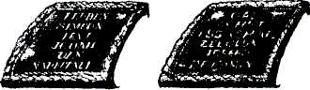
row in the breastplate was an onyx, whilst those on the shoulder-pieces of the ephod were sardonyxes (Ant., 3.7.5). Being very familiar with the dress of the high priest, his evidence must be conclusive. Moreover, the reference to the precious stones in Exo. 25:7 agrees with this, for it implies a difference between the onyx in the breastplate, and those on the ephod, in that both are individually specified. The word onyx signifies "finger nail." It is a gem that displays layers of different colours which alternate with each other, and bear some resemblance to the white and flesh coloured bands of the finger nail. The sardonyx, however, is more sharply defined, with bands of dark red and white, and thus is appropriate to the position in which the two gems are placed on the shoulders of the high priest. The red and white streaks of the gems, and the flash of light they would give forth as the sun struck upon them, were appropriate to their identification with the tribes of Israel, for their colours would suggest the purpose of their call: the red, sacrifice; the white, righteousness; and the sparkling reflection of the sun, God manifestation.
"And grave on them the names of the children of Israel" — Illustrating the mediatorial burden borne by the high priest on behalf of the children of Israel.
VERSE 10
"Six of their names on one stone, and the other six names of the rest on the other stone" — Six is the number of flesh, but when joined together, becomes the number of perfect government (12).
"According to their birth" — Again the flesh is emphasised. The names inscribed were according to the order of birth and differed to the order of inscriptions in the breastplate which was according to the positioning of the tribes, therefore revealing a divine arrangement.
The names on the shoulder-stones, therefore, were as follows: The first stone listed Reuben, Simeon, Levi, Judah, Dan, Naphtali; whilst the second stone continued with Gad, Asher, Issachar, Zebulun, Joseph, Benjamin. According to the following paraphrase, the message of the names teach: See a Son! Hear him, join him, praise him, and at the judgment after wrestling you will prevail. The second stone bore the message: A company of blessed ones shall receive their reward by dwelling with, and increasing, the family and influence of the Son of His right hand. It is significant, that the names of both the first and last sons of Jacob should speak of the Son!
VERSE 11
"With the work of an engraver in stone" — The stones were to be permanently engraved, illustrating that the future of Israel as a nation is essential to the purpose of Yahweh. He will never forget them(see Isa.49:15;Jer.31:3).
"Like the engraving of a signet, shalt thou engrave the two stones with the names of the children of Israel" — The Hebrew chotham, "signet," is from a root signifying "to close up," hence to complete, or to shut up. The same word is rendered "seal" in other places, and in Song 8:6 denotes everlasting love (for which see Jer. 31:3). The purpose of Yahweh is sealed up in Israel, as denoted by the signet-engraved gems on the shoulders of the high priest. The Lord Jesus Christ, as the ideal Israelite (Isa. 49:3) was sealed by God, and revealed the engravings thereof in the character he manifested, as well as in the doctrine he proclaimed (John 6:27). That "sealing" illustrated that he was the chosen of Yahweh (Hag. 2:23), as the engraving of the names of the tribes on the onyx stones testified that Israel was the chosen nation. The Lord Jesus, as high priest, has the names of the true "Israel of God" (Gal. 6:16) engraven upon him (Zech. 3:9), so that they constitute the sealed of God (2Tim. 2:19), "sealed unto the day of redemption" (Eph. 1:13; 4:30), though they may not be recognised among men as such.
"Thou shalt make them to be set in ouches of gold" — The "ouches" or settings of gold speak of characters established in faith. This is suggested by the Hebrew word for "ouches" which is mish-betsoth, a plural word in the feminine gender, referring to Israel as the Bride (Isa. 54:5). The word is derived from shabats, "to interweave." Hence the ouches were plaited settings of open or filigree work of gold, beautifully woven into a pattern, indicative of a character of faith wrought by Yahweh.
VERSE 12
"And thou shalt put the two stones upon the shoulders of the ephod" — The R.V. renders kethaiphoth as "shoulder-pieces," implying that the two sections of the ephod were joined together upon the shoulders.
"For stones of memorial unto the children of Israel" — This is better rendered "for the children of Israel." They were stones of memorial in that they were borne by the high priest upon his shoulders into the presence of Yahweh in the Most Holy. Thus Aaron became a type of Christ as the burden bearer of Israel, for he had to bear "the iniquity of the holy things" (Exo. 28:38), typifying the Lord upon whom was laid "the iniquity of us all" (Isa. 53:6). As Aaron interceded on their behalf in relation to the weaknesses of the flesh, the names were engraved according to the order of birth.
"And Aaron shall bear their names before Yahweh upon his two shoulders for a memorial" — Aaron became the burden bearer for Israel typifying the Lord as mediator of his people.
Two Settings of Gold — vv. 13-14.
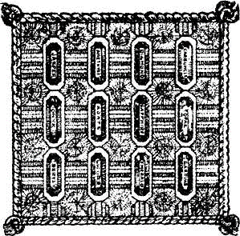

Two chains of gold were fastened to the ouches of gold, in order to connect the breastplate to the ephod.
VERSE 13
"And thou shalt make ouches of gold" — Settings of brocaded work in gold seem to be intended.
VERSE 14
"And two chains of pure gold at the ends; of wreathen work shalt thou make them" — The Hebrew word migbaloth rendered "at the ends," is given by Gese-nius as meaning "of wreathen work;" whereas the statement "of wreathen work" in the A.V. is from the Hebrew aboth, and can be rendered "a work of cords or ropes."
The description, therefore, should read: "Two chains of pure gold, of wreathen work, like unto ropes shalt thou make them." Gold intertwined to make a chain or rope is indicative of faith strengthened by unity and co-operation, for which the true Israel of God should be noted. The very meaning of aboth has the sense of strength through interlacing.
"And fasten the wreathen chains to the ouches" — The breastplate was secured to the ephod by the wreathen chains.
The Breastplate — vv. 15-21.
The breastplate of judgment was among the most mysterious and significant objects of divine worship. It was made of the same material as the ephod, but doubled over so as to form a bag. Two rings of gold were placed inwards at the bottom ends and two rings were attached opposite to the ephod just above the "curious belt," and these were bound one to the other bv a lace of blue. The wreathen chains, or ropes of gold, of the previous verses connected the breastplate to the ouches at the top of the breastplate. Thus the ephod, the onyx stones, and the breastplate were all linked together, comprising the prophetic dress of the high priest. See 1 Sam. 14:3, 18; 23:6; 30:7-8: 2Sam. 2:1.
VERSE 15
"And thou shalt make the breastplate of judgment with cunning work" — The Septuagint translates "breastplate of judgment" by the Greek word logeion, "oracle," a word appropriately related to Logos (John 1), from whence the voice of Yahweh was heard. The Hebrew choshen translated "breastplate," is said by Gese-nius to signify adornment. Certainly the breastplate, with its twelve gems, must have been the most striking and beautiful object in the whole attire of the high priest. Strong gives its meaning as "to "contain, or sparkle;" perhaps a pocket. Externally it represented the high priest as the mediator of the twelve tribes engraven upon the gems placed on his shoulder; but it was formed like a pocket, and, thus its interior expressed another, deeper significance. It contained within it the Urim and Thummim whereby Yahweh was consulted and the people informed concerning His will (see v. 30).
It is rendered breastplate in the A.V., not because the Hebrew word relates to that term, but because it was worn over the breast. It is called a "breastplate of judgment'' because it was used as a means of conveying Yahweh's decision on any issue. The Hebrew word is mishpat and denotes "decision" or a "judicial verdict." The breastplate, therefore, was the prophetic mouthpiece of the dress of the high priest; by its aid decisions were made. See Num. 26:55 for the use of the "lot" (decision) in conjunction with the breastplate.
"After the work of the ephod thou shalt make it; of gold, of blue, and of purple, and of scarlet, and of fine twined linen, shalt thou make it" — The breastplate was made of the same fabric as the ephod, and is to be aligned with it in symbolic meaning.
VERSE 16
"Foursquare it shall be being doubled" — Its foursquare shape was similar to that of the camp of Israel (Num. 2), and of the New Jerusalem, the Lamb's Bride (Rev. 21:16). It was doubled over, and so formed a bag for the use of the "lot" in coming to decisions in matters of inquiry. The doubling of a matter suggests certainty (Gen. 41:32), though here the word means to fold over, and only figuratively, to repeat.
"A span shall be the length thereof, and a span shall be the breadth thereof — A span is half a cubit, about 200mm (9 inches). The significance of the word comes from the span of the fingers reaching to about that length.
VERSE 17
"And thou shalt set in it, settings of stones" — The manner in which this was done is not revealed here, but in ch. 39:13 it is described as being similar to the ouches of gold that held the onyx stones on the shoulders of the high priest. The Hebrew word for "settings" is milu'ath in the feminine gender, signifying "to fill up, or complete" (see mg.). It is from the same root mala, here rendered "set," as is the word "multitude" in the statement made concerning Ephraim, the son of Joseph, and representative of his spiritual seed: "His seed shall become a multitude of nations" (Gen. 48:19, see mg.). The root mala, joined with the word yad (hand), and signifying "to fill the hand," is rendered "consecrate" (see Exo. 28:41; 29:9, 33, 35 etc.). Therefore, the expression in the verse before us suggests that the "filling" of the breastplate is symbolically related to Israel as a multitude of consecrated ones. It was filled by the stones which reflected the divine light.
"Even four rows of stones" — How were these rows of gems set out? The usual way is to illustrate them as placed in four rows of three gems, one row set beneath the other. But surely that would destroy the foursquare symmetry of the breastplate, for four rows of three gems each would be deeper than their width. The instructions given were to arrange the names of the tribes on the stones of the breastplate "according to the twelve tribes" (v. 21). This compares with the writing of the names of the tribes on the two onyx stones which was "according to their birth" (v. 10). Hence we believe that the setting of the stones in the breastplate followed the arrangement of the tribes around the tabernacle. This would mean that the gems were placed around the four edges of the breastplate, leaving the centre empty to display the glory of the gold, blue, purple, scarlet, and fine twined linen of which it was constructed in imitation of the gate, door and veil of the sanctuary. This would seem to be a much more appropriate arrangement than other suggestions for the placing of the gems. The four rows of gems would then answer to the four rows of tribes surrounding the tabernacle in the centre as a vast square.
Therefore, on the dress of the high priest, Israel was represented in two ways: on the brilliant stones that rested on his shoulders, their names were engraved according to their birth; whereas in the breastplate, they were engraved according to their tribes. The former revealed Israel in its weakness; the latter in its strength. The former is according to the flesh; the latter according to the divine purpose in the ultimate. In the former, Reuben, the natural firstborn takes the first position, but was deposed from this position of status, and Judah was given the preference (Gen. 49:8; IChr. 5:2). There is an Israel after the flesh, and an Israel after the spirit — surely, above all else, the twofold arrangement of the stones was a reminder to Israel, and to us, that "the flesh profiteth nothing," for, saith the Logos, or Oracle, the Breastplate of Yahweh's teaching: "the words that I speak unto you, they are spirit, and they are life" (John 6:63).
It is extremely difficult to specifically identify the precious stones used. There have been many laboured attempts to do so, but with the exception of a few, it is acknowledged that the subject is enveloped in obscurity. Perhaps this is how it should be; for we must accept the teaching of Yahweh in faith, awaiting His full manifestation, and the complete identity of the faithful, at that time when the great high priest himself will return to the earth "to make up his jewels."
"The first row shall be a sardius" — The Hebrew word is odem, closely related to Adam, the name given by God to the man and woman in the beginning, including them both in one appellative (Gen. 5:2). One of the titles given the Lord Jesus is the "last Adam" (ICor. 15:45), teaching that flesh, "a living soul," can become spirit.Some believe that the stone so described is the ruby, others claim that it is the deep red sardine stone which derived its name from Sardis, and is a variety of carnel ian. Reference to the sardine stone is found in Rev. 4:3, and applied to the human origin of the Lord Jesus Christ. Here it represents the tribe of Judah (cp. Rev. 5:5) which name means Praise, so calling upon flesh to praise Yahweh. Judah was to be the object of praise according to the blessing of Jacob (Gen. 49:8), and when the greatest of Judah's sons according to the flesh (Rom. 1:3) is manifested in spirit as the Lion of the tribe of Judah (Rev. 5:5), praise will ascend to Yahweh from all in heaven and in earth (Rev. 5:9-13).
Red is the colour of blood and of wine. Judah's land was to be a land of vineyards, and in a beautiful prophetic passage, predicting the glory of Christ, Jacob combined the aspects of wine and blood in one statement (Gen 49:11). It speaks of a dedicated life through sacrifice of flesh: by which means a person truly praises Yahweh.
Why was Judah placed first? Jacob explained that Reuben, a man of the flesh, would not prevail because of his proclivity towards the things of the flesh; and so the royal status was taken from him, and given to Judah. Reuben as the firstborn after the flesh, was superseded by a younger brother, as the last Adam superseded the status of the first Adam, and was given the legal title of "Firstborn of every creature" (Col. 1:15).
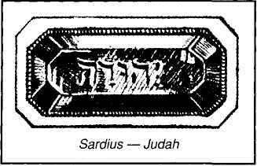

How important was this first stone of the breastplate, both in its exhortatory and prophetic import. It taught that the flesh profiteth nothing, and that natural Israel (as exemplified in Reuben) would have to give place to spiritual Israel (the Lion of the tribe of Judah).
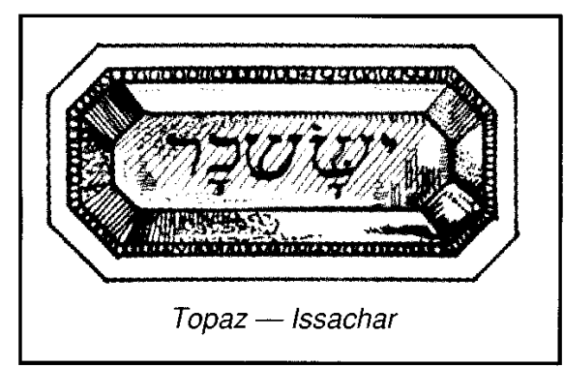

However, the gem is identified with Issachar whose name signifies Reward. The yellow-green hue of the gem is suggestive of faith rewarded. El-Shaddai was introduced to Abraham as his "exceeding great reward" (Gen. 15:1), and in fulfilment thereof, the Lord's concluding message to Abraham's spiritual seed includes the statement: "Behold, I come quickly; and my reward is with me, to give every man according as his work shall be" (Rev. 22:12). See the prophetic promise to Issachar in Gen. 49:14-15, and our notes thereon.
"And a carbuncle" — The name is now applied only to certain bright red garnets when cut convex and smooth, and the actual original identity of the stone in the verse before us is in doubt. The Hebrew word bareketh signifies "lightning," or "glittering," and denotes a gem flashing and glittering with light. On the gem was engraved the title of Zebulun, which means Dwelling (see Gen. 30:20; 49:13; Deu. 33:18-19). The terms of the various blessings bestowed on Zebulun, as described in these verses, indicate the full scope of the dwelling. It suggests a place of rest and security, as provided by a husband (Gen. 30:20), a haven for those who turn their backs upon the wickedness of Sidon (Gen. 49:13 — see notes in Expositor: Genesis), and a calling of them to the Mountain of Yahweh to offer the sacrifices of righteousness (Deu. 33:18-19; Isa. 2:2-4).
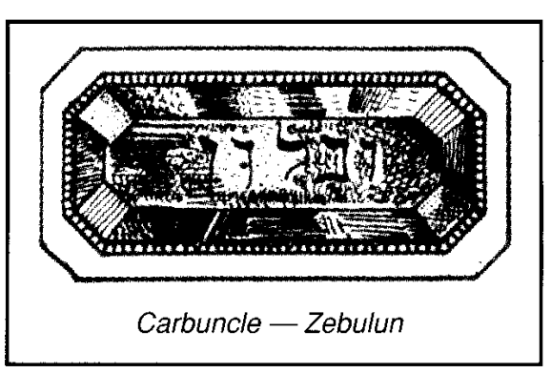
Though the stone may be red, it is different from the redness of the sardine stone, for it speaks of a life dedicated, given to the service of others.
The name Zebulun, together with that of its gem in the breastplate, present the thought of the redeemed dwelling with Yahweh, and giving light to others.
"This shall be the first row" — The first row of gems corresponds to the first group of three tribes that encamped under the standard of Judah, as described in Num. 2:3-9.
VERSE 18
"And the second row" — This row answers to the second group of tribes: Reuben, Simeon and Gad that encamped under the standard of Reuben on the south side of the tabernacle (Num. 2:10-16). This row of gems was evidently on the bottom side of the breastplate.
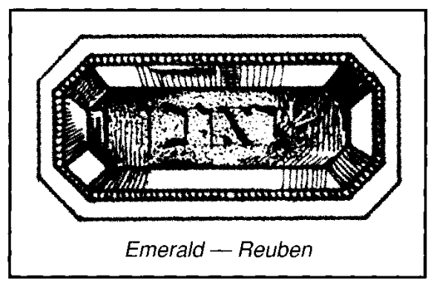
"Shall be an emerald" — There is some doubt as to whether the emerald is referred to by the use of the Hebrew nophech. The word signifies "to shine, to glisten." Upon this stone was engraven the name of Reuben, signifying See a Son! The name was proclaimed in triumph by Leah as she beheld her firstborn son. Though looked upon by Jacob as his might, the beginning of his strength, the excellency of dignity, and of power, Reuben proved unstable (Gen. 49:3-4), and the privileges of status that were conferred upon him because of his position in the family were transferred to others.
In the breastplate, however, Reuben represents unstable human nature by birth, identified with a stone of durable lustre and strength, which reflected the divine glory of light. The placing of the stone in the breastplate, therefore, represents the triumph of the Son over the flesh. "For," predicted Isaiah, "unto us a child is born, unto us a son is given" (Isa. 9:6), and believers are required to view him as the personification of divine glory.
Paul took up the same theme in writing to his Gentile brethren, calling upon them to "see the Son" in the one raised from the dead (Rom. 1:4-5). "We beheld his glory," wrote John, "the glory as of the only begotten of the Father" (John 1:14). He continues concerning those who would see the Son in his true significance: "to them gave he power to become the sons of God." In such Yahweh can see the Son reflected, for, adds Paul, "Christ in you" is the "hope of glory" (Col. 1:27).
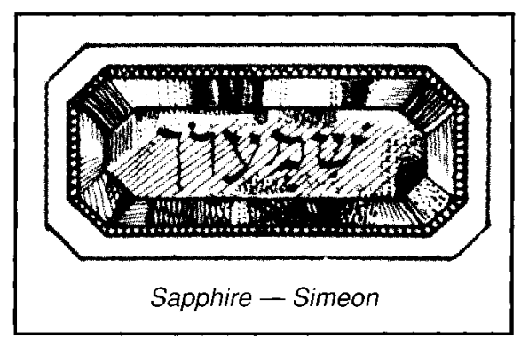
"A sapphire" — The sapphire is a deep-blue stone, like the blue of the heavens above, and therefore, recalls to mind the significance of blue, which speaks of things divine. The Hebrew word, sappeer signifies "to scratch or polish," hence "to write or number." It represented Simeon in the breastplate. Simeon's name means hearing, which is appropriate to the symbolical significance of blue. It is a divine characteristic "to hear," and as Yahweh is prepared to hear the pleadings of His people, so they, in turn, should hear and heed His Word. Faith comes by such hearing (Rom. 10:17), and without faith it is impossible to please God (Heb. 1 1:6). Faithful hearing will engrave divine principles deeply upon our consciousness, and will ever cause us to recall what Yahweh has said.
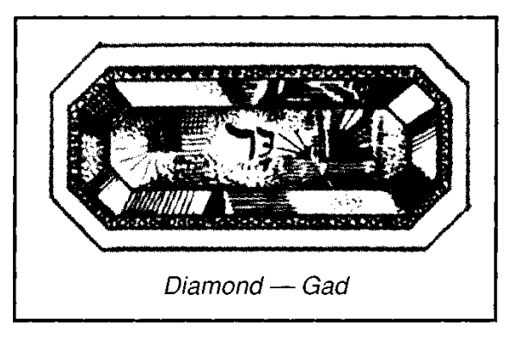
"And a diamond" — As it is considered that the diamond was unknown to the ancients, we can suppose that the mineral referred to was some form of corundum which is very hard and translucent. The Hebrew word is Yah-holam, derived from halam, "to break in pieces or bruise," hence to be strong and powerful, implying that this gem is extremely hard, and is capable of cutting or breaking all others. However, the Yah in front of the word denotes the future tense and therefore signifies "to become strong, powerful, so as to break in pieces or to bruise." This is to be the work of Christ with the glorified
saints, in subduing oppressors (Psa. 72:4; 2:9; 149:5-9; Rev. 2:27). Hence it is remarkable that the stone is identified with the tribe of Gad, for the word Gad signifies a troop, or company, and in this context points to the multitudinous Christ.
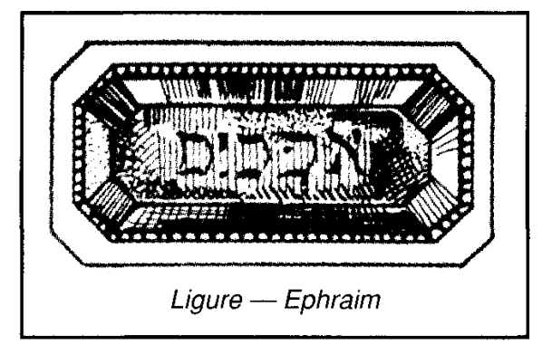
VERSE 19
"And the third row a ligure" — The significance of the Hebrew leshem is unknown. The English is a transliteration of the Greek found in the Septuagint and in Antiquities (3.7), by Josephus. The word is generally identified with the lug-kourion of Theophrastus. This appears to have been a deep-yellow gem, its name relating to the legend that it was the solidified urine of the lynx. Theophrastus refers to it as being much favored for engraving of signets, suggesting the jacinth or hyacinth, used by modern jewellers. Engraved specimens of these stones are often found in collections of ancient gems, and to such, most probably, the reference is made. Theophrastus also states that it is electric, attracting light particles etc., and that this has led to some confusing it with amber. The R.V. has "jacinth" for "ligure," whilst giving amber in the margin (see Linger's Dictionary).
In the breastplate, the gem represented Ephraim whose name signifies Double Fruit (see Deu. 33:13-17; Gen. 48:13-20; and note Joseph's reason for so naming his son, Gen. 41:52). This suggests the fruit-fulness of the Lord's labours (John 10:14-18; 12:25-25; 15:16). In the Apocalypse, the ligure appears as the jacinth (Rev. 21:20), and as the eleventh stone, answers to Joseph, (ch. 7:8), whose name signifies Increaser, the eleventh son of Jacob and father of Ephraim.
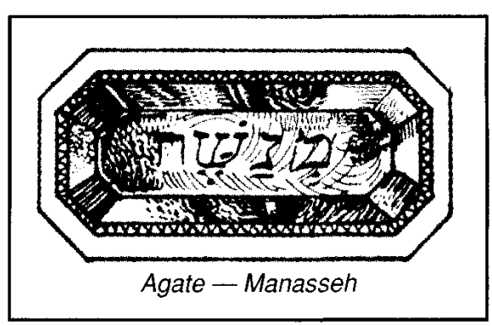
"An agate" — Strong suggests the Hebrew word shebuw has the idea of subdivision (suggesting separation) into flashes of light, and hence to flame. The stone represented Manasseh, whose name signifies Forgetfulness (Gen. 41:51). Manasseh was the firstborn of Joseph, who so named him because "God hath made me forget all my toil, and all my father's house." In saying this in Egypt, Joseph put behind him all the adverse experiences he had endured to that time, and awaited further directions of God. This led to the birth of Ephraim, and to fruitfulness. In Psa. 45:10, the spiritual Bride is exhorted to "forget her own people and her father's house," and thus to become the attractive and fruitful Bride of the great King. The agate is not mentioned in the Apocalypse, where Manasseh is represented by the sardius (Rev. 7:6; 21:20).
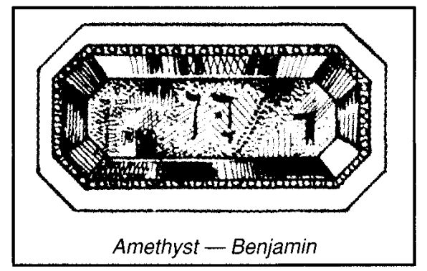
"And an amethyst" — Strong gives the Hebrew as achlamah, and provides the meaning as Dream-stone. The Oriental amethyst is a stone of great hardness and beauty, of a fine violet or purple colour, suggesting God manifestation. The stone in the breastplate represented Benjamin, whose name was changed from Benoni, Son of Sorrow, to that of Benjamin, Son of the Right Hand (Gen. 35:18). The Son of the Promise (Gen. 3:15), which was the subject of Joseph's dreams, experienced both sorrow and elevation. After being Benoni, the "man of sorrow and acquainted with grief (Isa. 53), the Lord was elevated to the right hand of the Father, the place of special honour (Acts 2:33-35).
The right hand of Yahweh is mentioned many times in Scripture. Through it He reveals Himself as glorious in power, dashing in pieces the enemy (Exo. 15:6); as saving (Psa. 17:7; 20:6); as sustaining (Psa. 18:35; 63:8); as manifesting righteousness (Psa. 48:10; Isa. 41:10); as purchasing (Psa. 78:54); as planting (Psa. 80:15); as being strengthened (Psa. 80:17); elevated (Psa. 89:13); made victorious (Psa. 98:1); exalted, and doing valiantly (Psa. 118:15-16). In Psa. 110 the term is directly predictive of the Lord as priest "after the order of Melchizedek," a title and prophecy which Christ applied to himself (Mat. 22:42-46). In the Apocalypse, the tribe of Benjamin is likewise represented by the amethyst (Rev. 21:20). The Greek word amethustos, used only here, however, is supposed to prevent intoxication (cp. Eph. 5:18).
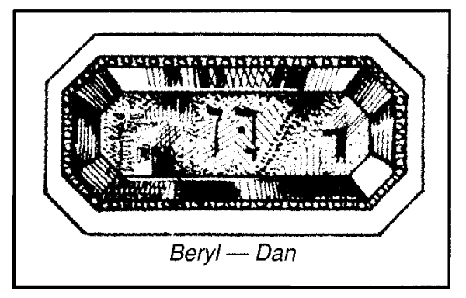
VERSE 20
"And the fourth row a beryl" — This stone in the breastplate represented Dan, the leading tribe of the fourth division. Dan signifies Judgment, and the beryl is appropriately related thereto. Its Hebrew name is Tarshish, which signifies to break or subdue. The judgment of God shall do this as far as the power of the flesh is concerned. The stone is used to describe the hands of the Bridegroom (Song 5:14), thus indicating that he is strong in labour as the wheels of the cherubic chariot, indicating strength to subdue (Eze. 1:16; 10:9). It also represents the body of the multiple man seen by Daniel (Dan. 10:6), thus aligning the vision with the pouring out of judgment in the Age to come. The stone, therefore, is emblematic of the mighty subduing power to be manifested through Christ and the glorified saints, the Israel of God, in judgment on the nations (cp. Gen. 30:6; 49:16-17; Deu. 33:22; Psa. 149:5-9; Acts 17:31). The beryl is a light green, or bluish-green stone, green being the colour of immortality, and blue that of God manifestation. In the Apocalypse, the beryl is used as emblematic of Levi; the tribe of Dan not being represented (Rev. 7). The reason for this, perhaps, is that the vision of the Apocalypse extends to the epoch when the judgments shall be finished, being followed by the education of the people. Hence Dan is replaced by Levi.
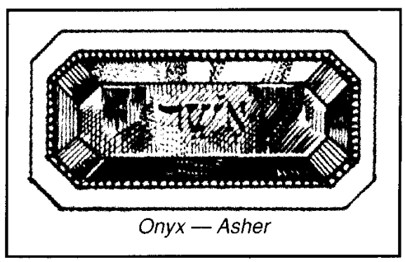
"And an onyx" — Josephus states that the stone in the breastplate was an onyx, whereas those on the shoulders of the high priest were sardonyxes, although they are described as onyx in Scripture. Onyx signifies Fingernail. The gem displays layers of different colours which alternate with each other, and bear some resemblance to the white and flesh-coloured bands of the fingernail. The sardonyx is similar, but more sharply defined, with bands of red and white. The Hebrew is shohham, and comes from a root signifying to flash forth in splendour. The stone represented Asher in the breastplate. Asher signifies Blessed or Happy. A related word describes the state of the righteous man (Psa. 1: 1), as well as that of the forgiven (Psa. 32:1). The destiny of such is to flash forth in splendour in the Age to come (Dan. 12:3), so that the stone is appropriate to the message of the tribe. In the foundations of the New Jerusalem, the onyx is not mentioned, though the sardonyx is supplied as representative of Naphtali. See comments in The Apocalypse Epitomised: Revelation.
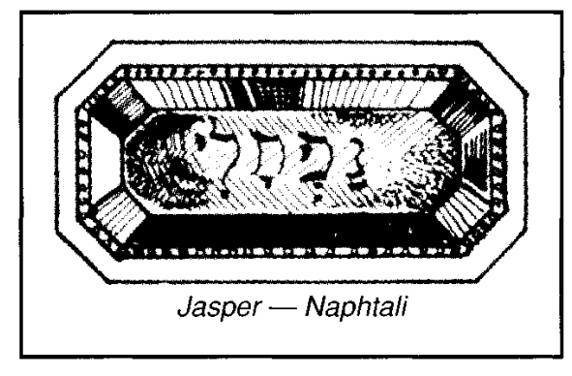
"And a jasper" — The jasper represented Naphtali in the breastplate. Again, the Hebrew name of the gem is appropriate to the tribe it represents. Its Hebrew title, yahshpeh, signifies to polish; whilst the meaning of Naphtali is to wrestle, to prevail. This suggests the striving against difficulties, and by enduring such trials, one "learns obedience," being "polished" to reflect the divine likeness. In the Apocalypse, the jasper represents Judah, whose name signifies Praise. So there is a progression of thought in the symbolic use of the stone, from wrestling, to polishing, and praising. The future shall witness the glorious effects of successful wrestling today, the appropriate emblem being the flashing forth of glory by the polished jasper in the breastplate of the high priest.
"They shall be set in gold" — The word for "set" is shabatsim, and signifies to interweave. The word, therefore, is suggestive of filigree work, an embroidery of gold, as a fitting background to the gems. Strong suggests the root meaning of the word implies that the settings were in squares which would be most appropriate to the square-formation of the tribes as they encamped.
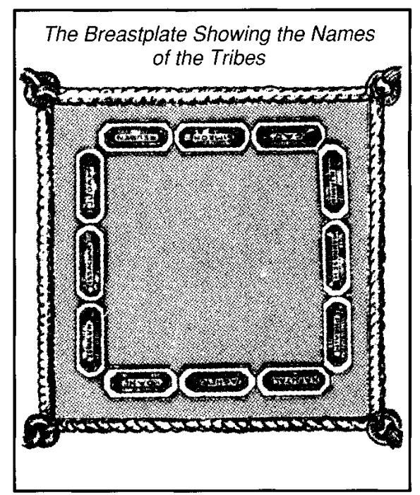
"In their inclosings" — The word milluath, is in the feminine gender, denot-ingfillings. It is derived from millis, to fill, hence to consecrate (see Exo. 29:22, 26, 27, 31), and is used to denote the activity of the priests who were set to work for Yahweh. Used in conjunction with gems representative of the tribes, it suggests that Israel was priestly in concept: "a kingdom of priests, and an holy nation" (Exo. 19:6). The R.V. renders the word as "settings" (see margin).
VERSE 21
"And the stones shall be with the names of the children of Israel, twelve, according to their names" — The significance of the number twelve (perfect government), together with the meanings of the names of the tribes, was emphasised in the placing of the stones in order in the breastplate.
"Like the engravings of a signet" — A signet gives the impress of authority (lKgs. 21:8; Est. 8:8; John 3:33; 6:27), showing that the object thus marked belongs to the one who has applied his
seal to it. In that way, Israel belongs to Yahweh (Isa. 43:1; Eze. 38:16), His chosen nation (Hag. 2:23), whom He has taken unto Himself. In doing so, He placed a difference between Israel and the other nations (Exo. 11:7), but this requires of them such obedience to His commands as will constitute them a holy people (Deu. 28:9; Lev. 19:2). A position of privilege brings with it an equal proportion of responsibility, and therefore, greater punishment if this is ignored (Amos 3:2).
The divine seal is upon the nation of Israel, showing that it belongs to Yahweh, and so warning others against touching His possession, His inheritance (cp. Psa. 116:15; Zech. 1:14-17).
"Every one with his name shall they be according to the twelve tribes" — Whereas the names of the tribes as inscribed upon the shoulder-pieces of the high priest were in the order of birth (v. 10), those on the breastplate were according to the tribal arrangement. The setting, therefore, evidently was foursquare, as follows:
First row: Judah (Praise), Issachar (Reward), Zebulun (Dwell).
Second row: Reuben (See a Son), Simeon (Hearing), Gad (Company).
Third row: Ephraim (Double-fruit), Manasseh (Forgetting), Benjamin (Son of the Right Hand).
Fourth row: Dan (Judgment), Asher (Blessing), Naphtali (Wrestling).
• The message proclaimed by the settings of the stones thus announced:
First row: Praise Him who shall reward you and cause you to dwell with Him.
Second row: See a Son, hear him in the company of the redeemed.
Third row: The rewards of the future will cause a forgetting of the past in the presence of the Son of His right hand.
Fourth row: The judgment will bring a blessing upon those who have successfully wrestled with the flesh.
How were the gems placed in the breastplate? The general idea is that they were set in four rows of three gems each one below the other. But this would create an oblong arrangement of gems, and appear rather incongruous to the purpose. As they are named according to the tribes, they would be more appropriately placed in the breastplate in that order, forming a square revealing the cloth of the covering, suggestive of the tribes surrounding the tabernacle. This would be according to the foursquare shape of the breastplate, rather than the traditional setting of the gems in four lines of three each; and we believe that they would have been placed therein, in this manner.
Chains Of Gold - vv. 22-25.
A golden chain of faith connects the onyx stones on the shoulders of the high priest (representing Israel according to birth) with the ephod and breastplate, and its stones, representative of Israel according to its tribes, organised as a kingdom.
VERSE 22
"And thou shalt make upon the breastplate" — See note, v. 15.
"Chains at the ends of wreathen work of pure gold" — See note, v. 14.
VERSE 23
"And thou shalt make upon the breastplate two rings of gold" — There is no end to a ring, so that the symbolism represents a faith that cannot be broken.
"And shalt put the two rings on the two ends of the breastplate" — The word "ends" is ketsouth, in the feminine gender, signifying the extremity. They were placed on the two extremities of the breastplate.
VERSE 24
"And thou shalt put the two wreathen chains of gold in the two rings which are on the ends of the breastplate" — So the breastplate was to be connected to the other garments of the high priest by a wreathen chain of gold, representing the victory of faith (Un. 5:4).
VERSE 25
"And the other two ends of the two wreathen chains thou shalt fasten in the two ouches, and put them on the shoul-derpieces of the ephod before it" — See introductory note to this section.
The Breastplate Bound To The Ephod - vv. 26-29.
Styled "the breastplate of judgment'' (v. 30), it was designed to announce decisions in connection with the Urim and Thummim (Deu. 17:1-13). Its presence on the dress of the high priest authenticated his voice as being the expression of Yahweh's will. Decisions were probably determined through the bag formed by the fold in the breastplate. See note, Num. 26:55.
VERSE 26
"And thou shalt make two rings of gold, and thou shalt put them upon the two ends of the breastplate in the border thereof, which is in the side of the ephod inward" — The word "border" is sepheth, and signifies lip or margin. The R.V. has "edge." These two rings were attached to the lower portion of the breastplate, whilst those of v. 23 were at its upper extremities.
VERSE 27
"And two other rings of gold thou shalt make, and shalt put them on the two sides of the ephod underneath" — The word "sides" is kaphethoth, denoting "shoulder-pieces" as in v. 7. So these two rings on the shoulder-pieces connected with those on the bottom of the breastplate.
"Toward the forepart thereof — "Toward" is from the Hebrew muwl, signifying "before."
"Forepart" is a translation of paniym, signifying faces. Significantly, therefore, the ephod, the dress of the high-priest, is described as having faces. The high priest represented Yahweh who acts through His faces, the Elohim, and Israelites were made conscious of that by such expressions.
"Over against the other coupling thereof — The Hebrew is "near its joining" (see A New Old Testament).
"Above the curious girdle of the ephod" — The "joining" of the ephod could be where the curious girdle was woven on to it. Compare v. 8.
VERSE 28
"And they shall bind the breastplate by the rings thereof unto the rings of the ephod with a lace of blue" — Thus rings of gold (faith that cannot be broken) were joined by laces of blue (God manifestation), so that breastplate and ephod were closely linked together, and thus united with the priest.
"That it may be above the curious girdle of the ephod" - See v. 8.
"And that the breastplate be not loosed from the ephod" — The dress of the high priest, prophetic of the garments of salvation, were designed to teach the nation to keep close to the high priest, whose vestments typically illustrated the will of Yahweh.
VERSE 29
"And Aaron shall bear the names of the children of Israel in the breastplate of judgment" — See note, v. 15. The word "judgment" is mishpat, from shaphat, to judge, or pronounce sentence, and signifies a decision or verdict. Such judgment could relate to the national conduct, or decisions, in regard to public welfare (see Exo. 28:30; 1 Sam. 23:9; 30:7).
"Upon his heart when he goeth in unto the holy place" — The high priest bore on his shoulders the names of the individual sons of Jacob, and their names according to the tribes, on his heart.
Because of its weakness, human nature (the heritage of birth) is a burden to be borne by the high priest in his intercessory work whether he be Aaron or Christ, hence the stones on his shoulders. But the names of the tribes organised as the kingdom of God were upon his heart, for the heart was to the Hebrews the organ of intellect, and their priestly mediator ever kept in mind Israel's God-given destiny.
"For a memorial before Yahweh continually" — The memorial contrasted the weakness of the flesh (the names on the shoulders according to birth) with the high destiny to which Israel are called (the names on the breastplate according to the placing of the tribes). It was exhibited continually every day, foreshadowing the ceaseless intercession of the Lord (Heb. 7:25).
The memorial was also brought to mind by sacrifice in that, as the priest bore the names of the children of Israel on his shoulders and over his heart, the shoulders and breast of the peace offering were given to him. The first was offered as a heave offering, and therefore recognised the high priest as Yahweh's representative; the second was a wave offering, and represented the activity that the priest manifested before Yahweh on behalf of the people (see Lev. 7:34; 10:15; Num. 18:18). As the heave and wave offerings of shoulders and breast were given to Yahweh through the priest, we should give our strength and intellect to Him through our high priest, the Lord Jesus Christ.
The Urim And Thummim — v. 30.
These mystical additions to the breastplate are now described, and their purpose is presented.
VERSE 30
"And thou shalt put in the breastplate of judgment the Urim and the Thummim" — This is a most intriguing statement, and one which commentators have discussed at length without arriving at any conclusion. What constituted the Urim and Thummim, and in what way were they placed in the breastplate of judgment?
In Eureka vol. 2, pp. 327-335, Bro. Thomas writes concerning the breastplate:
"The first place mention is made of it is in Exo. 28:15. It was not a plate of metal, but a texture wrought of gold, blue, purple, scarlet, and fine twined linen. It was foursquare and of equal sides. It was filled in with settings of precious stones; four rows of them, and three in a row, and each stone set in gold. Upon these twelve stones were engraved, as upon a seal, the names of the twelve tribes of Israel, thereby showing that these tribes were represented by them; so that symbolically speaking, the whole nation of Israel was contained in the square ornament, and borne upon the breast or heart of the high priest in the holy place. This ornament, styled khoshen mishpat, and in our version, 'the breastplate of judgment,' was attached to the aiphod, a robe called ephod, or the overall, because it was put on over all other vestments.
"Having prepared the foursquare texture, Moses was commanded to put into it the Urim and Thummim; that is, the twelve precious stones: not that the stones abstractly were the Urim and the Thummim, but were indispensable to its manifestation. The Urim were the glistering of the stones — the lights refracted and reflected from their cut and polished surfaces, and developing lights of divers colors. These were styled urim, lights; and the twelve stones themselves, thummim, fulnesses, that is, of number and measure — fulness of number, and fulness of measure; or 144,000 and 144 cubits and furlongs; because these are the perfections, or square of 12.
"The next remarkable place where the Urim and Thummim are named is in Deu. 33:8. There Moses speaks of them prophetically. He addresses the tribe of Levi, whose chief pontiff wore the ornament, or as it is allusively termed by Paul, 'the breastplate of righteousness,' and saith, 'Thy Thummim and thy Urim be of the Man thy Holy One, whom thou didst prove at Massah, and with whom thou didst strive at the waters of Meribah.' In Exodus 17, the particulars of this strife are recorded. The question in debate was 'Is Yahweh among us, or not?' This was affirmatively proved by His saying to Moses, Ί will stand before thee there upon the rock in Horeb; and thou shalt smite the rock, and there shall come water out of it, that the people may drink:' and by His doing what He said. Now, in all this there was a mystery hidden, which they did not see into, nor Moses, nor the Elohim themselves; but which we may discern: for, in 'the revelation of the mystery' taught by Paul, referring to this strife in ICor. 10:4, he says: 'They did all drink the same spiritual drink; for they drank of that Spiritual Rock that followed them; and that Rock was Christ.' The Holy Man, ish khasid, with whom they strove, stood upon the rock, and thus, in a figure, made the rock a part of himself; and representative of something afterwards to be smitten by certain, who, like Moses, should speak unadvisedly with their lips. In that way, it became a 'spiritual rock.' Paul says, 'the Rock was Christ;' that is, it was representative of him. The Holy Man upon the rock was the Elohistic representative of the Deity dwelling in light whom no man hath, or can see — 1 Tim. 6:16. He spoke the words of the Invisible One, by whose power, placed at his disposal, water was made to flow. Hence, Eternal and Almighty Power pervaded the rock in Horeb so long as the water gushed forth and followed them in their wanderings. The Holy Man himself was an embodiment of this power; and as the same power was afterwards to be manifested in the nature of Abraham, and thus become his Seed, the Rock became highly typical of Christ. Hence, the Power, of which the Holy Man on the rock was an expression, was Yahweh, or 'He who shall be,' first in Christ Personal, or Jesus; and afterwards, in Christ Mystical, or the Square of Twelve.
"In Moses' prophecy of Levi, he says: 'They have observed Thy word, and will keep Thy covenant.' The second generation of Levi in the wilderness had observed the divine word, but the covenant referred to they have not yet kept. Levi after the flesh has been in apostasy for ages, and will continue to be so until 'Yahweh, the Messenger of the Covenant,' shall come. When the time appointed arrives, he will suddenly come in, and proceed to the work of purifying the sons of Levi, that they may offer unto Yahweh an offering in righteousness — Mal. 3:1-4. From this future time, 'they will keep the covenant,' even the New Covenant of which Jesus, not Moses, is the Mediator. Then, when Yahweh-Christ, the Branch of Righteousness, shall sit upon the throne of his father David, and execute judgment and righteousness in the land of Israel, 'the priests the Levites shall not want a man before Me,' saith the Spirit by Jeremiah, 'to offer burnt-offerings, and to kindle meat offerings, and to do sacrifice continually' — ch. 33:15-18.
"When Levi, then, is in this purified condition contemporary with the reign of the Lamb and the 144,000, Levi's Urim and Thummim will be, as Moses testifies, 'of the Holy Man,' who will then be their High Priest after the order of Melchisedec. He will not need to wear on his breast such Urim and Thummim as Aaron wore. The Lights and Fulnesses will be of himself, he being Deity incarnately manifested; for 'it pleased the Father that in him should a\\ fulness dwell' — Col. 1:19.
"Ezra and Nehemiah, doubtless, understood that a priest was to stand up, in and from whom the reality signified by the Aaronic Urim and Thummim should proceed. This appears from Ezra 2:63; Neh. 7:65. In these places we learn that certain priests sought their genealogy in the register, but it could not be found; 'therefore were they, as polluted, put from the priesthood; and the Tirshatha said to them, that they should not eat of the most holy thing until there stood the Priest, kakkohain, for Urim and Thummim.' Although they were thus excluded from the priesthood, yet, if they were Israelites of faith, when the Priest who shall himself be Urim and Thummim shall stand in the temple, Ezekiel describes, they, having risen from the dead, will be permitted to eat of the most holy things in the Paradise or kingdom of the Deity.
"It has been remarked that, where the precious stones are mentioned, there is no mention of Urim and Thummim, as in Exodus 39:10; and that, where the Urim and Thummim are mentioned, there is no mention made of the stones, as in Leviticus 8:8, which seems to show they are one and the same thing. The reader, however, will have perceived that they are not exactly the same — that the difference between the Urim and the stones is the difference between various colored lights and the stones reflecting them; and yet, without the glistering gems there would be no light; so that the lights imply the stones, and the stones the lights, and the presence of the one argues that of the other. As to the Thummim, the difference between them and the stones is not a matter of lights, but of number and measure. If, by some accident, the filling in were deficient of one or more of the twelve stones, the Four-square Ornament would not have been Thummim, however bright the Urim of the gems present might have been. The deficient stones must have been supplied, and then Thummim would have been restored to the Holy Square."
In a very beautiful manner in Eureka (the whole of this section should be thoughtfully read), Bro. Thomas shows that the Urim and Thummim represented Christ personal and Christ multitudinous. The Urim represented the shining forth of divine light as from the Word; the Thummim represented the fulness of manifestation of both Christ and those to be gathered in both, Jew and Gentile.
Isaiah predicted that Gentiles would "glorify God in the fires" at a time when natural Israel would be cut off (Isa. 24:Π-Ι5). The word "fires" in this place is from the Hebrew urim: they shall "glorify Him as lights" in the world of darkness. This is a significant expression used of the saints by Paul in Phil. 2:14-15.
But whilst endorsing the application of the Urim and Thummim to Christ and the elect as so beautifully set out by Bro. Thomas, we do not believe that they relate directly to the gems in the breastplate of the high priest. The statement of this verse: "Thou shalt put in the breastplate of judgment the Urim and the Thummim," suggests an addition to the instructions regarding the setting of the stones on the outside of this article of dress. The breastplate was constructed so as to accomplish this. It was folded into two, and thus formed into a kind of pocket or pouch, into which something could be placed. It seems obvious, therefore, that the Urim and Thummim did not comprise the gems, for they were already affixed to the breastplate. Later, Moses is said to put them "m the breastplate" when Aaron was first clothed, and as he already had placed on him the breastplate and its gems, it seems clear that the Urim and Thummim were something apart from those twelve tribal stones (Lev. 8:8).
The two words are used together only five times in Scripture (Exo. 28:30; Lev. 8:8; Deu. 33:8; Ezr. 2:63; Neh. 7:65). The word urim occurs in that form two other times by itself (Num. 27:21; ISam.28:6). It is used of the high priest giving counsel from God to Joshua (Num. 27:21); it is mentioned as a form of communication by which Yahweh refused to answer Saul (1Sam. 28:6). It is clear that Joshua received guidance from it in leading Israel into Canaan. He therefore must have used it in the case of Achan (Josh. 9:14). Later, he exercised the lot in dividing the land to the tribes (Num. 34:17; Josh. 17:1-2, 14). It was the method used in choosing certain cities for the Levites in which to live (1Chr. 6:54, 61-65); for setting the order of the priesthood (1Chr. 24:5-7; 25:9); to enquire of Yahweh (Jud. 1:1-2; 20:18, 26-28); to select Saul (1Sam 10:20-22); to instruct David (1Sam. 22:10-15; 30:8; 2Sam. 2:1; 5:19, 23-25; 1 Chr. 14:10; 14-17).
It is significant that whereas God answered Saul by this method early in his reign (1Sam. 14:36-46), the record later says that He no longer would answer him by Urim (1Sam. 28:6), strongly suggesting that the revelation through the latter was connected with the lot.
In regard to the use of the lot, Pro. 16:33 says: "The lot is cast into the lap (properly, bosom), but the whole disposing thereof is of Yahweh." The reference here suggests the pouch of the breastplate that was over the bosom of the high priest, the use of which caused contentions to cease (Pro. 18:18). In deciding a matter by lot, probably certain gems or stones were placed into the pouch of the breastplate, and drawn forth again that Yahweh might make known His decision on a matter. If that be the case, then the Urim and Thum-mim evidently referred to those stones or gems, called the Lot. The word is goral in Hebrew, and denotes a stone or pebble.
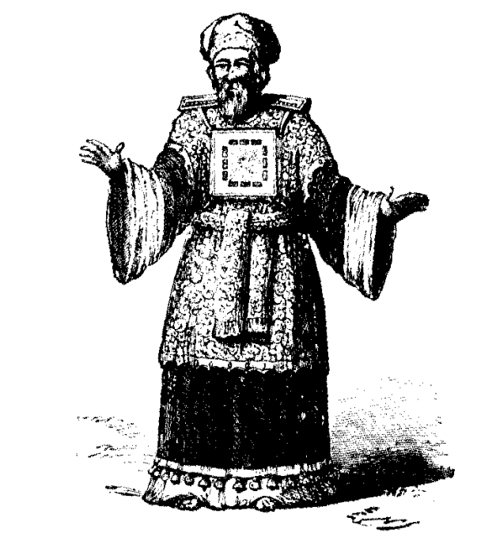
As Urim signifies lights, and Thummim means perfections suggesting complete truth, the stones (if stones they were) represented the shining forth of perfections: the revelations of Yahweh in such perfections as to cause contention to cease.
There is a further word that seems related to the same subject. Hosea speaks of Israel being "without an ephod, and without teraphim" during the period of their dispersion (Hos. 3:4), a state contrasted with their restoration when they shall "return, and seek Yahweh their God, and David their king; and shall fear Yahweh and His goodness in the latter days" (v. 5). What are the teraphim that are denied Israel at the time of their dispersion? The Septuagint translates the word as "manifestations." It is elsewhere rendered "images," and is related to a divine revelation (Eze. 21:21). Rachel took the images (teraphim) of Laban her father, who was deeply concerned at his loss. It has been suggested that possession of these mysterious objects (and we really do not know what they actually represented) denoted the right to property as do title deeds today. Whether this was so, or whether they were merely local means of determining divine truth, the use of the term by Hosea suggests that the word had good connotations, as well as idolatrous ones as in Ezekiel.
In view of this, the teraphim of Hosea (a plural word) could well relate to the Urim and Thummim, and denote special stones or gems used exclusively in the manner suggested above for the purpose of revealing the divine will and purpose. How this was done is not specifically revealed, but in some way, these objects, associated with the breastplate and its tribal gems, made known the will of Yahweh in any given circumstance.
If the possession of teraphim denoted the right to property, as has been strongly suggested by archaeologists concerning the teraphim of Laban that were wrongly purloined by Rachel, the statement of the prophet, that the people of Israel would abide many days "without teraphim," suggests that they would exist without right of possession of the land, which is in accordance with the facts.
"And they shall be upon Aaron's heart, when he goeth in before Yahweh" — To the Hebrew, the heart was the seat of intelligence. It is appropriate, therefore, that these important articles of dress should be so positioned when Aaron approached Yahweh, for they had relation to His purpose with Israel. This purpose is a matter of faith that stems from knowledge (Rom. 10:17).
"And Aaron shall bear the judgment of the children of Israel upon his heart before Yahweh continually" — The decisions and decrees delivered by the high priest to the people were those revealed by Yahweh, and there was to be continued reference to those judgments. Joshua, though a great man of faith, failed to make due investigation of Yahweh's will when the Gibeonites requested that he enter into covenant with them, and so was caught in the trap laid for him (see Josh. 9:14).
It is significant that the word "continually" (Heb. tamiyd) is used of the evil "imagination of the thoughts of men's hearts" (Gen. 6:5; cp. Isa. 65:3), and, in contrast, of the continual offerings required (IChr. 16:40; Eze. 46:14). Service to God must replace the power of the flesh in the hearts of His people.
The Robe Of The Ephod — vv. 31-35.
This important garment was made of blue. There was a binding around the neck of it to prevent tearing, and the hem was ringed with multicoloured pomegranates, interspersed with golden bells that tinkled at the movements of the high priest performing his duties.
VERSE 31
"And thou shalt make the robe of the ephod all of blue" — The word "robe" is meheel and signifies covering. It was blue, the colour of God manifestation, so identifying it with "the robe of righteousness" as part of "the garments of salvation" described by Isaiah (Isa. 61:10). Note that the A.V. marginal reference identifies the article of dress with that of a priest. This is significant, for those saved will constitute a royal priesthood in the age to come (Rev. 5:9-10).
Robes are essentially garments of dignity, insignias of office. As such, robes were worn by both kings and priests. The robe gave a royal status to the priest (see Zech. 6:13). As it was designed that "the law of truth" should be proclaimed from the mouth of the priest (Mal. 2:6-7), and that he should be a teacher of the people (2Chr. 15:3), it was appropriate that this item of dress, being his insignia, should express this. The colour called to mind the commandments of Yahweh (Num. 15:38-39), whilst the garment is also described, as we shall see, as having "mouth," and "head," and "lip."
The blue robe did not entirely cover the linen coat, for the white of the latter protruded below the blue of the former. This illustrated the lesson that there must first be a cleansing, purifying, or justification of flesh before a person can manifest the divine principles.
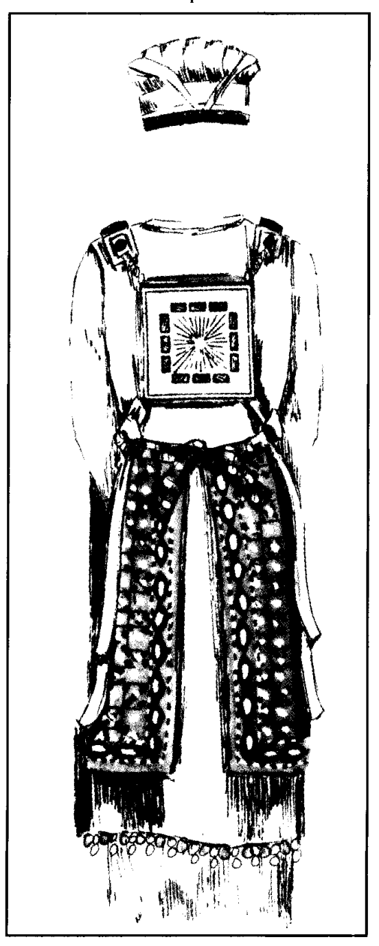
VERSE 32
"And there shall be an hole in the top of it, in the midst thereof — The literal Hebrew reads: "And shall be the mouth of the head of him in the midst." What a significant statement! The very insignia of the high priest's office proclaimed the object of his ministry to Israel: to use his mouth to proclaim the will of Yahweh to the people. Thus even the robe of the high priest illustrated to the people their need to hearken to, and heed his words on behalf of Yahweh.
"It shall have a binding of woven work round about the hole of it, as it were the hole of an habergeon, that it be not rent" — Literally: "A lip shall be to the mouth of him round about, the work of a weaver like the mouth of a habergeon." "Lip" implies speech. This is appropriate to the insignia of the priest for it was his duty to expound the Law to the people.
The word "habergeon" is tachara in Hebrew, derived from a root charah, "to glow or grow warm," and hence suggestive of a metallic, military garment. The Septuagint renders it by the word "fringe," but the English word habergeon signifies a coat of mail. Kitto identifies the Hebrew word with the Arabic ethpeal, "to fight." Perhaps the word (for its actual meaning is in doubt) signifies to be strengthened to fight. However, the description is appropriate to the work of priests in regard to the tabernacle, for their labours in connection therewith are likened to the fight of faith (see Num. 8:23-26; lTim. 6:12).
All these descriptive details show that the blue robe was a fitting insignia denoting the office of the high priest, and emphasising his duty. By its very colour it expressed the idea of heavenly standards of purity, for there is nothing purer, more calming, more relaxing than the deep, soft azure of heaven.
It was woven without seam (Exo. 28:32; John 19:23) expressing unity (Psa. 133; John 17:21-23). It had a mouth (the habergeon) with which to fight the battle of faith, and which would prevent the garment being rent, so destroying its unity. In this it pointed forward to the wonderful, peace-giving, unifying speech of the Lord (John 7:46; Luke 4:22).
It is significant that the coat, or vesture, worn by Christ, was "without seam, woven from the top throughout" (John 19:23). So strongly and beautifully was it made, that rather than divide it into four pieces, the soldiers, who claimed the garments of those executed by crucifixion,
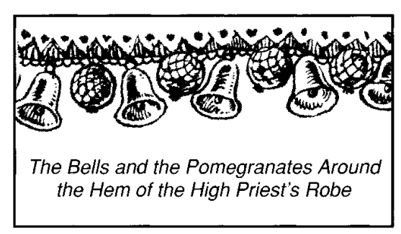
"And beneath upon the hem of it" — The A.V. margin renders hem as "skirts." In the vision seen by Isaiah (Isa. 6:1) the word is rendered "train," thus: "his train filled the temple." As John identifies the vision as relating to the glory of Christ (John 12:41), the skirts of the garment doubtless relate to the multitude of saints who have "put on Christ," and who, with him, constitute the true temple of Yahweh (2Cor. 6:16).
"Thou shalt make pomegranates of blue, and of purple, and of scarlet, round about the hem thereof — No more significant fruit could be selected to symbolise the fruits of Christ's offering: "When Thou shalt make his soul an offering for sin, he shall see his seed" (Isa. 53:10). When cut open the pomegranate exudes a red juice, and is seen to be packed with seeds. The purplish colour of the skin of the pomegranate suggests God manifestation, the qualities of which Christ exhibited in life; but when he was figuratively cut in two (like the covenant victim), and "poured out his soul [life] unto death," it was that ultimately there might be manifested a righteous seed brought nigh unto God. The pomegranates on the hem of the high priest's garment were variegated: blue, purple, and scarlet, emphasising the spiritual principles of the Word (blue), God manifestation (purple), and Sacrifice (scarlet), through which the saving work of God is wrought.
"And bells of gold between them round about" — Gold is the symbol of a tried faith, so that "bells of gold" are representative of the voice of faith.
VERSE 34
"A golden bell and a pomegranate, a golden bell and a pomegranate, upon the hem of the robe round about" —
Suggestive of words and deeds, for one without the other is incomplete. Indeed, words unmatched by deeds, lead to hypocrisy (Jas. 2:14-24).
VERSE 35
"And it shall be upon Aaron to minister" — The sound of the bells spoke of an essential part of the ministry of the high priest, and witnessed to what was required of those who would use the means of the mediation he represented.
"And his sound shall be heard when he goeth in unto the holy place before Yahweh, and when he cometh out, that he die not" — Aaron walked through the holy place to the sound of the tinkling bells, the rustle of his garments speaking of words and deeds. But as he represented the people, this constituted also a profound and beautiful allegory of the divine requirements in the Israel of God ministering in the holy place (Eph. 2:6). For who would hear the sound of tinkling bells and rustling garments of the high priest once he entered the tabernacle? Certainly not the people at the entrance of the court, some distance from the sacred tent itself, and certainly not the ordinary priests and Levites, even though they would be positioned closer to it, for such a gentle sound could not penetrate the thick walls of the holy dwelling place of Yahweh. Yahweh alone would hear it, as it is Yahweh alone who is able to properly assess the true "sound" of the activities of saints as they walk in the antitypical "holy place before Him." Without a proper proclamation of the words of truth, and a genuine manifestation of divine qualities in action, those "called to be priests" will ultimately die. But when Yahweh hears and sees the Truth properly proclaimed in doctrine, and genuinely manifested in deeds, He will ultimately bestow upon those who do so life eternal in the age to come.
The Plate Of Pure Gold - vv. 36-38.
Upon the forehead of the high priest, close to the white mitre of righteousness, was affixed a band of gold displaying the simple declaration: "Holiness to Yahweh." It was placed in such a position as to remind Israelites that "with the mind they should serve God" (Rom. 7:25), and therefore the mind should he separated unto Him. When this is done, a person's life will conform more closely to the divine will. The mind exercises the most powerful influence in the body, and must be controlled by the Word, if the thinking of the spirit is to overcome that of the flesh (Rom. 8:6-8). The high priest wore the band of gold as a reminder of this. The Lord, our high priest, needed no such band, for his mind was constantly at one with that of his Father.
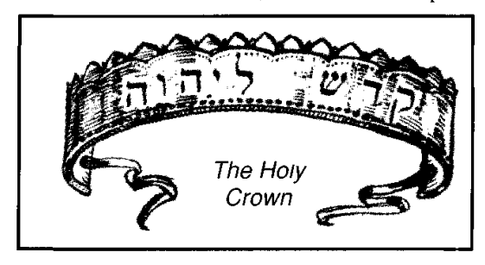
VERSE 36
"And thou shalt make a plate of pure gold" — The word "plate" is a translation of tseets signifying "to glisten," and it is generally rendered as "flower" (e.g. Psa. 103:15; Isa. 28:1; 40:6-8). This suggests that the band of gold represented the flower of Truth; a mind that unfolds to its beauty by being given over to Yahweh. It is possible to understand a doctrine academically, but it is not until it becomes part of a person's mental process, and is manifested in action that it can be said that one has attained unto the full result of his understanding. The band of gold, representing a mind of faith, stood for the ultimate effect of the Word. It is elsewhere described as a "crown," and is thus representative of a crown of glory (Exo. 29:6; 39:30; Lev. 8:9). It was constantly worn by the high priest, being "fastened on high" (Exo. 28:37). So positioned, the gold would glisten with glory as it reflected either the light of the sun, the light of the lampstand, or the light of the shekinah glory in the Most Holy. These forms of light reflected thereon would bring out its beauty as the colours of a flower.
"And grave upon it like the engravings of a signet" — Such engravings are permanently etched, and cannot be erased. The inscription on the band of gold constituted the divine seal, indicating what Yahweh desires in His worshippers. The Lord declared that he was "sealed" by the Father (John 6:27), and the Word teaches that all who come unto Yahweh must likewise become "sealed" by the Truth (2Cor. 1:22). Persons thus "sealed" will do as though by nature, the things of the law, for they will "shew the work of the law written in their hearts" by the Truth (Rom. 2:14-15).Such are represented as being "sealed in the forehead" (Rev. 7:2-4; 14:1), the antitype of the band of gold on the forehead of the high priest.
"Holiness to Yahweh" — The words are Kodesh Yahweh. The former is from the root kadash, "to be clean," and implies separation and consecration. True Israelites are called upon to worship Yahweh "in the beauty of holiness," or in "holy array," as the Hebrew has it (IChr. 16:29; 2Chr. 20:21; Psa. 29:2; 90:17). The white robes of the ordinary priests symbolised these divine principles set before Israelites, for "white linen is the righteous acts of saints" (Rev. 19:8). Their minds are to reflect the message inscribed on the plate of gold placed on the forehead of the high priest, which proclaimed the separation and consecration of a mind motivated by faith in Yahweh. In fact, the plate of gold proclaimed what the holy people, as a priestly community (Exo. 19:6), were called upon to be (see Jer. 2:3). As the temple of the future will be dedicated according to these requirements (Zech. 14:20-21), so saints, as the spiritual temple, should reflect divine characteristics in action. They are called upon to be sharers of His holiness (Heb. 12:10, 14; 1Pet. 1:15; Rev. 20:6).
VERSE 37
"And thou shalt put it on a blue lace" — The word "lace" is pathyl, the same word as is rendered "ribband" in Num. 15:38. This blue lace, therefore, matched the ribband of blue which every Israelite was called upon to wear, so that he might remember his heavenly obligations. The word is from a root pathal, "to twine" or "struggle," which is appropriate to the manifestation of righteousness. From Exo. 39:31 we learn that the plate of gold was tied into place by the blue ribband or lace: a significant colour as we have seen.
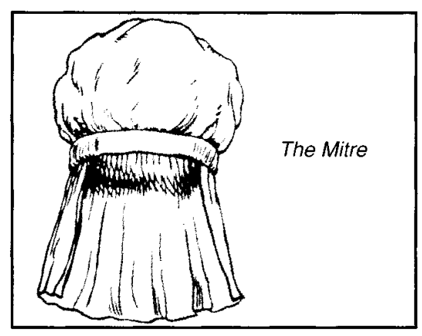
"That it may be upon the mitre" — It was probably affixed to both ends. The "mitre" was a turban of white linen (Exo. 39:28), representing a crown of righteousness. Thus the gold of faith, ascribing holiness to Yahweh, was connected by the blue lace, reminding one of the obligations of obedience, to the white linen mitre, the crown of righteousness. And all were connected with the forehead, which should be yielded unto Yahweh.
"Upon the forefront of the mitre it shall be" — Importantly connected to that prominent and significant place because, as Paul remarked, "With the mind I myself serve the law of God; but with the flesh the law of sin" (Rom. 7:25).
VERSE 38
"And it shall be upon Aaron's forehead, that Aaron may bear the iniquity of the holy things, which the children of Israel shall hallow in all their holy gifts" — These "gifts" were the offerings of Israel, made holy because they were consecrated to Yahweh, but associated with "iniquity" because offered by an unclean people. As such, they were treated as unfit for presentation to Yahweh except through a cleansing medium which was the high priest. The defilement was neutralised by the constant assertion of the holiness of Yahweh. In the antitype, the Lord Jesus "bare our sins in his own body to the tree" (IPet. 2:24) in that he possessed our nature which is the author or seat of sin (Mark 7:15-23). Thus, upon him was laid "the iniquity of us all" (Isa. 53:6), in that he came in our fallen nature. But he was able to bear this, and yet render perfect obedience because of the holiness of his mind. He thereby set forth "the righteousness of God" for all to see (Rom. 3:25-26; see also Num. 18:1). The ability of the Lord to do this was through the heritage he received in his divine parentage. Therefore, he did not accomplish the victory in his own strength, but in the ability he derived from Yahweh; neither will we render acceptable obedience in our own strength, but only through that which comes to us in the Lord Jesus.
A contrast is shown between the plate of gold upon the forehead of the high priest ascribing holiness to Yahweh, and the mark of leprosy imposed on the forehead of Uzziah the king when he unlawfully attempted to force his way into the holy place. His action in so doing was primarily a sin of the mind, as is shown by the narrative, for it states that "when he was strong his heart (to the Hebrews, the seat of intelligence) was lifted up to his own destruction" (2Chr. 26:16-21). He was driven out of the temple a leper. In Christ, we are called upon to "bring into captivity every thought to the obedience of Christ" (2Cor. 10:5). That is the ideal, although, through weakness of the flesh, we fail to attain unto it.
"And it shall be always upon his forehead that they may be accepted before Yahweh" — The plate of gold must always remain on the forehead of the high priest as an incentive to the people. In that regard, it provided a contrast to the worst form of leprosy, the unrestrained carnal mind, the mark of which was found in the forehead of those so afflicted (Lev. 13:42-44). Leprosy is treated as a living death, and under the Law represented active sin.
The plate of gold also contrasted with the whore's head (Jer. 3:3), and in that regard with the religious prostitute of Rev. 17:5 who likewise had an inscription upon her forehead: Mystery, Babylon the Great: the Mother of harlots and abominations of the earth. Earlier, the Apocalypse contrasts the "names of blasphemy" upon the heads of the beast (Rev. 13:1) with the Name of Yahweh, inscribed, or sealed, upon the foreheads of the redeemed (Rev. 7:3; 9:4; 14:1).
The Coat Of Fine Linen — v. 39.
The white coat of fine linen is now described. This was the innermost garment of the high priest, and therefore provided the foundation for the other garments — a covering of the flesh in white. It was a gown worn directly over the drawers. According to Josephus (Ant. 3.7.2) it reached to the feet, and had tightly-fitting sleeves.
VERSE 39
"And thou shalt embroider the coat of fine linen" — The word "coat" is kethoweth and signifies "to cover, to hide." It is the same word as used in Gen. 3:21 relating to the coats provided Adam and Eve by the angel of Yahweh. Though this was the high priest's undergarment, it was the only garment allocated to the ordinary priests (Exo. 39:27). In regard to this coat of covering see Isa. 61:10 mg; Gal. 3:26,29; IPet. 1:16. It points to the covering obtained in Christ. It was made of "fine linen"; thus of outstanding quality such as cannot be produced today. It is claimed that its manufacture was a secret art that died with the ancient Egyptians. J.G. Wilkinson in Manners and Customs of the Ancient Egyptians states: "The Egyptians were always celebrated for their manufacture of linen and other cloths, and the produce of their looms was exported to, and eagerly purchased, by foreign nations. The fine linen and embroidered work, the yarn and woollen stuffs of the upper and lower country are frequently mentioned, and were highly esteemed... Nor was the praise bestowed upon that manufacture unmerited; and the quality of one piece of linen found near Memphis fully justifies it, and excites equal admiration at the present day, being to the touch comparable to silk, and not inferior in texture to our finest Cambric" (vol. 2, pp. 72, 75). Similarly, Christ, who was called out of Egypt (Mat. 2:15) was unique in the quality of his righteousness.
The material is described as being "embroidered." The Hebrew shabats signifies "interwoven." Rotherham thus renders: "Weave in checker work." A cognate word is rendered "wrought" (Psa. 45:13), being related to the Bride's resplendent clothing. The same word is translated "set" in v. 20, and there relates to an "embroidery" in gold, probably the filigree settings of the gems of the breastplate.
"And thou shalt make the mitre of fine linen" — See the reference to linen above.
"And thou shalt make the girdle of needlework" — See note, ch. 26:36. For a description of the girdle of the coat, see ch. 39:29.
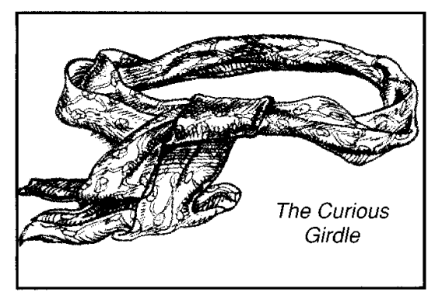
Further Garments — vv. 40-43.
The garments of the lower order of priests, and the breeches are now described.
VERSE 40
"And for Aaron's sons thou shalt make coats" — Lacking the official dignity of the high priest, this lower order of priests appear only in white. See Rev. 3:4-5, 18; 4:4; 6:11; 7:9, 13-14; 15:6; 19:8, 11, 14. The white-frocked priests of Israel contrasted with the black-frocked pagan priests of the Canaanites, described as chemarim, a word derived from the Hebrew kamar, signifying "black." Such attire is now recognised in the representatives of the church system — a stark contrast to the priests appointed of God in Israel.
"And thou shalt make for them girdles" - See note: ch. 29:9.
"And bonnets shalt thou make for them" — See note: ch. 29:9.
"For glory and for beauty" — Though lacking the resplendent glory of the high priest (as ordinary saints do that of their Lord), they had a glory of their own, contrasting with the garments, or coverings, of the people generally.
VERSE 41
"And thou shalt put them upon Aaron thy brother, and his sons with him" — This ceremony is later described in greater detail.
"And shalt anoint them" — See note Exo. 29:7; 30:30.
"And consecrate them" The word is malath yad and signifies "to fill the hands of (see margin). After being clothed and anointed, the hands of the priests were filled with an offering, indicating that they were separated to such labour. See note, ch.29:9.
"And sanctify them" — They were set apart for divine use, this being the significance of the word used.
"That they may minister unto Me in the priest's office" — To "minister" in this context signifies to act as a servant. The hands of the priests were "filled" with an offering to indicate the channel of their service and labour.
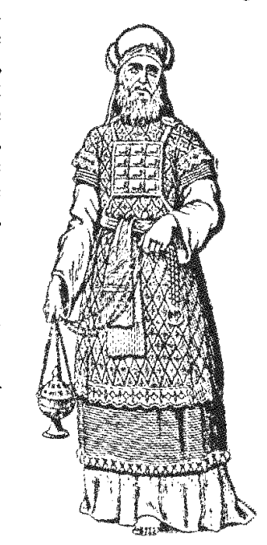
VERSE 42
"And thou shalt make them linen breeches" — The Hebrew word bad is here used for "linen," contrasting with shesh as used elsewhere in this chapter. However, both words are used in Exo. 39:28 for the same garment, and in Lev. 16:4, 23, 32 the linen of the atonement garments is described as the Hebrew bad. The angelic man, as seen by Ezekiel the prophet, is clothed in the same linen (Heb. bad - Eze. 9:2-3, 15; 10:2,6-7).
The word is derived from the root badad, "to divide, be solitary," and is translated "alone" in Lev. 13:46; Num. 23:9; Deu. 33:28. This, perhaps, implies that a quantity of linen was set aside for particular purposes. The use of both words {bad and shesh translated "linen" and "fine linen" respectively) in Exo. 39:28 suggests that bad denotes a different weave of the same basic material. Evidently the breeches were only put on when the priests ministered in the tabernacle of the congregation. They reached from the loins to the knees, but being hidden from human sight, the covering was only apparent to Yahweh. This suggests that sexual irregularities should be excluded even in thought (Mat. 5:27-28).
"To cover their nakedness" — The Hebrew is the flesh of nakedness (see mg.). It is so described to indicate the evil condition of the flesh in the sight of God, for as Adam and Eve recognised their nakedness following their transgression (Gen. 3:7, 10), so the principle of sin is seen in the nakedness of flesh (Exo. 32:25).
The purpose of this covering to be provided is described in ch. 20:26.
"From the loins even unto the thighs they shall reach" — Josephus says that they reached to the knees.
VERSE 43
"And they shall be upon Aaron, and upon his sons, when they come in unto the tabernacle of the congregation" — The Hebrew mo'ade, rendered "congregation" signifies appointed meeting. The term relates to the Tent of the Meeting, which was the place where priest and people met with Yahweh.
"Or when they come near unto the altar to minister in the holy place" — In such statements as these, the "holy place" includes the court in which was placed the altar.
"That they bear not iniquity, and die" — To "bear iniquity" is to incur guilt, or to have sin imputed to a person. If the priest, through forgetfulness, entered the sanctuary without this necessary article of clothing, and so risked an unseemly exposure of his person, he was to be accounted guilty, and risked the penalty of death. This taught that the greatest circumspection is necessary when approaching Yahweh in worship. Immodest dress, or the unseemly display of flesh, is most inappropriate, and believers should maintain the highest standards of attire when approaching the Deity.
The people were also commanded to abstain from even legitimate sexual intercourse at such times (cp. Exo. 19:15), and in the case of the priests, even the thought of it was to be excluded, and that part of the body completely hidden away. Sexual thoughts were to be entirely excluded when the priest was performing the ministry of Yahweh.
"It shall be a statute for ever unto him and his seed after him" — This statute, and the provision of this clothing, made the prohibition of Exo. 20:26 unnecessary.

